Natural Science June Exam June 2014

Mrs Magid
Beis Yaacov Girls High School / Mesivta Shaarei Torah
Gr 8

Name:______________________________

Answer ALL the questions. Ensure that your handwriting is legible. Do not write in red ink. Good luck!

Question 1: Atoms (54 marks)

  - Complete the following sentences by filling in the missing words: (4)
    - Elements are pure substances because all the atoms of a specific element are identical.
    - Some elements such as oxygen exist in bonded pairs. These are called diatomic molecules.
    - The atoms in a compound are always combined in a fixed ratio.
    - When we mix different elements or compounds together, there is no chemical reaction.

  - Identify the following as an element, a compound or a mixture: (3)
    - Carbon dioxide compound
    - Air mixture
    - Hydrogen gas element

  - Use the periodic table to write down the SYMBOL AND NAME of the element that: (12)
    - Is in period 1, group 18 He/helium
    - Has 16 protons in the nucleus of one atom S/Sulfur
    - Is in group 1 and the 2nd period Li/lithium
    - Has 8 electrons in the orbitals of one atom O/oxygen
    - Has 28 subatomic particles in the nucleus of an atom Si/silicon
    - Has 7 neutrons in nucleus the nucleus of one atom N/nitrogen

  - The boiling point of water is 100°C. If a sample of water boils at 102°C, what do you know about the sample? Give a reason for your answer. (2)
It is not pure. Pure water boils at 100°C

  - Draw a labelled mercury (Hg) atom indicating all the things that an atom is made up of, including the charges of the different components. Remember all the rules of scientific diagrams! (10)
1 mark for showing and labelling neutrons
1 mark for showing and labelling protons and 1 mark for charge
1 mark for showing and labelling electrons and 1 mark for charge
1 mark for labelling the nucleus
1 mark for labelling the orbital
1 mark for showing correct number of p
1 mark for showing correct number of e
1 mark for showing correct number of n
1 mark for size
1 mark for label

  - For the following, decide whether each is a mixture or a pure substance. If it is a mixture, say if it’s homogeneous or heterogeneous: (9)

    - Mud mix - hetero
    - A cup of coffee mix - homo
    - Non-iodated table salt pure
    - Oxygen pure
    - Sponge cake batter mix - homo
    - Iron pure

  - Insert the words in the box on the side of the flow chart into the appropriate places. (10)

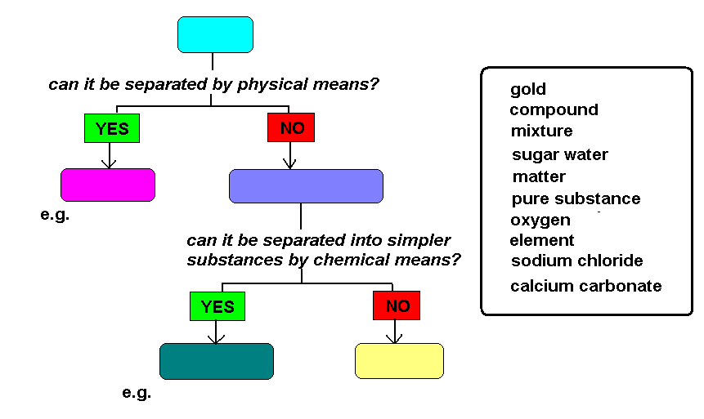
A

D
B
C

e.g. H
G
F
E

A: Matter
B: Mixture
C: Sugar water
D: Pure substance
E: Compound
F: Sodium chloride, calcium carbonate
G: Element
H: Oxygen, gold

  - In the graphs below, which one represents and endothermic reaction and which one represents an exothermic reaction? Explain. (4)
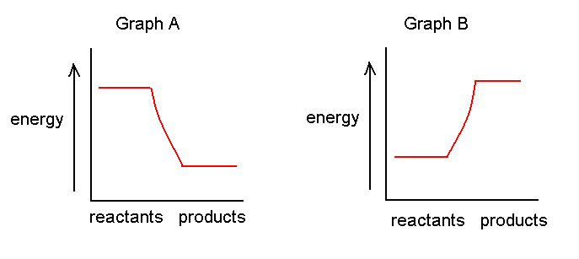
In graph A, the reaction has lost energy, so it’s endothermic. In graph B, the reaction has gained energy so it’s exothermic.

Question 2: The particle model of matter (30 marks)

  - Railway lines are made of steel, which expands and contracts as the temperature changes. Use the particle model of matter to explain what happens to the railway tracks when the temperature increased and decreases. (6)
When the temperature increases, the material expands (1). This is because the parties gain energy (1) and the particles move faster and further (1).
When the temperature decreases, the material contracts (1). This is because the particles lose energy (1) and the particles move slower and come closer together (1).

  - You burn toast in the kitchen. A minute later your mom calls out from the bedroom – “what is burning?” Use the particle model of matter to explain how your mom knew that something was burning even though she did not see or hear it. (2)
The particles of the burnt toast diffuse through the air. The travel from a place of high to low concentration until they are evenly distributed, therefore they eventually reach the bedroom.

  - You heat up water to boiling point in a pot. Describe what happens to the water in a paragraph. You must use the following words: energy, particles, move/moving, state, gas. (5)
I added energy to the water so the particles started moving faster and further apart. I added enough energy so that there was a change of state from liquid to gas.

  - Which two factors affect density? (2)
Mass and volume

  - Why does a balloon filled with helium rise? (1)
Helium is less dense than air

  - See the diagram below and answer the questions that follow. The values represented below are in ml.

Cylinder A Cylinder B Cylinder C
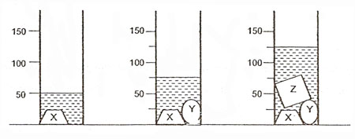
    - What is the volume of object Y? Show your calculation. Provide the answer in cm^{3.} (4)
Volume of obj Y = volume of object x+y – volume of obj X = 75ml-50ml = 25ml = 23cm3

    - What is the volume of object Z? Show your calculation. Provide the answer in cm^{3.} (4)
Volume of obj z = volume of object x+y+z – volume of obj X+y = 125ml-75ml = 50ml = 50cm3

    - Assume that the mass of object Y is 0.5 kg. Calculate the density of object Y. (3)
D=m/v = 0.5kg/25cm3 = 0.02kg/cm3

    - Assume that the density of object Z is 12g/cm³. Calculate the mass of object Z. (3)
M=dv = 12g/cm3 * 50cm3 = 600g

Question 3: Chemical reactions (25 marks)

  - For the following, decide whether or not a chemical reaction has taken place. Say yes if it is chemical reaction, no if it’s not a chemical reaction: (6)
    - Ice cream melting No
    - Burning wood Yes
    - Liquid water freezing to ice No
    - A nail rusting Yes
    - Photosynthesis Yes
    - Water evaporates from your glass No

  - For the following, provide TWO indications that a chemical reaction is taking place: (10)
    - A candle flame burning smell, feels hot
    - Lighting a match smell, feels hot
    - Cooking an egg colour change, feels hot, smell, looks different
    - Baking a cake colour change, feels hot, smell, looks different
    - Brewing beer colour change, bubbling, smell

  - ONE hydrochloric acid (HCl) reacts with ONE potassium hydroxide (KOH) to form ONE potassium chloride (KCl) and ONE water (H₂O).

    - Write out the chemical reaction using the symbols. (3)
HCl + KOH → KCl + H₂O

    - Using different coloured pens (where a certain colour represents a certain element) draw out the chemical reaction. (6)

 | + |  | → |  | +

Question 4: Static electricity (21 marks)

  - Complete the following sentences by filling in the missing words: (8)

    - One element cannot be changed into another element by a chemical reaction.
    - The nucleus of an atom is made up of positively charged particles called protons and electrically neutral particles called neutrons.
    - Atoms are neutral because the number of electrons is equal to the number of protons.
    - Like charges repel each other.
    - Unlike charges attract each other.
    - The build-up of electrons in an object is called static.
    - Lightening is a form of natural static electric discharge.

  - How does friction cause static electricity? (2)
The rubbing causes electrons get transferred from one material to another. One material becomes positively charged and one material becomes negatively charged.

  - What causes an electric spark? (2)
When a material is negatively charged and electrons jump off onto an electrical conductor.

  - Why does a rubbed balloon stick to the wall? (3)
The balloon becomes negatively charged from the rubbing. The wall is neutral. A neutral and a charged item attract.

  - Draw a diagram indicating the charges in the balloon and in the wall to support your answer to the previous question. (3)

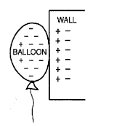

  - Why is it not safe to stand next to a tree during an electric storm? (1)
Lightening is attracted to tall things.
  - Why is it not safe to speak on a land line phone during an electric storm? (1)
Lightening may travel in electric wires.

  - Why is it not safe to have a bath during an electric storm? (1)
Lightening is attracted to electricity conductors such as water.

Total = 130 marks

