Physical Sciences November Exam Paper 1: Physics graph paper at least 3
Mrs Magid
Beis Yaacov Girls High School
Gr 10

Name:______________________________

Instructions:
- Please refer to the data sheet on page 15.
- Ensure that your handwriting is legible.
- Do not use shorthand in your answers.
- You need not answer in full sentences.
- Consider the mark allocation. For example, 3 marks require you to make 3 correct and relevant points.
- You may use a calculator.
- Do not write in red ink.
GOOD LUCK!

Total: 140 marks
Time: 2h

Question 1: One word/term answers (5)

- Provide a one name or term for each of the following descriptions: (5×1=5)

  - A physical quantity that has magnitude only. Scalar
  - The distance between two consecutive points that are in phase. Wavelength
  - The “energy packets” of light. Quanta/quantum
  - The rate of change of an object’s velocity. Acceleration
  - A wave in which the particles of a medium move at right angle to the direction of the wave motion. Transverse wave

Question 2: Multiple choice (22)

- Circle the correct answer: (11×2=22)

  - Which one of the following quantities is a vector?
- Time
- Distance
- Velocity
- Speed

  - A runner ran the 200m final at a time of 19.36s. If he started at rest and ended the race running at a velocity of 12m/s, what was his constant acceleration throughout the race?
- 0.61 m/s²
- 1.61 m/s²
- -0.61 m/s²
- -1.61 m/s²

  - A car travels up the hill at a constant speed. It then travels faster as it goes down the other side of the hill. Which velocity vs. time graph best represents the motion of the car?
  - A stone is dropped from the top of a building. After 2s, the stone will have _______ than it had at the top of the building.
- Greater gravitational potential energy
- Less kinetic energy
- Greater kinetic energy
- Less mechanical energy

  - Which of the following regarding electromagnetic waves is correct? In a vacuum, electromagnetic waves have the same _______.
- Speed
- Frequency
- Wavelength
- Amplitude

  - A motorist sees a dog in the road 100m ahead of him. He slams the breaks and brings the car to a stop. He slowed down at a constant rate of 4.5m/s². What velocity was the motorist travelling at when he saw the dog>
- 30m/s
- 2m/s
- 450m/s
- 900ms/

  - An atom which is positively charged has
- Lost proton
- Lost electrons
- Gained protons
- Gained electrons

  - Astronauts are in a spaceship orbiting the moon. They see an explosion on the moon. Why can’t they hear it?
- Explosions do not occur in space
- Sound cannot travel through vacuum
- Sound is reflected away from the spaceship
- Sound travels too quickly through space to affect the eardrum

  - The gravitational potential energy of an object relative to the ground is dependent on the object's _______.
- Speed
- Velocity
- Position
- Change in velocity

  - A characteristic property of motion at constant acceleration is that the …
- Change in position per unit time is constant
- Change in velocity per unit time is constant
- Velocity remains constant for the duration of the motion
- Change in position remains constant for the duration of the motion

  - Which ONE of the following statements is correct? All waves …
- Are transverse
- Are longitudinal
- Transmit energy
- Travel through a vacuum

Question 3: Scalars and vectors (6)

- An aeroplane flies for 250km at an angle of 200°. It then turns and flies a further 200km at an angle of 300° before landing. Using the head to tail method, construct an accurate vector diagram to find the resultant displacement of the aeroplane. Use the graph paper provided and use a scale of 50km:1cm (6)
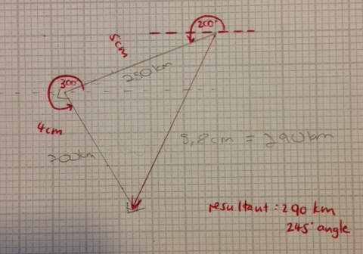

Question 4: Speed, velocity and acceleration (30)

  - An athlete runs an oval track with a circumference of 400m. The starting and finishing points are at the same place. The athlete takes 1 minute and 55 seconds to complete the race. What is her average speed for this race? (3)
Speed = distance/time = 400m/115s = 3.48m/s

  - A police car is traveling at 15m/s when a truck travelling at 40m/s overtakes the police car. It takes the policeman in the police car 10s to contact headquarters and establish that the truck is a stolen truck. It then begins to accelerate to chase the truck. The velocity vs. time graph below represents the motion from the time that the truck initially passes the police car.

22.5

    - What was the distance between the two vehicles when the police car started accelerating to chase the truck? (5)
Police car: D=VT =15m/s*10s=150m
Truck: D=VT =40m/s*10s=400m
Distance between the 2 was 400m-150m=250m

    - Sketch a position vs. time graph of the two vehicles from 0-25s on graph paper. Make sure that you use the same x axis (time) as in the velocity vs. time graph, and label the graph correctly. (6)
Truck for the first 25s:
Δx = ΔvΔt = (40)(25) = 1000m.
Because it’s a straight line in the v vs t graph in the positive axis, the x vs t graph will be a straight line with a positive slope.
Police car for the first 10s:
Δx = ΔvΔt = (15)(10) = 150m
Because it’s a straight line in the v vs t graph in the positive axis, the x vs t graph will be a straight line with a positive slope.
Police car for 10-25s
Δx = ΔvΔt+½ΔvΔt = (15)(15)+½(30)(15) = 225+225 = 450m
Because it’s a diagonal line with a positive slope in the v vs t graph and in the positive axis, the x vs t graph will be a sloped upward curve speeding up

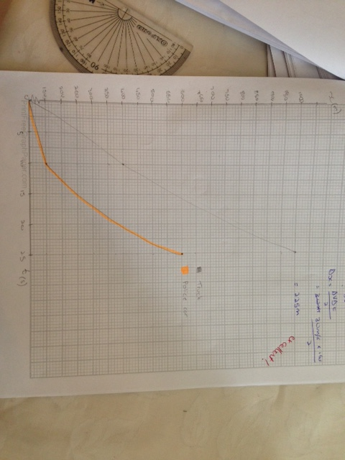

Labels on axes 1
Scales 1
Curve of car plotted correctly 2
Curve of truck plotted correctly 2

    - Did the truck exceed the speed limit of 120km/h? Motivate your answer. (2)
Yes. 40m/s is 144km/h

  - A man runs from point A in a straight line along a track ABCDEFG. The velocity-time graph below represents the motion of the man.
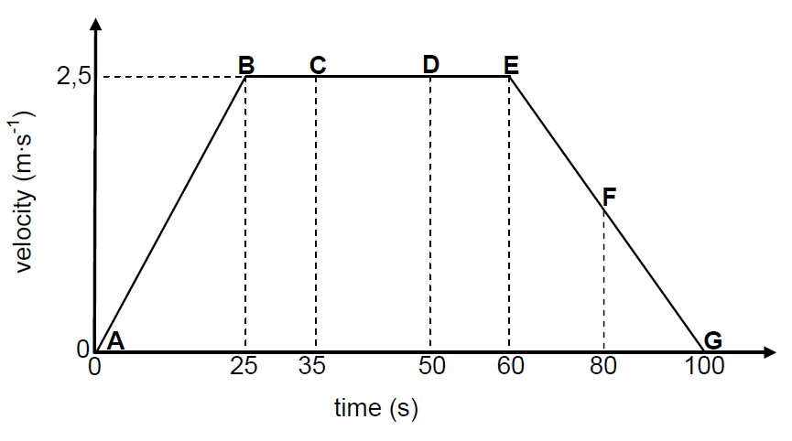

    - Using the information on the graph, describe the motion of the man from A to B. Use the values on the graph in your explanation. (4)
The man starts from rest (1) and increases velocity at a constant rate (1) in positive direction (1) until he reaches 2.5m/s after 25s (1).

    - Using the information on the graph, describe the motion of the man from B to E. Use the values on the graph in your explanation. (3)
The man moves at a constant velocity of 2.5m/s (1) in positive direction (1) for 35s (1)

    - Using the information on the graph, describe the motion of the man from E to G. Use the values on the graph in your explanation. (3)
The man slows down with a constant decrease in velocity in the positive direction (1) until he reaches 0m/s after 40s (1).

    - Calculate the distance covered by the man in 100s. (4)
Area under graph
AB:
Δx = ½ΔvΔt = ½(2.5)(25) = 31.25m
BE:
Δx = ΔvΔt = (2.5)(35) = 87.5m
EG:
Δx = ½ΔvΔt = ½(2.5)(40) = 50m
Add the three to get 168.75m

Question 5: Ticker timer (14)

- To investigate the motion of a trolley travelling at uniform acceleration, a runway is set up as shown in the sketch below. The slope of the runway is adjusted before readings are taken. The ticker tape is analysed and the displacement (change in position) is measured after each 0.2 s. The table below shows the data obtained.

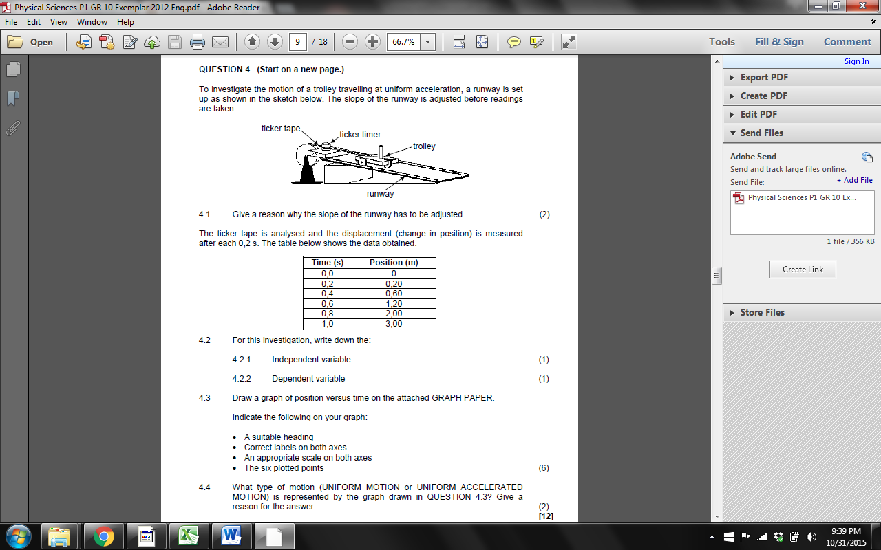

  - What is the dependent variable? (1) displacement/position
  - What is the independent variable? (1) time
  - Use graph paper to draw a graph of position vs. time. Indicate a suitable heading, correct labels on the axes, appropriate scales and 6 plotted points. (6)
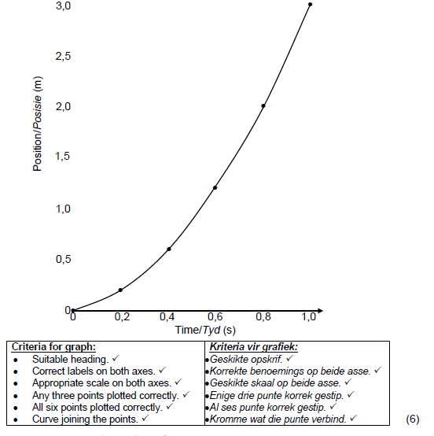
Heading 1
Labels on axes 1
Scales 1
4 points plotted correctly – half mark each 2
Joining curve 1

  - What type of motion is represented by the graph? (2) constant/uniform acceleration/increase in velocity

  - What is the velocity of the trolley at 0.4s? (4)
Tangent plotted correctly 1
V=xf-xi/tf-ti read off the graph correctly 2
Accept answers around 2.3m/s

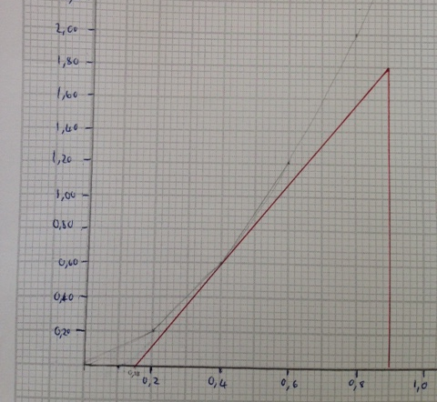

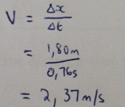

Question 6: Equations of motion (11)

- A delivery van is travelling along a straight road at 15m/s. He sees a boy crossing the pedestrian crossing 50m ahead. It takes the driver 1s to react and apply the brakes. It takes another 3 seconds for the van to come to a stop.

  - Did the driver of the delivery van exceed the speed limit? Explain. (2)
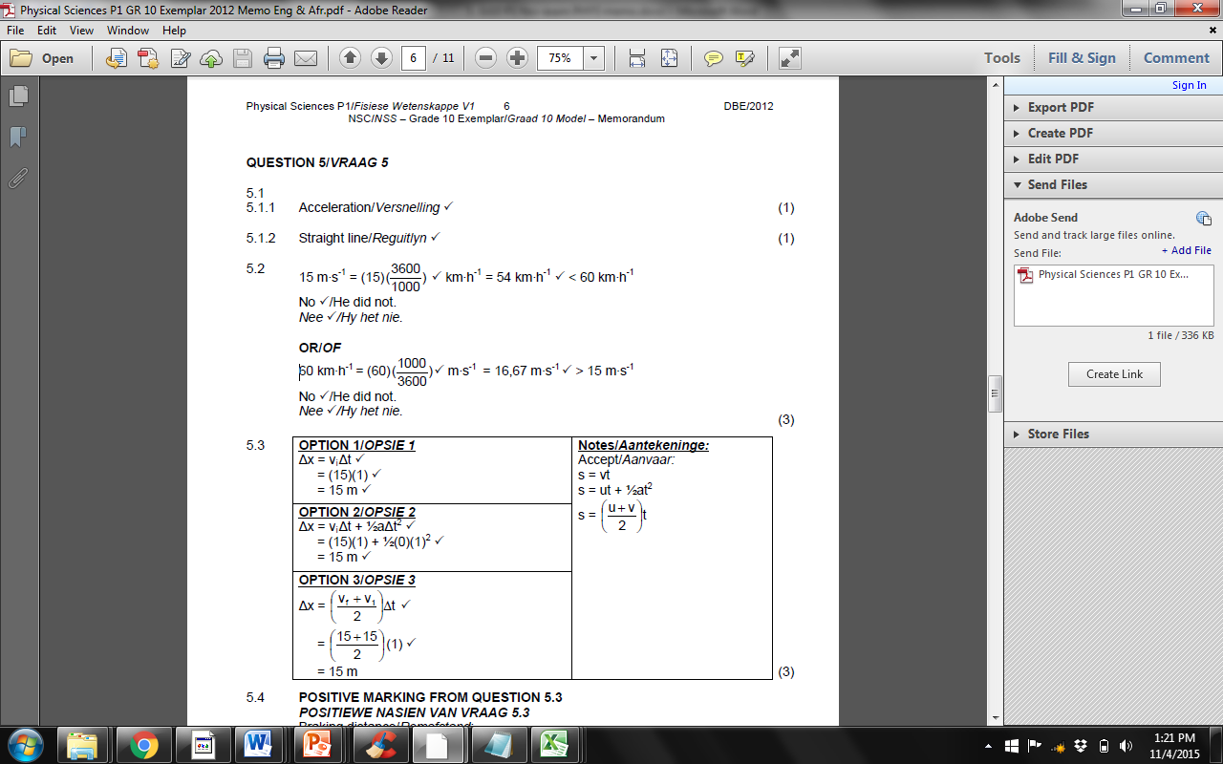

  - Calculate the distance that the delivery van travels during the 1s reaction time. (3)

  - Will the van stop before the pedestrian crossing? Show all calculation. (5)
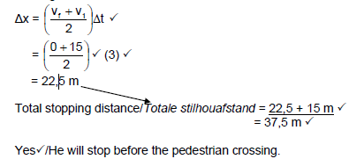

  - Will the stopping distance of the van INCREASE or DECREASE when the road is wet and slippery? (1)
Increase

Question 7: Mechanical energy and equations of motion (14)

- An object with a mass of 0.2kg is released at point A and moves along section AC of a curved track. The vertical height of point A above point x on the ground is 0.8m. Ignore the impacts of friction.
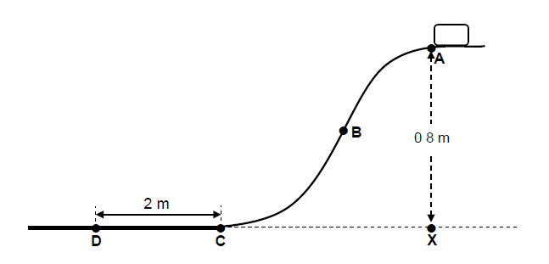

  - State the principle of conservation of mechanical energy. (2)
In a closed system, the mechanical energy is conserved or potential energy equals kinetic energy in a closed system. Closed system may also be described as a system with no other influences on it.

  - Calculate the gravitational potential energy at point A just before it is released. (3)
Ep=mgh= (0,2)(9,8)(0,8)
= 1,568 J

  - At point B the speed of the object is 3m/s. Use the principle of conservation of mechanical energy to calculate the vertical height of point B above the ground. (4)
E= mgh_{M}(B) = E_{M}(A) / (E_{p} + E_{k})_{B} = (E_{p} + E_{k})_{A} / mgh_{B} + ½mv_{A} + ½mv2B
(0,2)(9,8)h + ½(0,2)(3)² = (0,2)(9,8)(0,8) + ½(0,2)(0)²
h = 0,34 m

  - The object reaches point C at a velocity of 3.96m/s. Using equations of motion, calculate the acceleration that the object experiences as it moves from point C to point D. (5)
v_{f}² = v_{i}² + 2aΔx
(0)² = (3,96)² + 2a(2)
a = -3,92 m∙s⁻²
a = 3,92 m∙s⁻² slowing down/negative acceleration

Question 8: Transverse pulses and waves (16)

  - The diagram below shows two waves, A and B, of the same wavelength but different amplitudes crossing each other.

    - Define the term amplitude. (1)
Maximum displacement of particles from position of rest

    - Show the shape of the resulting wave on the diagram as the two waves, A and B, cross each other. (1)
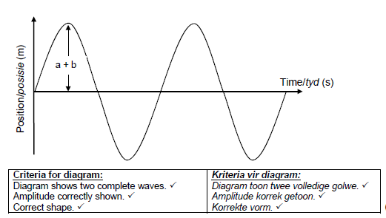

    - Which wave property is illustrated in the previous question? (1)
Constructive interference

  - Water waves crash against a seawall. Eight waves hit the seawall in 5s. The distance between successive troughs is 9m. The height of the wave from trough to crest is 1.5m.
    - Write down the letters that indicate any two points that are in phase. (1)
E.g. BD

    - Write down the letters that indicate any two points that represent one wavelength. (1)
E.g. DF

    - Calculate the amplitude of the wave. (2)
1.5m/2 = 0.75m

    - Show that the period of the wave is 0.625s. (6)
V=D/t = 72m/5s=14.4m/s
T=λ/v
=9m/14.4m/s = 0.625s

    - Calculate the frequency of the wave. (3)
F=1/T = 1/0.625s = 1.6Hz

Question 9: Longitudinal waves and sound (14)

- The sound wave below has a period of 0.001s. It was generated by a singer performing in a theatre with a temperature of 25°C. The distance between the centres of points A and C is 345mm as measured on an oscilloscope.

  - Provide a label for A. (1) Compression
  - Provide a label for B. (1) Refraction
  - Provide a label for the section AC. (1) Wavelength
  - Calculate the speed of the wave in m/s. (4)
V=D/t = 345mm /0.001s= mm/s = 345000mm/s = 345m/s

  - An audience member commented that the singer maintained a constant pitch and loudness. What is meant by pitch and loudness? (2)
Pitch - how high or low the note sounds/change in frequency
Loudness – how soft or loud the sound/change in amplitude

  - If the diagram below represents the loudness and pitch of the singer, redraw the diagram to represent the singer with:

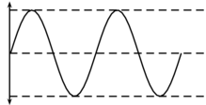
Loudness and pitch of the singer

    - A higher pitch. (1) waves have same amplitude but closer together

    - A softer sound. (1) waves have lower amplitude but same frequency

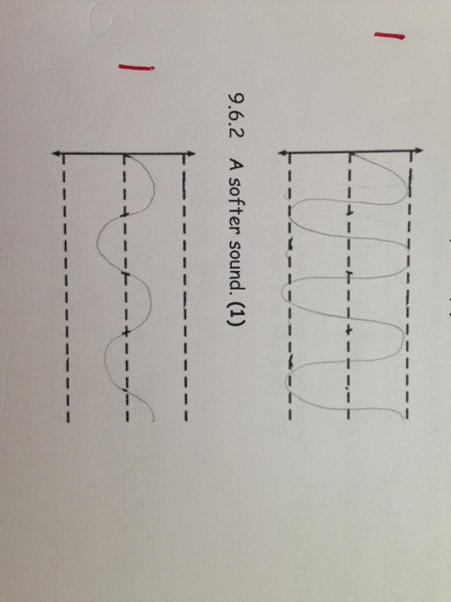

  - While the singer is performing, how long will it take a person in the audience 25m away from her to hear her? (The speed of sound is 344m/s). (3)
t = D = 25m/344m/s= 0.07s
v

Question 10: Electromagnetic radiation (8)

  - Which is the wave type with the lowest amount of energy? (1) radio waves
  - Which is the wave type with greatest penetrating ability? (1) gamma rays
  - Which is the wave type that we identify as heat? (1) infrared
  - Which is the wave type that can only penetrate as deep as the skin? (1) UV rays
  - Ultrasound is used to obtain an image of a baby when a mom is pregnant. Briefly explain why we cannot use x-rays to obtain the image. (1)
X-rays have the ability to penetrate our cells and damage DNA. This is dangerous for the baby.

  - An x-ray photon has a wavelength of 2.1×10⁻⁹m. Calculate how much energy the photon imparts on the body. (3)
E = hc
λ
= 6.6×10⁻³⁴ J.s × 3×10⁸ m/s
2.1×10⁻⁹m
= 9.4×10⁻¹⁷ J

Total = 140 marks

