Natural Sciences November Exam

Mrs Magid
Beis Yaacov Girls High School / Mesivta Shaarei Torah
Gr 9

Name:______________________________

Instructions:
- Please refer to the periodic table on page 14.
- Ensure that your handwriting is legible.
- Do not use shorthand in your answers.
- You need not answer in full sentences.
- Consider the mark allocation. For example, 3 marks require you to make 3 correct and relevant points.
- You may use a calculator.
- Do not write in red ink.
GOOD LUCK!

Total: 135 marks
Time: 2h

Question 1: One word/term answers (5)

- Provide a one name or term for each of the following descriptions: (5×1=5)
  - A force experienced by a rope when two children are pulling against each other. ______________________
  - A substance that determines if a solution is an acid or a base. ______________________
  - The mass of an atom measured in amu. ______________________
  - A substance that cannot conduct electricity. ______________________
  - The amount of matter in something. ______________________

Question 2: Multiple choice (12)

- Circle the correct answer: (12×1=12)

  - The atomic number of sodium is 11 and its mass number is 23. The neutron number is:
- 11
- 12
- 23
- 34
  - What is the common name for sodium chloride?
- Sugar
- Milk of magnesia
- Table salt
- Calcium carbonate

  - A compound in which carbon, hydrogen and oxygen are bonded in the ratio 1 : 2 : 2 is:
- H₂CO₃
- C₂H₄O₂
- CH₂O₂
- C₄H₂O

  - Which of these elements is a Noble Gas?
- Helium
- Oxygen
- Carbon
- Hydrogen

  - Which list below includes ONLY diatomic molecules?
- Fluorine, chlorine, iodine, nitrogen
- Iodine, helium, hydrogen, oxygen
- Calcium, oxygen, chlorine, nitrogen
- Oxygen, hydrogen, carbon, bromine

  - Which of the following describes a chemical reaction?
- Water evaporating
- Droplets of water forming on the outside of your cold glass
- Fat melting
- Wood burning

  - A compound that contains more than two elements is
- Silicon dioxide
- Sodium sulphate
- Magnesium oxide
- Lithium iodide

  - An example of a metalloid:
- Silicon
- Aluminium
- Calcium
- Copper

  - Which of the following represent compounds?
P

Q
Q
R

S

- P, R and S
- R and S
- P and S
- All of the above

  - Which of the following factors does not affect the resistance of a conducting wire?
- Length
- Thickness
- Type of metal used
- Potential difference

  - The accompanying diagram shows an incomplete circuit. Which component should be connected in the space to make the lamp light?

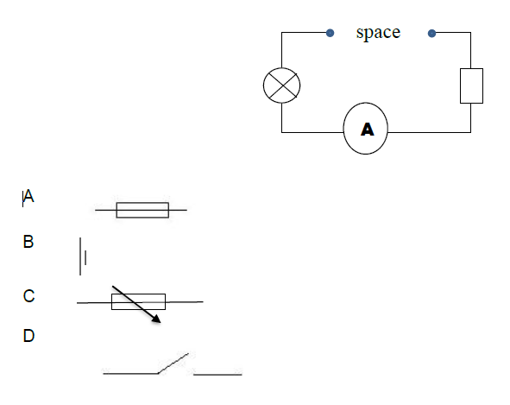

  - Which of the following is not an acid?
- Vinegar
- Bleach
- Lemon juice
- Orange juice

Question 3: Compounds and chemical reactions (24)

  - Complete the table: (9)

Chemical formula of compound | Name of compound (based on naming methods) | Names of the different elements in the compound | The ratio of the different elements in the compound
Cu(NO₃)₂
H₂SO₄
NH₄

  - Balance the following chemical equation: (2)
CaO + HCl CaCl₂ + H₂O

_________________________________________________________

  - Write out and balance the following chemical equation: (4)
Hydrogen iodide + chlorine iodine + hydrogen chloride

_________________________________________________________

  - Name 4 elements that are semi-metals and provide their symbols. (4)

_________________________________________________________

_________________________________________________________

  - Refer to the periodic table in answering the questions that follow.

    - What is the atomic number of mercury? (1) ______________

    - What is the atomic mass of mercury? (1) ______________

    - How many protons are there in an atom of mercury? (1) ______________

    - How many neutrons are there in an atom of mercury? (1) ______________

    - How is mercury an exception to all other metals? (1)

_________________________________________________________

Question 4: Reactions of metals and non-metals with oxygen (14)

  - Complete the table based on the reaction of metals in oxygen: (6)

Name of element | Flame colour | Name of the product | Effect on red litmus paper
Sodium
Potassium

  - Are the chemical reactions of the metals in the previous question endothermic or exothermic? (2)

_________________________________________________________

_________________________________________________________

  - Consider the passage below and answer the questions that follow:
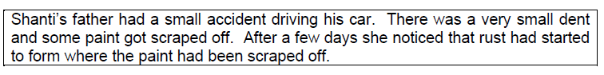
  - Explain the cause of rust. (3)

_________________________________________________________

_________________________________________________________

  - What advice would you give Shanti’s father in relation the rust problem? (1)

_________________________________________________________

  - Are rust and corrosion the same thing? Elaborate. (2)

_________________________________________________________

_________________________________________________________

Question 5: Acids, bases and pH values (7)

  - What is the scale called that measures the strength of acids and bases? (1)

_________________________________________________________

  - You have a sample of ammonia. You add phenolphthalein to the sample. It turns pink. What does that tell you about ammonia? (1)

_________________________________________________________

  - Consider the passage below and answer the questions that follow:

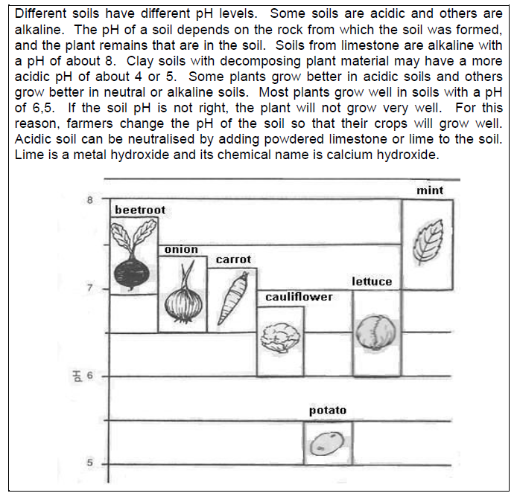

    - In what pH range will potatoes grow well? (1)

_________________________________________________________

    - If the soil has a pH of 7.6, which plants could be grown best? (2)

_________________________________________________________

    - What can a farmer do if his soil has a pH of 4? Explain how this method works using your knowledge of neutralisation. (2)

_________________________________________________________

_________________________________________________________

Question 6: Reactions of acids with bases and metals (13)

  - Study the following experimental setup. Answer the questions that follow:
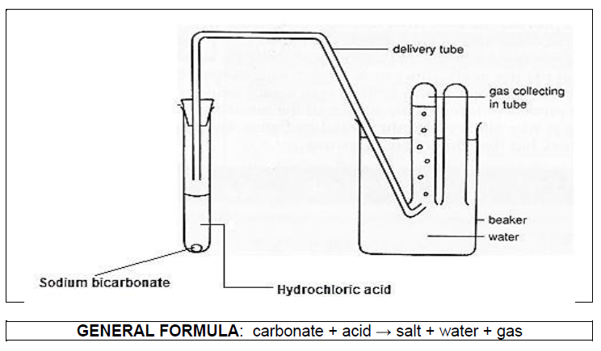
    - Which of the following pH values would you expect hydrochloric acid to have? Circle the correct answer. (1)
pH = 1, pH = 6, pH = 7, pH = 8, pH = 13

    - What type of chemical reaction is this? (1) _________________________

    - What gas is released during this experiment? (1) _______________________

    - Explain briefly how you would test for this gas. (1)

___________________________________________________________
  - In the following neutralisation chemical reactions, identify the TYPE of base involved in each reaction.

    - Copper oxide + Sulfuric acid → Copper sulfate + Water (1)

___________________________________________________________

    - Copper carbonate + Hydrochloric acid → Copper chloride + Water + Carbon dioxide (1)

___________________________________________________________

    - Hydrochloric acid + Sodium hydroxide → Sodium chloride +Water (1)

___________________________________________________________

  - Consider the following chemical reaction:
Hydrochloric acid + Zinc → Zinc chloride + Hydrogen

    - Is the chemical reaction below a neutralization reaction? Explain. (2)

___________________________________________________________

___________________________________________________________

    - How would you test for the presence of hydrogen? (1)

___________________________________________________________

    - What chemical reaction happens during the hydrogen test? (3)

___________________________________________________________

___________________________________________________________

Question 7: Forces (21)

  - If the net force on an object is zero, what can you say about the forces acting on the object? (1)

___________________________________________________________

  - If the object moves, what can you say about the forces acting on the object? (1)

___________________________________________________________

  - What is the invisible force of attraction between masses? (1)

___________________________________________________________

  - Which force resists motion and creates heat? (1)

___________________________________________________________

  - Describe a scenario that results in an electrostatic force, and explain between which objects the force exists. (3)

___________________________________________________________

___________________________________________________________

___________________________________________________________

  - A man has a mass of 120kg. He stands on a bathroom scale Mars. He knows that 3kg on Mars is 11.1N.

    - What is the weight of the man on Earth? Show all calculation. (3)

    - What is the mass of the man on Mars? Explain. (3)

___________________________________________________________

___________________________________________________________

___________________________________________________________

    - What is the weight of the man on Mars? Show all calculation. (6)

    - Why is the man’s weight on Mars less than that of Earth? (2)

___________________________________________________________

___________________________________________________________

Question 8: Electric cells and circuits (26)

  - Draw a circuit below that has an open switch, two cells, and a variable resistor and a light bulb in parallel. Place an ammeter in order to measure total current and a voltmeter to measure the voltage of the variable resistor. Draw it in pencil and make it large and neat. (6)

  - In the circuit diagram below, the voltmeter reading is 10V. Answer the questions that follow about this circuit:
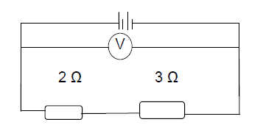
    - Calculate the combined resistance of the resistors. (2)

    - Calculate the current flowing through the circuit. (3)

    - Calculate the voltage across the 3Ω resistors. (2)

    - Calculate the potential energy of each cell. (2)

  - In the circuit diagram below, the bulbs are identical. Answer the questions that follow about this circuit:

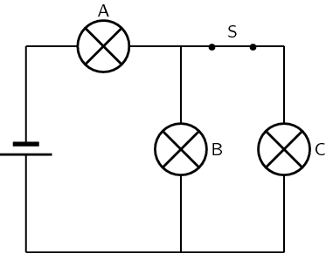

    - Assume that the circuit’s total current is 6A. What is the current across resistor A, B and C? (3)

A – ______
B – ______
C – ______

    - How bright is bulb A compared to B and C? (1)

____________________________________________________________

    - What happens to the light bulbs A, B and C after switch S has been opened? (3)

A – ________________________________
B – ________________________________
C – ________________________________

    - Place an arrow on the diagram to show the direction of current. (1)
    - Assume that the voltmeter reading across bulb A is 16 V and the ammeter reading is 4.5 A. Calculate the resistance of the bulb. (3)

Question 9: Safety with electricity and the national electricity grid (13)

  - Consider the passage below and answer the questions that follow:

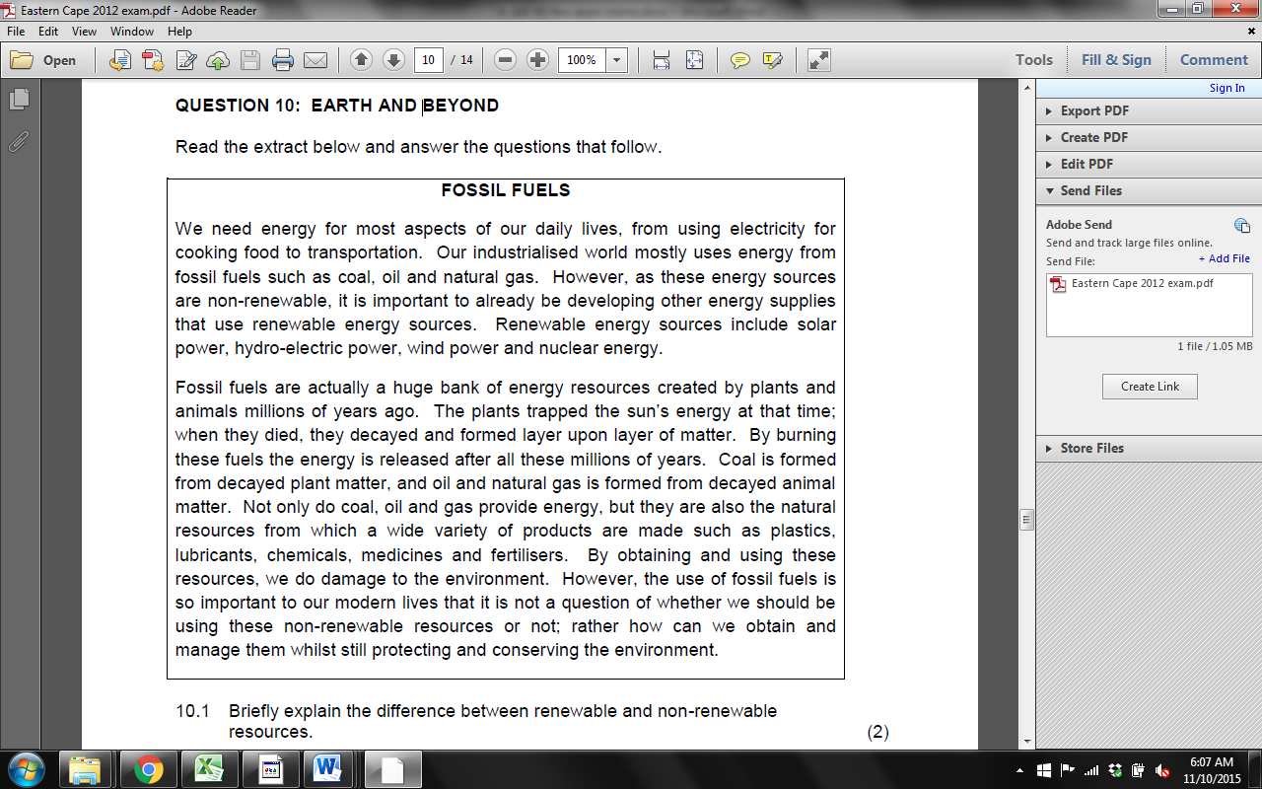

    - Briefly explain the difference between renewable and non-renewable SOURCES of energy. (2)

_________________________________________________________

_________________________________________________________

_________________________________________________________

    - Consider a coal-fired power plant. Complete the table below in steps, providing the main activity and the energy transformation in each step in a coal-fired power plant, ending with the formation of electricity. The first step has been completed for you as an example: (8)

Raw coal – chemical energy

    - What is a fuel in a power plant? (2)

_________________________________________________________

_________________________________________________________

    - What is the fuel in a nuclear power plant? (1)

_________________________________________________________

Total = 135 marks

