Natural Science November Exam: 2 hours 25 November 2013

Mrs Magid
Beis Yaakov Girls High School
Gr 9

Name:______________________________

Answer ALL the questions. Ensure that your handwriting is legible. Do not write in red ink. Good luck!

Question 1: Experiments integrating graphs and ‘matter and material’ (47 marks)

  - Sugar is broken down into lactic acid by a type of bacterium called Lactobacillus.

Scientists often use a gelatine based substance called agar inside a petri dish on which to grow bacteria. John wants to prepare a pure sample of Lactobacillus, but he only has a mixed culture medium of four different bacteria. This means that when he places his mixed culture medium on the agar in the petri dish, he will end up with potentially 4 different types of bacteria growing.

The bacteria grow in colonies. This means that they grow in clumps. Each clump will be made up of one type of bacterium.

John prepares some agar and adds some sugar and some calcium carbonate to the agar solution. Calcium carbonate is a cloudy substance which reacts with acid to form a colourless solution.

He spreads some of his culture medium on the agar and leaves it for three days. At the end of three days, the agar plate looks like this:

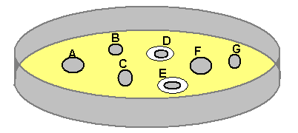

John labels the bacterial colonies A, B, C, D, E, F and G.

    - Identify the Lactobacillus colonies (2)

____________________________________________________________

    - Gives a reason for your answer. (1)

____________________________________________________________

____________________________________________________________

    - Explain the chemical reaction that has taken place based on the information given to you above. (3)

____________________________________________________________

____________________________________________________________

____________________________________________________________

    - When we learnt about acids and bases, we learnt about different types of neutralisation reactions. What is a neutralisation reaction? (1)

____________________________________________________________

    - Write out the GENERAL neutralisation reaction has taken place above in words? (4)

____________________________________________________________

    - What is the colourless solution that has been produced by Lactobacillus? (1)

____________________________________________________________

  - Table A below shows the pH values in different parts of the digestive system.

Table A
Organ | pH Range
Mouth | 6.5 – 7.5
Stomach | 2
Small intestine | 7.5 – 8

A scientist tested 3 different enzymes to find out how they reacted in different pHs. Table B shows his data.

(Note: Rate of enzyme activity was measured in g/min, which is g of product that the enzyme makes per minute)

Table B
pH | Rate of enzyme activity (g/min)
pH | Enzyme A | Enzyme B | Enzyme C
1 | 100 | 0 | 0
2 | 250 | 0 | 0
3 | 80 | 0 | 0
4 | 10 | 10 | 0
5 | 0 | 60 | 0
6 | 0 | 180 | 60
7 | 0 | 260 | 180
8 | 0 | 20 | 260
9 | 0 | 0 | 20
10 | 0 | 0 | 0

The scientist knows that the three enzymes are:
- Salivary amylase – secreted by the salivary glands in the mouth.
- Pancreatic proteinase – secreted by the pancreas into the small intestine.
- Gastric proteinase – secreted by the stomach.

Unfortunately, the scientist cannot remember which set of data (Enzyme A, B and C) corresponds with which enzyme. Help him to solve his problem by doing the following:

    - Draw a graph showing the data in Table B (you have been provided with graph paper). (20)

    - From the graph, work out which enzyme is which and label it clearly on your
graph. (3)

____________________________________________________________

____________________________________________________________

____________________________________________________________

    - We talk about the stomach having a ‘pH of 2’. What does the term ‘pH’ mean? (1) What are the pH ranges? (3)

____________________________________________________________

____________________________________________________________

____________________________________________________________

    - If you mix a base with double the amount of acid, what will my resulting solution consist of? (3) Will it be acidic, basic or neutral? (1)?

____________________________________________________________

____________________________________________________________

    - How would you measure whether something is an acid, base or neutral? Provide only one way. (4)

____________________________________________________________

____________________________________________________________

____________________________________________________________

____________________________________________________________

Question 2: Matter and material (24 marks)

  - Below are two graphs, one of an exothermic reaction and one of an endothermic reaction. Identify which is which and give a reason for each. (6)
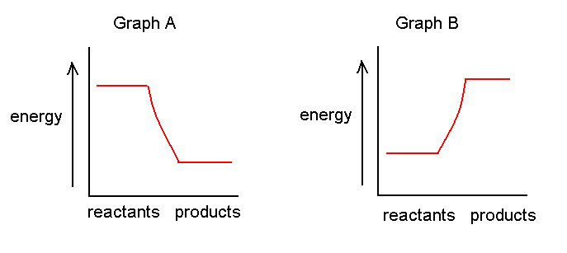 ___________________________________________________________
____________________________________________________________

____________________________________________________________

____________________________________________________________

____________________________________________________________

  - Use the following diagram to explain the difference between an element and a compound. (6)
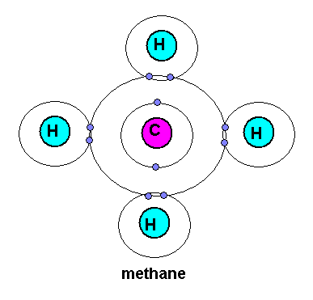
____________________________________________________________

____________________________________________________________

____________________________________________________________

____________________________________________________________

____________________________________________________________
  - Insert the words in the box on the side of the flow chart into the appropriate places. (7)

Gold
Compound
Matter
Element
Sodium chloride
Calcium carbonate
Oxygen

 |  | Can it be separated into simpler substances by chemical means?
 | Yes |  |  | No
E.g. |  |  |  | E.g.
  - Evaporation takes place at room temperature. How does this take place? Explain at a particle level (2)

____________________________________________________________

____________________________________________________________

____________________________________________________________

  - Will evaporation be faster or slower on a hot day relative to a cold day? Explain at particle level. (3)

____________________________________________________________

____________________________________________________________

____________________________________________________________
Question 3: Mining and the environment (15 marks)

  - A mining company has started mining in a certain area without any permits. You are an environmental scientist hired to tell the mine what it needs to do in order to mine legally.

You note the following information:
- The mine is pumping water from the river nearby to use in the processing plant.
- The mine has dug a deep hole in the ground and is pumping its dirty water into the hole
- You notice a cycad species (a plant) at the mining site which you know to be critically endangered.
- You measure the dust emissions coming from the mine’s dumps using dust monitors and find the levels to be extremely high.
- You measure the particulate matter coming from the processing plant, and you find that the sulfur emissions are extremely high.

For each of the above, explain:
- The danger for the environment in what the mine is doing
- What you would advise the mine to do in order to be in line with the law (5*3=15)

- ________________________________________________________

________________________________________________________

- ________________________________________________________

________________________________________________________

________________________________________________________

- ________________________________________________________

________________________________________________________

________________________________________________________

- ________________________________________________________

________________________________________________________

________________________________________________________

- ________________________________________________________

________________________________________________________

________________________________________________________

Question 4: Energy and change (44 marks)

    - We learnt about 7 different types of energy. What energy transfers take place in the following situations (6*2=12):

    - A plant photosynthesising.

____________________________________________________________

    - A nuclear power plant generating electricity.

____________________________________________________________

    - A coal-fired power plant generating electricity.

____________________________________________________________

    - A light bulb burning.

____________________________________________________________

    - A radio blasting.

____________________________________________________________

    - A cricket making sounds by rubbing its wings together.

____________________________________________________________

  - Circle the correct answer:
    - The energy possessed by matter due to its motion is (1) .
A potential energy
B kinetic energy
C static energy
D none of the above

    - The energy of a moving object is (1)
A kinetic energy
B potential energy
C chemical energy
D nuclear energy

    - An example of the conversion of gravitational potential energy into kinetic energy is (1)
A a falling raindrop
B a gasoline powered engine
C striking a match
D a hockey puck sliding on ice

  - Write a few paragraphs explaining why switching to renewable energy sources will alleviate the problem of global warming. In your paragraph you will need to:
- Explain what the greenhouse effect is (2)
- Explain what the theory of global warming states (2)
- Explain how the use non-renewable energy sources contribute to the problem (2)
- Explain how renewable energy sources will alleviate the problem, and include at least one example of a renewable energy source. (2)

____________________________________________________________

____________________________________________________________

____________________________________________________________

____________________________________________________________

____________________________________________________________

____________________________________________________________

____________________________________________________________

____________________________________________________________

____________________________________________________________

____________________________________________________________

____________________________________________________________

____________________________________________________________

____________________________________________________________

____________________________________________________________

____________________________________________________________

____________________________________________________________

  - Is electrical energy potential or kinetic? Explain, giving examples. (4)

____________________________________________________________

____________________________________________________________

____________________________________________________________

____________________________________________________________

  - A man pushes a 5879 g box for 8 m across a smooth surface with a force of 120 N. How much work does he do on the crate? (Remember to show all units of measurement, all steps of your calculation and all conversions). (3)

  - The man now lifts the box onto a table that is 134 cm tall. (8)

  - It took the man 20 seconds to push the box across the smooth surface and 5 seconds to lift the box onto the table. How much power did it take in total to complete both tasks? (6)

Total = 130 marks

