Natural Sciences November Exam

Mrs Magid
Beis Yaacov Girls High School / Mesivta Shaarei Torah
Gr 7

Name:______________________________

Instructions:
- Please refer to the periodic table on page 12
- Ensure that your handwriting is legible.
- Do not use shorthand in your answers.
- You need not answer in full sentences.
- Consider the mark allocation. For example, 3 marks require you to make 3 correct and relevant points.
- You may use a calculator.
- Do not write in red ink.
GOOD LUCK!

Total: 140 marks
Time: 2h

Question 1: Properties of material (40)

  - Every material has a different set of properties that we need to consider when we manufacture the material. (1)

  - Provide three examples of materials that are strong and mention why they need to be strong: (4)

Name of material 1
Name of material 2
Why does material 1 need to be strong?
Why does material 2 need to be strong?
Note: it is not enough to say “to hold up things”. That’s too general. Motivate with an example e.g. “concrete needs to hold up a building”

  - Define melting point? (3)
Melting point is the temperature 1 at which a solid 1 and becomes a liquid 1.

  - Define boiling point? (3)
Melting point is the temperature 1 at which a liquid 1 and becomes a gas 1.

  - What is the melting point of water? (1)
0°C

  - What is the boiling point of water? (1)
100°C

  - What does it mean if a material is flexible? (2)
It means that it is easy to bend 1 a material without the material breaking 1

  - You test the flexibility of wood, plastic, metal and cardboard. List the materials in order of most flexible to least flexible. (2)
Cardboard, plastic, wood, metal

  - Electric current is the flow of electrical energy. An electrical conductor allows electrical energy to pass through it. An electrical insulator does not allow electrical energy through it. (2)

  - You conduct the following experiment to test which materials are able to conduct electricity:

You connect a battery and a light bulb to an electric circuit. You then connect the following materials in the circuit to see if the light bulb lights up: a piece of metal, wood, aluminium foil, plastic, glass and cardboard.

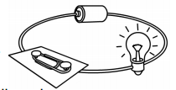

Complete the following table to record your findings: (6)

Material | Light on or off? | Conducts electricity? Yes or no
Metal | On | Yes
Wood | Off | No
Aluminium foil | On | Yes
Plastic | Off | No
Glass | Off | No
Cardboard | Off | No

  - Heat conductivity is how well heat can flow through a material. Materials with poor heat conductivity don’t allow heat to pass through them and are called heat insulators. Materials that allow heat to flow through them are called heat conductors. (3)

  - You conduct the following experiment to test which materials are able to conduct heat:

You take a bowl of boiling water. You place different materials into the boiling water for 2 minutes. You take them out, dry them and feel them to find out which are warm and which are not warm. Here is a list of the materials you used: a stainless steel spoon, a piece of aluminium foil, a wooden spoon and a plastic spoon.

Complete the following table to record your findings: (4)

Material | Warm or not warm? | Conducts heat? Yes or no
Stainless steel spoon | Warm | Yes
Aluminium foil | Warm | Yes
Wooden spoon | Not warm | No
Plastic spoon | Not warm | No

  - Provide three reasons that plastic bags are useful to us based on the properties of plastic bags. (3)
They are light-weight, strong, inexpensive, are waterproof and are used in many types of packaging to keep food items fresh, flexible, can be reused, can be recycled.

  - Why does plastic have a negative impact on the environment? Provide three reasons. (3)
It is made from non-renewable energy which is a limited resource.
We use so much of it and a lot ends up in landfills.
It can block sewage systems and drains.
Making plastic uses a lot of water and energy.
Animals can choke on it.

Question 2: Separating mixtures (18)

  - Consider diagram below. It represents a separation method which has separated alcohol with a boiling point of 78°C and ether with a boiling point of 34°C.

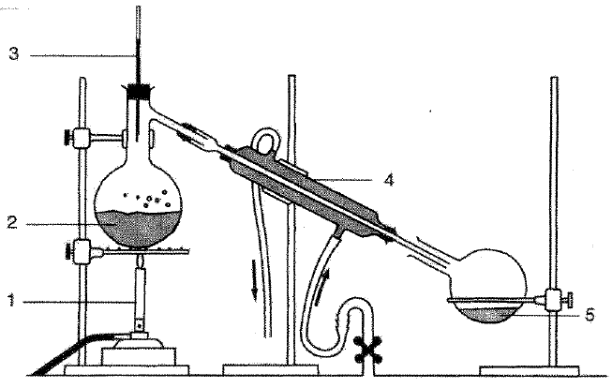

    - What method of separation does this represent? (1) Distillation
    - Which liquid is represented by 2? (1)Alcohol
    - Which liquid is represented by 5? (1)Ether

  - What is a solution? (2)
A solution is a mixture that consists of a solid dissolved in a liquid. 1 mark for mixture of solid and liquid. 1 mark for dissolved

  - In the diagram below, label the solute and the solvent. Make sure to follow all the rules of scientific diagrams. (3)

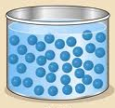

1 mark for labelling the solvent correctly – the liquid
1 mark for labelling the solute correctly – the dots
1 mark for following rules of scientific diagrams including a title.

  - What two methods may you use to separate a solution? (2)
Evaporation and distillation

  - Explain why you cannot use filtration to separate a solution. (2)
The solute and the solvent would run through 1 the filter paper 1.

  - The municipality collects waste from dustbins at homes, once a week and takes it to landfill sites for dumping. Most of our household waste ends up on landfill sites where it decomposes over time. What is recycling? Provide an example. (2)
Take waste and convert it into a material that you can use again. E.g. take plastic bottles and turn into plastic bags.

  - Unfortunately, recycling is not commonly practiced in South Africa. Why do you think this is the case? (1)
We don’t have the correct infrastructure or there are no laws to make people recycle.

  - Provide one reason why it is important to recycle. (1)
So that we don’t fill up the landfill site too fast, we are running out of limited resources, minimize new stuff that has to be made from scratch, to that there is less environmental impact.

  - If we do not dispose of waste properly, e.g. we don’t recycle or we throw litter on the floor, what are two environmental impacts? (2)
Pollution of water, pollution of soil, damage to plants and animals, blocking of sewage and storm-water drains, spread of disease from blocked drains, landfill sites get full which means illegal ones are built.

Question 3: Acids, bases and neutrals (25)

  - You conduct the following experiment to test which materials are acidic, basic or neutral

You dip red and Blue Litmus paper into the following: vinegar, aspirin solution, Eno solution, shampoo, soap, bicarbonate of soda solution, salt water, sugar water, lemon juice. You note the colour change in the litmus paper.

Complete the following table to record your findings: (24*½=12)

Material | Colour in red litmus paper | Colour in blue litmus paper | Acid, base or neutral
Fizzy drink | Red | Red | Acid
Eno solution | Blue | Blue | Base
Shampoo | Blue | Blue | Base
Liquid soap | Blue | Blue | Base
Bicarbonate of soda solution | Blue | Blue | Base
Salt water | Red | Blue | Neutral
Sugar water | Red | Blue | Neutral
Orange juice | Red | Red | Acid

  - How do you test to ensure that the substance that is being tested is neutral? Explain. (3)
Test the substance with both Red and Blue Litmus paper 1. If it stays red in Red Litmus, it could be acid or neutral 1, but if it stays blue in Blue Litmus, it is definitely a neutral substance 1.

  - Match the type of acid with where it is found: (5)

Acid | Where it is found
A) Citric acid | 1. Stomach juices
B) Ethanoic acid | 2. Sour milk
C) Lactic acid | 3. Coke
D) Carbonic acid | 4. Lemon juice
E) Hydrochloric acid | 5. Vinegar

A) 4
B) 5
C) 2
D) 3
E) 1

  - Of the above acids, list the weak acids and the strong acids. (5)
Weak acids: citric, ethanoic, lactic, carbonic
Strong acids: hydrochloric

Question 4: The periodic table of elements (29)

  - Fill in the missing words/terms: (7)

The Periodic Table is a classification system to show us all the elements that make up matter all around us. An element is a pure substance because it is made only of particles of that kind (e.g. oxygen). A compound is made up of two or more elements (e.g. water is made of hydrogen and oxygen).
Dmitri Mendeleev developed the Periodic Table in 1869. He arranged the elements in the pattern we still use today, in rows and columns based on their properties. The rows are called periods and the columns are called groups. Each element has its own name and chemical symbol.

  - What group is fluorine in? (1) 17

  - What period is sodium in? (1) 3

  - Consider the element cobalt in your periodic table.

    - What is the chemical symbol of cobalt? (1) Co
    - What is the atomic number of cobalt? (1) 27
    - What is the mass number of cobalt? (1) 59
    - Is cobalt a metal, non-metal or metalloid? (1) metal
    - Provide names of two metals in the same period as cobalt. (2) elements 19-31
    - Provide the symbols of two semi-metals in the same period as cobalt. (2) Ge, As
    - How many non-metals are in the same period as cobalt? (1) 3
    - How many non-metals are in the same group as cobalt? (1) 0

  - Most metals are solid at room temperature. Which metal is an exception? (1)
Mercury

  - Most metals are silver grey in colour. Which metals are exceptions? (2)
Copper and gold

  - Which are the only three naturally magnetic metals? (3)
Iron, Cobalt and Nickel

  - Semi-metals are semi-conductors. What does this mean? (2)
Not good conductors of electricity at room temperature. They are good conductors of electricity at higher temperatures.

  - What does malleable mean? (1)
Ability to be bent without breaking

  - What does ductile mean? (1)
Ability to be stretched without breaking

Question 5: Sources of energy (28)

  - Define renewable and non-renewable energy. (2)
Non-renewable energy: Energy that gets used up and cannot be replaced.
Renewable energy: Energy that does not run out and can be replaced.

  - Why is coal considered a non-renewable energy source? Do not redefine non-renewable energy. Explain it for coal specifically. (2)
Coal is mined. Once we have run out of coal to mine, we cannot get it back, or it takes longer to make than the rate at which we are using it.

  - Why is biomass energy considered a renewable energy source? Do not redefine renewable energy. Explain it for biomass specifically. (2)
We burn crops. Then we can regrow the crops. So we can replace it.

  - Provide the FORMS OF ENERGY that are associated with the following SOURCES. Only provide the main/most dominant energy forms. See the example below: (15)

SOURCE of energy | FORM of energy
An oven that is on (2) | Electrical, heat  (Note that the mark allocation is 2 and that I asked for the main energy forms. There may be light energy from a light inside the oven and sound energy from the oven fan. But I asked for the MAIN energy forms, and those are electrical and heat.)
A flying butterfly (1) | Mechanical
A gas heater that is on (2) | Chemical, heat
An electric blanket that is on (2) | Electrical, heat
A burning candle (3) | Chemical, heat, light
A tidal barrage that is turning (2) | Mechanical, electrical
Wind turbine that is turning (2) | Mechanical, electrical
Geothermal energy that is being produced (3) | Heat, mechanical, electrical

  - We see these all around Johannesburg: a geyser connected to a solar device. Would the geyser be connected to solar cells or solar panels? Explain your answer. (2)

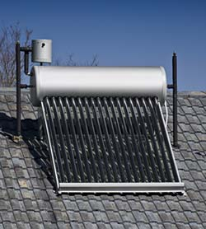

Solar panels. Solar panels do not make electricity but heat up the water in the geyser.

  - What do we mean when we say that the sun is the ultimate source of energy? (1)
All the energy that we have originates with the sun

  - Explain the statement “the sun is the ultimate source of energy” from the perspective of biomass energy. (2)

We would not have biomass if plants did not photosynthesise. Plants need the sun to photosynthesise.

  - You live in a town that is currently using electricity that comes from coal and electricity that comes from hydropower. That means that the town has a coal fired power plant and a hydropower plant. Describe an advantage and a disadvantage of each. (2)

Coal advantage: it is reliable meaning that it’s always making electricity, can makes lots of electricity. Not that it is cheap to make electricity from coal because we have both infrastructures.

Coal disadvantage: will run out, lets out pollution

Hydropower advantage: it will never run out, it doesn’t make pollution

Hydropower disadvantage: it’s difficult to make lots of electricity, it is not always reliable e.g. if drought. Not that it’s expensive to start, because it’s already there. If it’s there then it’s cheaper than coal.

Total = 140 marks

