Natural Sciences November Exam

Mrs Magid
Beis Yaacov Girls High School / Mesivta Shaarei Torah
Gr 9

Name:______________________________

Instructions:
- Please refer to the periodic table on page 14.
- Ensure that your handwriting is legible.
- Do not use shorthand in your answers.
- You need not answer in full sentences.
- Consider the mark allocation. For example, 3 marks require you to make 3 correct and relevant points.
- You may use a calculator.
- Do not write in red ink.
GOOD LUCK!

Total: 135 marks
Time: 2h

Question 1: One word/term answers (5)

- Provide a one name or term for each of the following descriptions: (5×1=5)

  - A force experienced by a rope when two children are pulling against each other. Tension
  - A substance that determines if a solution is an acid or a base. Chemical indicator. Accept universal indicator. For a specific type of indicator award half a mark
  - The mass of an atom measured in amu. Atomic mass
  - A substance that cannot conduct electricity. Insulator. Do not accept an example of an insulator
  - The amount of matter in something. Mass

Question 2: Multiple choice (12)

- Circle the correct answer: (12×1=12)

  - The atomic number of sodium is 11 and its mass number is 23. The neutron number is:
- 11
- 12
- 23
- 34
  - What is the common name for sodium chloride?
- Sugar
- Milk of magnesia
- Table salt
- Calcium carbonate

  - A compound in which carbon, hydrogen and oxygen are bonded in the ratio 1 : 2 : 2 is:
- H₂CO₃
- C₂H₄O₂
- CH₂O₂
- C₄H₂O

  - Which of these elements is a Noble Gas?
- Helium
- Oxygen
- Carbon
- Hydrogen

  - Which list below includes ONLY diatomic molecules?
- Fluorine, chlorine, iodine, nitrogen
- Iodine, helium, hydrogen, oxygen
- Calcium, oxygen, chlorine, nitrogen
- Oxygen, hydrogen, carbon, bromine

  - Which of the following describes a chemical reaction?
- Water evaporating
- Droplets of water forming on the outside of your cold glass
- Fat melting
- Wood burning

  - A compound that contains more than two elements is
- Silicon dioxide
- Sodium sulphate
- Magnesium oxide
- Lithium iodide

  - An example of a metalloid:
- Silicon
- Aluminium
- Calcium
- Copper

  - Which of the following represent compounds?
P

Q
Q
R

S

- P, R and S
- R and S
- P and S
- All of the above

  - Which of the following factors does not affect the resistance of a conducting wire?
- Length
- Thickness
- Type of metal used
- Potential difference

  - The accompanying diagram shows an incomplete circuit. Which component should be connected in the space to make the lamp light? B

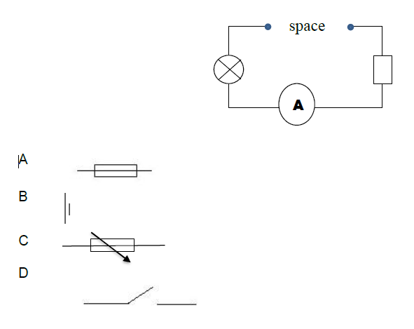

  - Which of the following is not an acid?
- Vinegar
- Bleach
- Lemon juice
- Orange juice

Question 3: Compounds and chemical reactions (24)

  - Complete the table: (9)

Chemical formula of compound | Name of compound (based on naming methods) | Names of the different elements in the compound | The ratio of the different elements in the compound
Cu(NO₃)₂ | Copper nitrate | Copper nitrogen oxygen | 1:2:6
H₂SO₄ | Hydrogen sulfate | Hydrogen sulfur oxygen | 2:1:4
NH₄ | Nitrogen tetrahydride | Nitrogen hydrogen | 1:4

  - Balance the following chemical equation: (2)
CaO + HCl CaCl₂ + H₂O
CaO + 2HCl CaCl₂ + H₂O

  - Write out and balance the following chemical equation: (4)
Hydrogen iodide + chlorine iodine + hydrogen chloride
2 HI + Cl₂ I₂ + 2HCl

  - Name 4 elements that are semi-metals and provide their symbols. (4)

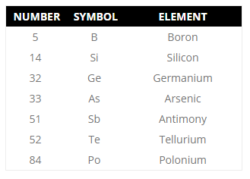

  - Refer to the periodic table in answering the questions that follow.
    - What is the atomic number of mercury? (1)
80
    - What is the atomic mass of mercury? (1)
201 amu (half mark without amu)
    - How many protons are there in an atom of mercury? (1)
80
    - How many neutrons are there in an atom of mercury? (1)
121
    - How is mercury an exception to all other metals? (1)
Liquid at room temp. If only say liquid then half mark.

Question 4: Reactions of metals and non-metals with oxygen (14)

  - Complete the table based on the reaction of metals in oxygen: (6)

Name of element | Flame colour | Name of the product | Effect on red litmus paper
Sodium | Yellow | Sodium oxide | Blue
Potassium | White | Potassium oxide | Blue

  - Are the chemical reactions of the metals in the previous question endothermic or exothermic? (2)
Exothermic. They release heat.

  - Consider the passage below and answer the questions that follow:
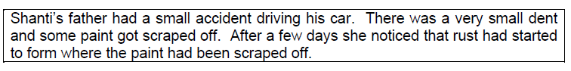
  - Explain the cause of rust. (3)
When iron 1 reacts with oxygen 1 in the presence of moisture/water 1.

  - What advice would you give Shanti’s father in relation the rust problem? (1)
Repaint

  - Are rust and corrosion the same thing? Elaborate. (2)
No. Rust is one example of corrosion.

Question 5: Acids, bases and pH values (7)

  - What is the scale called that measures the strength of acids and bases? (1)
pH scale

  - You have a sample of ammonia. You add phenolphthalein to the sample. It turns pink. What does that tell you about ammonia? (1)
It is a base.

  - Consider the passage below and answer the questions that follow:

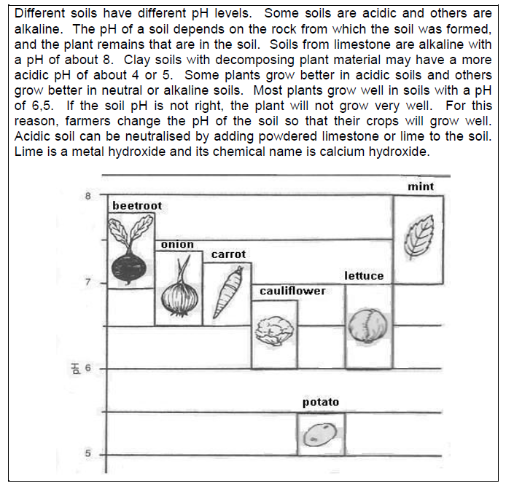
    - In what pH range will potatoes grow well? (1)
5-5.5
    - If the soil had a pH of 7.6, which plants could be grown best? (2)
Beetroot and mint
    - What can a farmer do if his soil has a pH of 4? Explain how this method works using your knowledge of neutralisation. (2)
He can add lime/calcium hydroxide (base) 1. An acid and a base will make something that is neutral 1.

Question 6: Reactions of acids with bases and metals (13)

  - Study the following experimental setup. Answer the questions that follow:
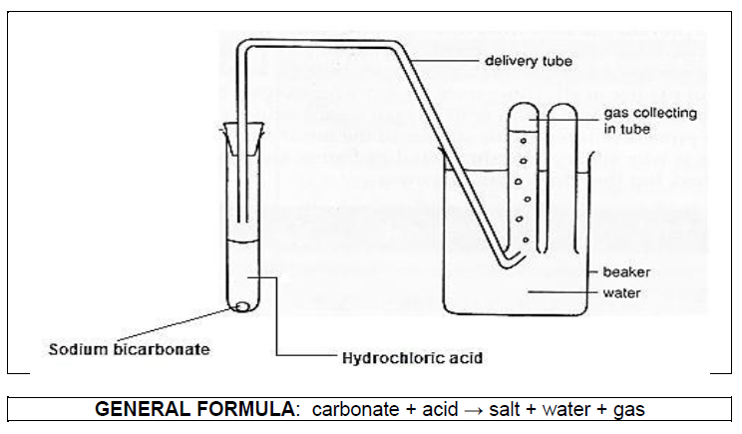
    - Which of the following pH values would you expect hydrochloric acid to have? (1)
pH = 1, pH = 6, pH = 7, pH = 8, pH = 13
pH1
    - What type of chemical reaction is this? (1)
Neutralisation
    - What gas is released during this experiment? (1)
Carbon dioxide
    - Explain briefly how you would test for this gas. (1)
Bubble though limewater and if it turns milky then it’s carbon dioxide.

  - In the following neutralisation chemical reactions, identify the TYPE of base.

    - Copper oxide + Sulfuric acid → Copper sulfate + Water (1)
Metal oxide

    - Copper carbonate + Hydrochloric acid → Copper chloride + Water + Carbon dioxide (1)
Metal carbonate

    - Hydrochloric acid + Sodium hydroxide → Sodium chloride +Water (1)
Metal hydroxide

  - Consider the following chemical reaction:
Hydrochloric acid + Zinc → Zinc chloride + Hydrogen

    - Is the chemical reaction below a neutralization reaction? Explain. (2)
No. It is an acid and a metal, not a base.

    - How would you test for the presence of hydrogen? (1)
Put a flame to it and hear a popping sound

  - What chemical reaction happens during the hydrogen test? (3)
Hydrogen reacts with oxygen to form water

Question 7: Forces (21)

  - If the net force on an object is zero, what can you say about the forces acting on the object? (1)
They are balanced

  - If the object moves, what can you say about the forces acting on the object? (1)
They are unbalanced

  - What is the invisible force of attraction between masses? (1)
Gravitational force

  - Which force resists motion and creates heat? (1)
Frictional force

  - Describe a scenario that results in an electrostatic force, and explain between which objects the force exists. (3)
E.g. take off jersey and electrons jump from hair to jersey 2. There is now electrostatic force of attraction between the two 1

  - A man has a mass of 120kg. He stands on a bathroom scale Mars. He knows that 3kg on Mars is 11.1N.

    - What is the weight of the man on Earth? Show all calculation. (3)
Weight = mass * gravity(Earth) = 120kg*9.8 = 1176N

    - What is the mass of the man on Mars? Explain. (3)
120kg. Mass does not change because it is the amount of matter in you which does not change.

    - What is the weight of the man on Mars? Show all calculation. (6)
Gravity(Mars) = weight/mass = 11.1N/3kg = 3.7
Weight = mass * gravity(Mars) = 120kg*3.7 = 444N

    - Why is the man’s weight on Mars less than that of Earth? (2)
Mars has less gravity because it is smaller.

Question 8: Electric cells and circuits (26)

  - Draw a circuit below that has an open switch, two cells, and a variable resistor and a light bulb in parallel. Place an ammeter in order to measure total current and a voltmeter to measure the voltage of the variable resistor. Draw it in pencil and make it large and neat. (6)
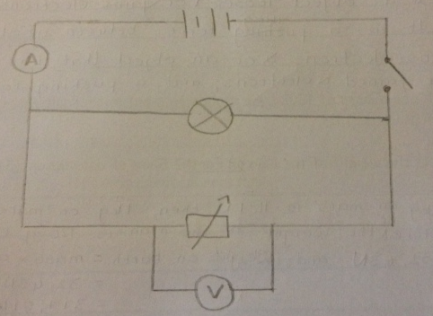

  - In the circuit diagram below, the voltmeter reading is 10V. Answer the questions that follow about this circuit:
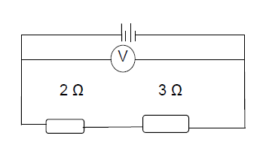

    - Calculate the combined resistance of the resistors. (2)
RT=R1+R2 =3Ω+2Ω = 5Ω

    - Calculate the current flowing through the circuit. (3)
I=V/R = 10V/5Ω = 2A

    - Calculate the voltage across the 3Ω resistors. (2)
3/5 of the 10 volts = 6V or V=RI = 3 Ω*2A=6V

    - Calculate the potential energy of each cell. (2)
10V/2 = 5V

  - In the circuit diagram below, the bulbs are identical. Answer the questions that follow about this circuit:

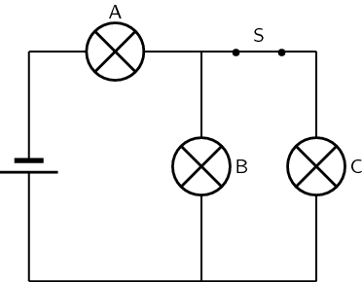

    - Assume that the circuit’s total current is 6A. What is the current across resistor A, B and C? (3)
A – 6A
B – 3 A
C – 3 A

    - How bright is bulb A compared to B and C? (1)
Bulb A is twice as bright

    - What happens to the light bulbs A, B and C after switch S has been opened? (3)
A – stays same
B – glows brighter
C – stops glowing

    - Place an arrow on the diagram to show the direction of current. (1)

    - Assume that the voltmeter reading across bulb A is 16 V and the ammeter reading is 4.5 A. Calculate the resistance of the bulb. (3)
R=V/I = 16V/4.5A=3.56Ω

Question 9: Safety with electricity and the national electricity grid (13)

  - Consider the passage below and answer the questions that follow:

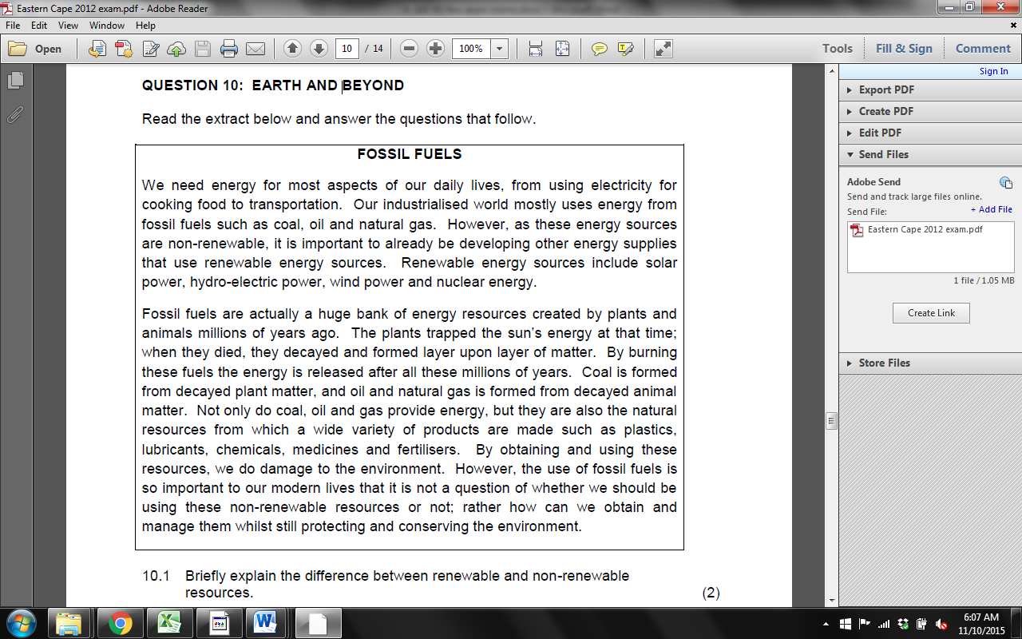

    - Briefly explain the difference between renewable and non-renewable SOURCES of energy. (2)
Non-renewable sources of energy means that it cannot be recreated once used.
Renewable sources of energy are sources that we cannot run out of.

    - Consider a coal-fired power plant. Complete the table below in steps, providing the main activity and the energy transformation in each step in a coal-fired power plant, ending with the formation of electricity. The first step has been completed for you as an example: (8)

Raw coal – chemical energy

Burning coal – heat energy
Heating water to make steam – heat energy

Turning turbine – mechanical energy

Magnets in a generator – electrical energy.

    - What is a fuel in a power plant? (2)
Something that can generate enough heat 1 to convert large amounts of water into steam 1.

    - What is the fuel in a nuclear power plant? (1)
Uranium atoms/radioactive atoms

Total = 135 marks

