Natural Sciences November Exam

Mrs Magid
Beis Yaacov Girls High School / Mesivta Shaarei Torah
Gr 7

Name:______________________________

Instructions:
- Please refer to the periodic table on page 13
- Ensure that your handwriting is legible.
- Do not use shorthand in your answers.
- You need not answer in full sentences.
- Consider the mark allocation. For example, 3 marks require you to make 3 correct and relevant points.
- You may use a calculator.
- Do not write in red ink.
GOOD LUCK!

Total: 140 marks
Time: 2h

Question 1: Properties of material (38)

  - Every material has a different set of _________________ that we need to consider when we manufacture the material. (1)

  - Provide two examples of materials that are strong and mention why they need to be strong: (4)

Name of material 1: _________________
Name of material 2: _________________
Why does material 1 need to be strong?

____________________________________________________________

Why does material 2 need to be strong?

____________________________________________________________

  - Define melting point? (3)

____________________________________________________________

____________________________________________________________

  - Define boiling point? (3)

____________________________________________________________

____________________________________________________________

  - What is the melting point of water? (1) _______

  - What is the boiling point of water? (1) _______

  - What does it mean if a material is flexible? (2)

____________________________________________________________

____________________________________________________________

  - You test the flexibility of wood, plastic, metal and cardboard. List the materials in order of most flexible to least flexible. (2)

____________________________________________________________

  - Fill in the missing words/term: (2)
Electric current is the flow of electrical energy. A _________________ allows electrical energy to pass through it. An _________________ does not allow electrical energy through it.

  - You conduct the following experiment to test which materials are able to conduct electricity:

You connect a battery and a light bulb to an electric circuit. You then connect the following materials in the circuit to see if the light bulb lights up: a piece of metal, wood, aluminium foil, plastic, glass and cardboard.

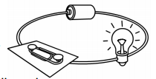

Complete the following table to record your findings: (6)

Material | Light on or off? | Conducts electricity? Yes or no
Metal
Wood
Aluminium foil
Plastic
Glass
Cardboard

  - Fill in the missing words/term: (3)
Heat conductivity is how well _________________ can flow through a material. Materials with poor heat conductivity don’t allow heat to pass through them and are called _________________. Materials that allow heat to flow through them are called _________________.

  - You conduct the following experiment to test which materials are able to conduct heat:

You take a bowl of boiling water. You place different materials into the boiling water for 2 minutes. You take them out, dry them and feel them to find out which are warm and which are not warm. Here is a list of the materials you used: a stainless steel spoon, a piece of aluminium foil, a wooden spoon and a plastic spoon.

Complete the following table to record your findings: (4)

Material | Warm or not warm? | Conducts heat? Yes or no
Stainless steel spoon
Aluminium foil
Wooden spoon
Plastic spoon

  - Provide three reasons that plastic bags are useful to us based on the properties of plastic bags. (3)

____________________________________________________________

____________________________________________________________

____________________________________________________________

  - How does plastic have a negative impact on the environment? Provide three reasons. (3)

____________________________________________________________

____________________________________________________________

____________________________________________________________

Question 2: Separating mixtures (18)

  - Consider diagram below. It represents a separation method which has separated alcohol with a boiling point of 78°C and ether with a boiling point of 34°C.

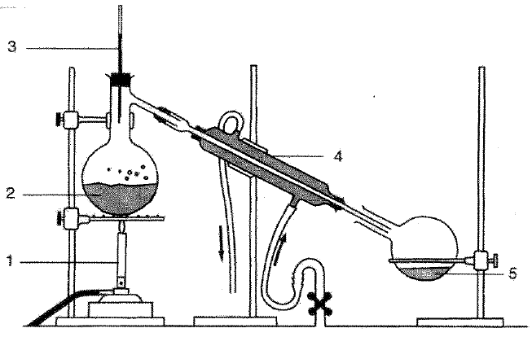

    - What method of separation does this represent? (1) _________________
    - Which liquid is represented by 2? (1) _________________
    - Which liquid is represented by 5? (1) _________________

  - What is a solution? (2)

____________________________________________________________

____________________________________________________________

  - In the diagram below, label the solute and the solvent. Make sure to follow all the rules of scientific diagrams. (3)

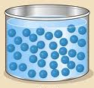

  - What two methods may you use to separate a solution? (2)

____________________________________________________________

  - Explain why you cannot use filtration to separate a solution. (2)

____________________________________________________________

____________________________________________________________

  - The municipality collects waste from dustbins at homes, once a week and takes it to landfill sites for dumping. Most of our household waste ends up on landfill sites where it decomposes over time. What is recycling? Provide an example. (2)

____________________________________________________________

____________________________________________________________

____________________________________________________________

  - Unfortunately, recycling is not commonly practiced in South Africa. Why do you think this is the case? (1)

____________________________________________________________

____________________________________________________________

  - Provide one reason why it is important to recycle. (1)

____________________________________________________________

  - If we do not dispose of waste properly, e.g. we don’t recycle or we throw litter on the floor, what are two environmental impacts? (2)

____________________________________________________________

____________________________________________________________

Question 3: Acids, bases and neutrals (25)

  - You conduct the following experiment to test which materials are acidic, basic or neutral

You dip red and Blue Litmus paper into the following: vinegar, aspirin solution, Eno solution, shampoo, soap, bicarbonate of soda solution, salt water, sugar water, lemon juice. You note the colour change in the litmus paper.

Complete the following table to record your findings: (12)

Material | Colour in red litmus paper | Colour in blue litmus paper | Acid, base or neutral
Fizzy drink
Eno solution
Shampoo
Liquid soap
Bicarbonate of soda solution
Salt water
Sugar water
Orange juice

  - How do you test to ensure that the substance that is being tested is neutral? Explain. (3)

____________________________________________________________

____________________________________________________________

____________________________________________________________

____________________________________________________________

  - Match the type of acid with where it is found: (5)

Acid | Where it is found
A) Citric acid | 1. Stomach juices
B) Ethanoic acid | 2. Sour milk
C) Lactic acid | 3. Coke
D) Carbonic acid | 4. Lemon juice
E) Hydrochloric acid | 5. Vinegar

A) ____
B) ____
C) ____
D) ____
E) ____

  - Of the above acids, list the weak acids and the strong acids. (5)
Weak acids:

____________________________________________________________

Strong acids:

____________________________________________________________

Question 4: The periodic table of elements (29)

  - Fill in the missing words/term: (7)

The Periodic Table is a classification system to show us all the _________________ that make up _________________ all around us. An element is a _________________ because it is made only of particles of that kind (e.g. oxygen). A _________________ is made up of two or more elements (e.g. water is made of hydrogen and oxygen).
Dmitri Mendeleev developed the Periodic Table in 1869. He arranged the elements in the pattern we still use today, in rows and columns based on their _________________. The rows are called _________________ and the columns are called _________________. Each element has its own name and chemical symbol.

  - What group is fluorine in? (1) ____

  - What period is sodium in? (1) ____

  - Consider the element cobalt in your periodic table.

    - What is the chemical symbol of cobalt? (1) ______
    - What is the atomic number of cobalt? (1) ____
    - What is the mass number of cobalt? (1) ____
    - Is cobalt a metal, non-metal or metalloid? (1) __________________

    - Provide names of two metals in the same period as cobalt. (2)

____________________________________________________________

    - Provide the symbols of two semi-metals in the same period as cobalt. (2)

____________________________________________________________

    - How many non-metals are in the same period as cobalt? (1) ____
    - How many non-metals are in the same group as cobalt? (1) ____

  - Most metals are solid at room temperature. Which metal is an exception? (1)

____________________________________________________________

  - Most metals are silver grey in colour. Which metals are exceptions? (2)

____________________________________________________________

  - Which are the only three naturally magnetic metals? (3)

____________________________________________________________

  - Semi-metals are semi-conductors. What does this mean? (2)

____________________________________________________________

____________________________________________________________

  - What does malleable mean? (1)

____________________________________________________________

  - What does ductile mean? (1)

____________________________________________________________

Question 5: Sources of energy (30)

  - Define renewable and non-renewable energy. (2)

____________________________________________________________

____________________________________________________________

____________________________________________________________

____________________________________________________________

  - Why is coal considered a non-renewable energy source? Do not redefine non-renewable energy. Explain it for coal specifically. (2)

____________________________________________________________

____________________________________________________________

  - Why is biomass energy considered a renewable energy source? Do not redefine renewable energy. Explain it for biomass specifically. (2)

____________________________________________________________

____________________________________________________________

  - Provide the FORMS OF ENERGY that are associated with the following SOURCES. Only provide the main/most dominant energy forms. See the example below: (15)

SOURCE of energy | FORM of energy
An oven that is on (2) | Electrical, heat  (Note that the mark allocation is 2 and that I asked for the main energy forms. There may be light energy from a light inside the oven and sound energy from the oven fan. But I asked for the MAIN energy forms, and those are electrical and heat.)
A flying butterfly (1)
A gas heater that is on (2)
An electric blanket that is on (2)
A burning candle (3)
A tidal barrage that is turning (2)
Wind turbine that is turning (2)
Geothermal energy that is being produced (3)

  - We see these all around Johannesburg: a geyser connected to a solar device. Would the geyser be connected to solar cells or solar panels? Explain your answer. (2)

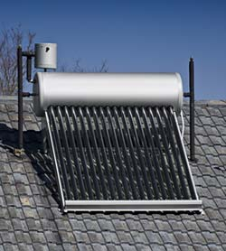

____________________________________________________________

____________________________________________________________

  - What do we mean when we say that the sun is the ultimate source of energy? (1)

____________________________________________________________

____________________________________________________________

  - Explain the statement “the sun is the ultimate source of energy” from the perspective of biomass energy. (2)

____________________________________________________________

____________________________________________________________

____________________________________________________________

  - You live in a town that is currently using electricity that comes from coal and electricity that comes from hydropower. That means that the town has a coal fired power plant and a hydropower plant. Describe an advantage and a disadvantage of each. (4)

Advantage of coal power in this scenario:

____________________________________________________________

____________________________________________________________

Disadvantage of coal power in this scenario:

____________________________________________________________

____________________________________________________________

Advantage of hydropower in this scenario:

____________________________________________________________

____________________________________________________________

Disadvantage of hydropower in this scenario:

____________________________________________________________

____________________________________________________________

Total = 140 marks

