Natural Science November Exam

Mrs Magid
Beis Yaacov Girls High School / Mesivta Shaarei Torah
Gr 7

Name:______________________________

Instructions:
- Ensure that your handwriting is legible. If I cannot read your handwriting during the test, I will not award the marks after the test.
- Do not use shorthand in your answers. You will lose 1 mark for each.
- You need not answer in full sentences.
- Consider the mark allocation. For example, 3 marks require you to make 3 correct and relevant points.
- You may use a calculator.
- Do not write in red ink.

Question 1: Sources of energy (15 marks)

  - Provide a word/phrase source for each of the following: (6)
- The main source of electricity in South Africa. Coal
- Falling water is used to produce this energy. Hydropower
- Energy formed by radioactive atoms. Nuclear
- Turbines that look like propellers on stands. Wind turbines
- The generation of energy from the movement of tides. Tidal barrage
- A fuel that comes from burning living things. Biomass energy

  - A rural community lives at the top of a high mountain. They hold a community meeting to discuss the following options as energy sources: solar energy, wind energy, biomass energy. List their options from the most ideal to the least ideal. Explain your answer (hint: think of the practicality of installing it, the cost of installing it, the reliability of the energy and the amount of energy that can be produced). (6)

Solar power is practical from an installation and cost perspective, it’s quite reliable as there is usually light energy and it can produce a fair amount of energy.

Wind energy is practical from an installation and cost perspective, it’s not as reliable as there is not always wind and it can produce a less energy than solar.

Biomass energy is not practical as cost and installation of a plant are immense. They also need to grow the biomass as fast as they use it. It is however reliable as long as they have enough biomass and can produce a lot of power.

  - Why is it better to heat water using solar energy rather than firewood? Provide three reasons. (3)

Solar energy causes no pollution, burning wood causes pollution.
Solar energy is available most of the time once installed.
Firewood has to be collected all the time.
Firewood would have to be grown at the same rate that it’s being use.

Question 2: Potential and kinetic energy (18 marks)

  - Complete the following table: (6)

Type of potential energy | Example | Your own example
Gravitational | A person at the top of a flight of stairs | xxx
Chemical | An energy drink | xxx
Elastic | A stretched elastic band | Xxx

  - Complete the following table: (4)

Energy system | Example
Mechanical | Xxx
Biological | Xxx

  - Three children are skateboarding on a hill. Their positions are shown in the diagram below.

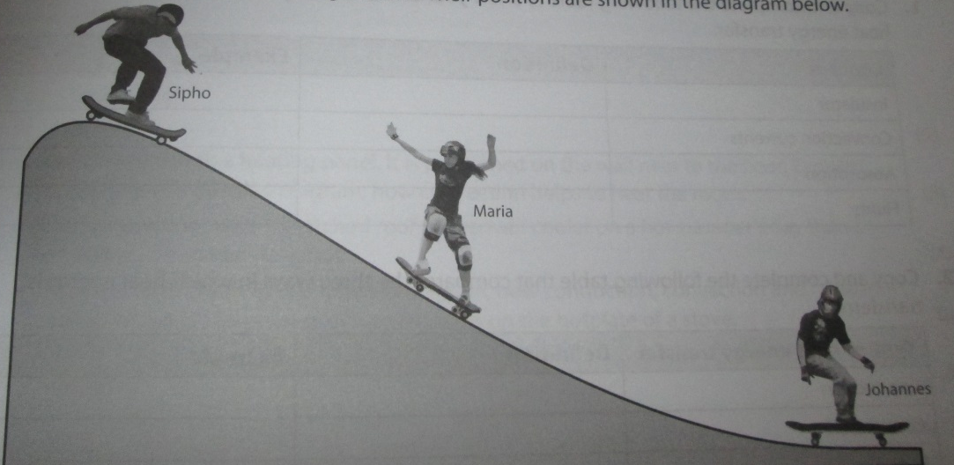
Johannes
Maria
Sipho

- Explain why Johannes has less gravitational potential energy than Sipho. Hint: you need to define gravitational potential energy in order to answer this question in full. (2)
Gravitational potential energy is the energy stored in an object because of its position above the earth. Jahannes is at the bottom of the hill and Sipho is at the top of the hill. Therefore Johannes has the lowest gravitational potential energy.

- Explain why Maria has kinetic energy. Hint: you need to define kinetic energy in order to answer this question in full. (2)
Kinetic energy is the energy an object has because it’s moving. Maria is moving down the hill.

  - Joseph filled his car’s petrol tank when he left Bloemfontein. When he arrived in Nelspruit, the fuel gauge showed that the tank was empty. Explain the concept of conservation of energy by explaining what happened to the fuel in Joseph’s car. Hint: you need to mention the energy conversions/transfers that have taken place in order to answer this question in full. (4)

The chemical energy in the petrol was converted into mechanical, sound and heat energy when the car moves. (2)
Energy is never destroyed or created. So the chemical energy in the petrol is equal to the mechanical+sound+heat energy. (2)

Question 3: Heat transfer (22 marks)

  - Complete the following sentences by circling the correct word/phrase: (3)

An insulator is a material that transfers heat energy (easily/poorly). People use insulating material to minimise (heat loss/heat gain) in winter and (heat loss/heat gain) in summer.

  - How are conduction and convection involved in the process of heating soup on a hotplate? Show this using a labelled diagram. Remember to follow the rules of scientific diagrams. (4)
1 mark for showing correct convection arrows.
1 mark for showing correct conduction arrows.
1 mark for correct convection label.
1 mark for correct conduction label.
-1 mark if did not follow rules of scientific diagrams.

  - How is radiation involved in heating up a car that is parked in the street? (2)
The sun’s light gets absorbed by the car and gets converted into heat energy.

  - Zuko and Zanele conducted an investigation to determine which sock material best insulates the feet.

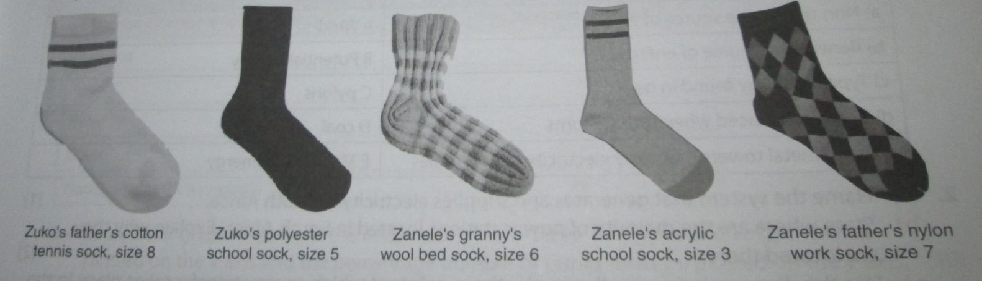

They heated water to 37°C, and poured it into 6 water bottles of identical volume. They placed each sock around a water bottle and recorded the temperature of the water in each bottle after 1 hour.
They recorded the following information:
- The water temperature in the bottle with the cotton sock dropped from 37°C to 31.3°C.
- The water temperature in the bottle with the polyester sock dropped from 37°C to 32.6°C.
- The water temperature in the bottle with the wool sock dropped from 37°C to 33.7°C.
- The water temperature in the bottle with the acrylic sock dropped from 37°C to 23°C.
- The water temperature in the bottle with the nylon sock dropped from 37°C to 32.7°C.

- Work out the drop in temperature for each sock by filling in the table below: (5)

Sock type | Temperature drop in the water bottle covered by the sock for 1 hour (°C)
Cotton sock | 5.7
Polyester sock | 4.4
Wool sock | 3.3
Acrylic sock | 14
Nylon sock | 4.3

- Draw a bar graph showing the drop in temperature for each sock. Hint: for the numbers with decimal places, you will need to estimate where in the block the bar will end. You need to use a ruler and the mm markings on the ruler to get the best estimate possible. (5)

Temperature drop in the water (°C) | 15
Temperature drop in the water (°C) | 14
Temperature drop in the water (°C) | 13
Temperature drop in the water (°C) | 12
Temperature drop in the water (°C) | 11
Temperature drop in the water (°C) | 10
Temperature drop in the water (°C) | 9
Temperature drop in the water (°C) | 8
Temperature drop in the water (°C) | 7
Temperature drop in the water (°C) | 6
Temperature drop in the water (°C) | 5
Temperature drop in the water (°C) | 4
Temperature drop in the water (°C) | 3
Temperature drop in the water (°C) | 2
Temperature drop in the water (°C) | 1
 |  | Cotton sock | Polyester sock | Wool sock | Acrylic sock | Nylon sock

- Which sock would best insulate the feet? Explain. (2)
Wool sock because the temperature in the water bottle dropped the least.

- Provide one way in which the accuracy of the experiment could be improved. (1)
Socks should be same size.
Socks should completely cover the hot water bottle.

Question 4: Rules of scientific diagrams (15 marks)

  - There are certain guidelines that scientific diagrams must abide by. Below is a scientific diagram of a plant. However, there are several problems with this diagram. NOTE THAT ALL THE LABELS ON THIS DIAGRAM ARE IMPORTANT AND NEED TO REMAIN WHEN YOU REDRAW THIS DIAGRAM!

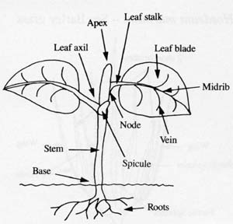

- List 5 problems with the diagram based on the rules of scientific diagrams. (5)

Label lines with arrows
Label lines not parallel
Label lines don’t end at the same point
Drawn in 3D
No title
Accept: All in one colour
Accept: Soil = unnecessary detail

- On the next page, redraw the diagram correctly following all the rules of scientific diagrams. (10)

Question 5: Classification (20 marks)

  - Multiple choice - circle the correct letter (4)

The overarching job of a biologist is to:
a. | understand as much as possible about plants and animals and how they work
b. | name and group living things
c. | study plants
d. | study animals

Why do biologists organize living things into groups?
a. | so they can find them in the wild more easily
b. | so that the living things are easier to study
c. | so they can make sense of the variety of rocks on Earth
d. | so products from living things can be easily found in groceries

When biologists classify plants or animals, the more characteristics they have in common:
a. | The closer together on Earth they live.
b. | The easier it is to tell them apart.
c. | The more closely related they are.
d. | The more distantly related they are.

Each animal and plant has been given a name in ________, which was the international language of the scholars at the time.
a. | English
b. | French
c. | Latin

  - Complete the sentences: (6)

Biology is the study of living things. Biology can be divided into different studies, such as zoology botany and ecology. Karl von Linne was a Swedish botanist who worked out a method for naming and grouping living organisms. This process is known as classification. This is based on dividing organisms into groups with similar characteristics.

  - See the animals in the diagrams below. Arrange them into 5 groups based on what you think are the closest relatives. Include at least 2 organisms per group. Use ALL the organisms I have provided below. For each group, make sure that you can state what you think is the shared character. NOTE THAT YOU NEED NOT CLASSIFY THEM IN THE WAY THAT THEY ARE CLASSIFIED IN REAL LIFE. COME UP WITH YOUR OWN UNIQUE CLASSIFICATION SYSTEM. (10)

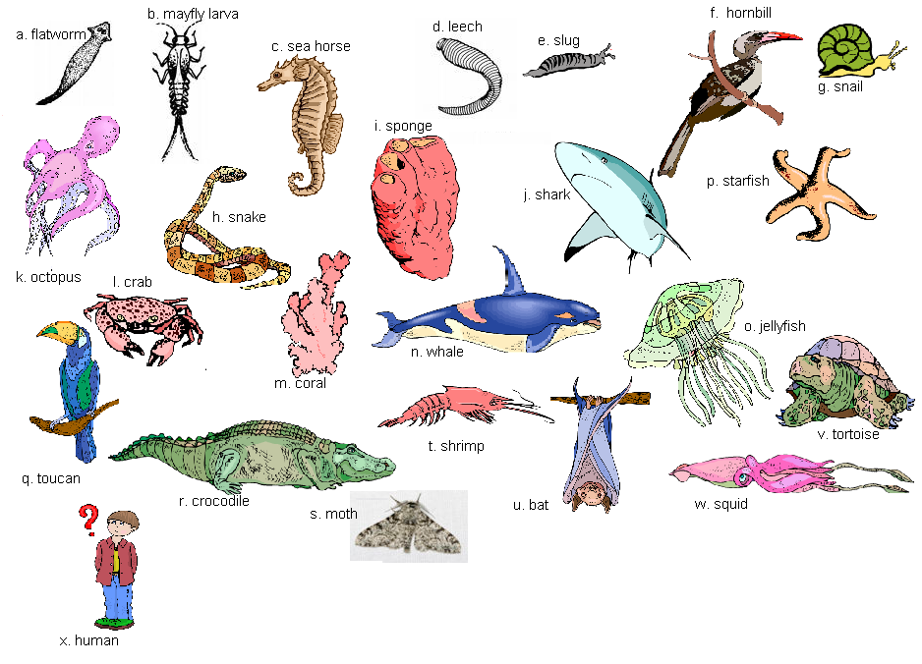
Group | Members | Shared character/s
1

2

3

4

5

Question 6: Living things (20 marks)

  - Consider the impala below. It is a living thing. List the 7 characteristics of living things and explain it in relation to the impala. (Clue: an impala is an animal, not a plant. Don’t provide an explanation that relates to plants or you will lose marks). (7×2=14)

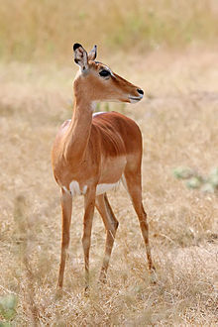

1. It needs food. Impala eat plants
2. It needs to breath. Impala breathes in oxygen and breathes out carbon dioxide
3. Produces waste products. It excretes through exhalation or going to the toilet
4. It moves around. We can see an impala move clearly
5. It grows. From being a baby to an adult it grows.
6. It reproduces. Impalas have babies
7. It is sensitive to changes in its environment. For example, it can smell a lion approaching. Accept other examples of they make sense

  - Multiple choice - circle the correct letter (3)

Which of the following do ALL living things need to survive?
a. | Water
b. | Oxygen
c. | Sunlight
d. | carbon dioxide

To be considered alive the living thing must have:
a. | at least one characteristic of living things
b. | most characteristics of living things
c. | all the characteristics of living things

Another word for living things is:
a. | Organ
b. | Organism
c. | Organelle

  - What is biodiversity? (2)

All living things in a given area.

  - Provide one thing that may threaten biodiversity in ecosystems. (1)

Litter/pollution, clearing the land for buildings, overusing plants or animals e.g. for food

Total = 110 marks

