Physical Science November Exam Paper 1: Chemistry
Mrs Magid
Beis Yaacov Girls High School
Gr 10

Name:______________________________

Instructions:
- Ensure that your handwriting is legible.
- Do not use shorthand in your answers.
- You need not answer in full sentences.
- Consider the mark allocation. For example, 3 marks require you to make 3 correct and relevant points.
- You may use a calculator.
- Do not write in red ink.

  - Circle the correct answer. (10)

- Example of a heterogeneous mixture.
- Muesli.
- Petrol.
- Water.
- Smoke.

- The name given to group 7 elements in the periodic table.
- Alkali metals.
- Halogens.
- Alkali earth metals.
- Noble gases.

- In the reaction 2Na + H₂O → 2NaOH + H₂, what is the ratio of water to sodium hydroxide?
- 1:2.
- 1:1
- 2:2
- 1:3

- When atom X of an element in group 1 reacts to form X⁺, the…
- Mass number of X increases.
- Atomic number of X increases.
- Charge of the nucleus increases.
- Number of filled energy levels decreases.

- Which of the following elements can form an ionic bond?
- He and O.
- N and C.
- F and N.
- Na and Cl.

- The following electron configuration represents 1s²2s²2p³
- O.
- N.
- C.
- F.

- An example of a chemical change is…
- Iron is left outside and begins to rust.
- Salt is stirred into water.
- Sand is mixed with water.
- Oil and vinegar are mixed to make salad dressing.

- How many electrons are there in Mg²⁺?
- 12.
- 14.
- 10.
- 11.

- In an exothermic reaction, the following occurs:
- The reacting substances gain chemical energy.
- The surroundings gain thermal energy.
- The products of the reaction have more mass than the reactants.
- The temperature of the reacting mixture decreases.

- Which of the following statements in incorrect?
- In an ionic equation, the total electrical charge of the reactants must be equal to the total electrical charge of the products.
- An equation can be balanced by placing whole numbers or coefficients in front of the chemical formulae.
- In a balanced chemical equation, the total mass of the reactants need not equal the total mass of the products.
- A balanced chemical equation shows the mass relationship between the reactants and products.

  - Write down the chemical formula for each of the following (hint: either use the naming method or the ion method): (4)
- Potassium chloride KCl
- Iodine I₂
- Ammonium carbonate. (NH₄)₂CO₃
- Calcium hydroxide. Ca(OH)₂

  - Name the following compounds: (4)
- FeCl₃ Iron chloride
- SO₂ Sulfur dioxide
- AgNO₃ Silver nitrate
- MnO₂ Manganese dioxide

  - For each of the following, say whether the substance is ionic or molecular. (4)
- potassium nitrate (KNO₃) Ionic
- ethanol (C₂H₅OH) Covalent
- sucrose (a type of sugar) (C₁₂H₂₂O₁₁) Covalent
- sodium bromide (NaBr) Ionic

  - The table below shows the melting and boiling points of some substances in the laboratory.

Substance | Melting point (°C) | Boiling point (°C)
Ethanol | -117 | 78
Butane | -138 | 0
Fluorine | -220 | -188
Iodine | 114 | 183
Acetic acid | 16 | 118
Benzene | 5 | 80
Sulfur | 115 | 444

- Based on the table above, fill in the table below by listing which of the substances are solids, liquids and gases at room temperature (25°C). (7)

Solid | Liquid | Gas
Iodine  Sulfur | Ethanol  Acetic acid  Benzene | Butane  Fluorine

- Name the substance that is a liquid at 100°C. (1) acetic acid

- Name the substances that are solid between 100°C and 113°C. (2) iodine and sulfur

- Name the substance that is a liquid at 400°C. (1) sulfur
- Draw labelled diagrams that clearly represent particle arrangement in solids, liquids and gases. (3)

  - Below is a heating curve of a known substance.
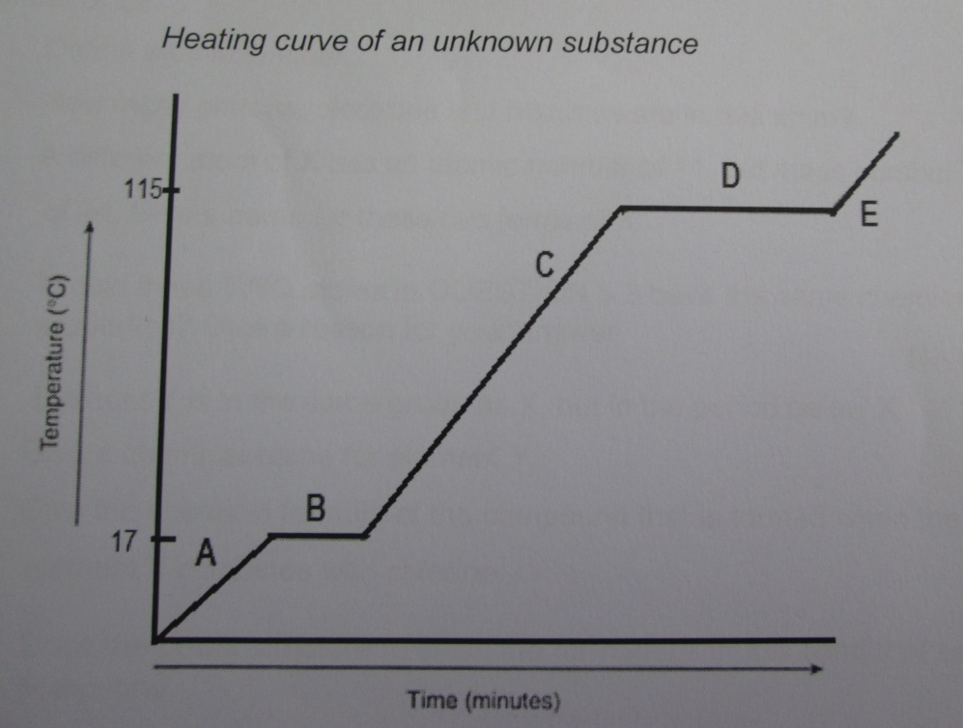

- Name the physical state(s) of the substance at point A, C and E. (3) A solid C liqid E gas

- At which temperature does the substance melt? (1) 17°C

- Indicate the temperature that represents the boiling point of the substance. (1) 115°C

- Using the kinetic molecular theory, describe the change that this substance undergoes from A to C at a molecular level. (4)
Solid particles gain energy and move further apart (1).
There is a period of no temp change (B) when all the energy goes towards breaking the forces of attraction between solid particles (2).
Once all the material is in liquid form, the temperature may rise (1).

  - Atom of element X has an atomic number of 11 and a mass number of 23.
- Define atomic number. (2) the number of protons in the nucleus of an atom.

- How many protons, neutrons and electrons are in this atom? (3) 11 p, 11 e and 12 n

- A different atom of X has an atomic number of 11 but a mass number of 24. Give a name for these two forms of X. (1) Isotopes

- Represent the two atoms in the question above using isotopic symbols. (2)
²³₁₁Na ²⁴₁₁Na

- Would these two atoms in the question above have the same chemical properties? Give a reason for your answer. (2)
Yes. The chemical properties of a material depends on the number of protons.

- Element Y is in the same group as X but in the period below X. Give the chemical name for element Y. (1)
Potassium (do not accept symbol)

- Give the chemical formula of the compound formed when element Y combines with chlorine. (1)
KCl (do not accept name)

- Draw the Lewis structure to show the formation of the bond that occurred in this compound. (3)

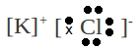

  - Explain what metallic bonding is, and draw a diagram of electron-sea model of a metal. (5)
The electrons from all the metal atoms form a ‘sea’ of electrons that flow around the nucleus of metal.

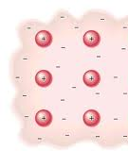

  - This question is based on the periodic table of elements. The letters shown below in the table are not the symbols of the elements. Use only the letter shown in the table to answer the following questions:
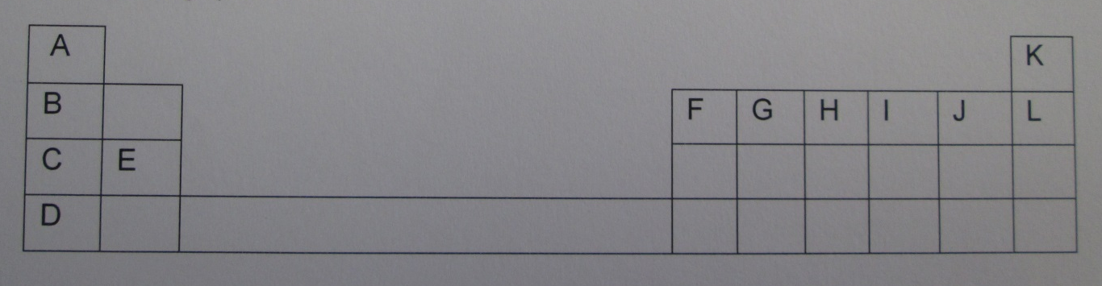

    - Which letter represents the only non-metal in group 1? (1) A
    - Name the group that letter K represents in the periodic table of elements. (1) Noble gases
    - How many protons are there in an atom of the letter K? (1) 2
    - Which letter represents an element that has its valence electron arranged in the fourth energy level? (1) D
    - Draw an Aufbau diagram of an atom represented by letter J. (2)
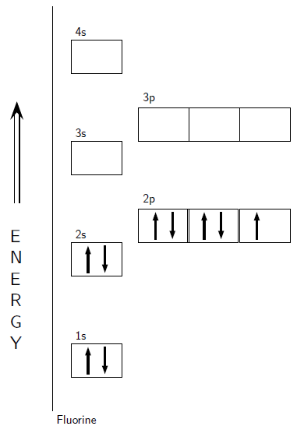
    - How many valence electrons are there in the atom represented by letter J? (1) 7

  - If a sample contains 79% Mg-24, 10% Mg-25 and 11% Mg-26, calculate the relative atomic mass of an atom of magnesium in that sample. (3)
Ar = (79/100*24)+(10/100*25)+(11/100*26) = 24.32
The relative atomic mass of magnesium is 24.

  - The following questions relate to the periodicity of elements in the periodic table.

    - What can you say about the melting point of potassium relative to argon? Explain in general terms. (2)
Potassium has a higher melting point. Metals have a higher melting (and boiling) point than non-metals.

    - The atomic radius of sodium is greater than the atomic radius of lithium. Explain why that is the case. (2)
As you go down a group, an extra layer, or shell of electrons is added (with increasing principal quantum number), so the atomic radius increases.

    - The atomic radius of lithium is greater than the atomic radius of oxygen. Explain why that is the case. (2)
As you move across a period, the number of protons in the nucleus increases, and so the electrostatic pull on the electrons is greater and they are thus closer to the nucleus as you move across a period.

    - Explain why lithium is more reactive than oxygen based on ionisation energy. (2)
Because the electrostatic pull on the electrons in stronger
Lithium has a lower ionisation energy so its outer electron is easier to move. This is because the electrostatic forces of attraction between electrons and nucleus are weaker.

  - You and your friend are investigating the temperature changes that occur when calcium chloride is added to sodium bicarbonate in aqueous solution. You record the following temperatures:

Time (s) | 0 | 30 | 60 | 90 | 120 | 150
Temperature (°C) | 21 | 34 | 42 | 45 | 46 | 46

    - What is the independent variable? (1)
Time

    - What is the dependent variable? (1)
Temperature

    - Plot the results on an accurately drawn graph below. Remember to give your graph a title. (8)

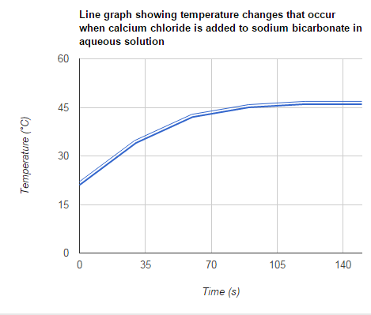

    - Is it an endothermic or an exothermic reaction? Provide a reason for your answer. (2)
Exothermic. The temp increases, because more energy is being released than is taken in.

  - Write a balanced equation to show how each of the following ionic compounds dissociate in water. (6)
    - Sodium sulphate (Na₂SO₄)
Na₂SO₄(aq) → 2Na⁺ (aq) + SO₄²⁻ (aq)

    - Potassium permanganate (KMnO₄)
KMnO₄(aq) → K⁺ (aq) + MnO₄⁻ (aq)

    - Sodium phosphate (Na₃PO₄)
Na₃PO₄ (aq) → 3Na⁺ (aq) + PO₄³⁻ (aq)

  - Draw a diagram to show how KCl dissolves in water. (4)

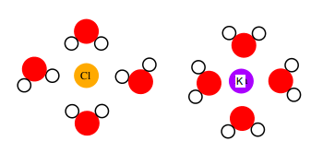

  - For each of the following reactions, provide the balanced ionic equation, the net ionic equation and the molecular equation. (5×3=15)

    - Sodium sulfate (Na₂SO₄) reacts with calcium nitrate (Ca(NO₃)₂) in aqueous solution to form a precipitate.

Ionic equation
2Na⁺ (aq) +SO₄²⁻ (aq) + Ca²⁺ (aq) + 2NO₃⁻ (aq) → 2Na⁺ (aq) + 2NO₃⁻ (aq) + CaSO₄ (s)

Net ionic equation
SO₄²⁻ (aq) + Ca²⁺ (aq) → CaSO₄ (s)

Molecular equation
Na₂SO₄ (aq) + Ca(NO₃)₂ (aq) → 2NaNO₃ (aq) + CaSO₄ (s)

    - Sodium hydroxide (NaOH) reacts with nitric acid (HNO₃) in aqueous solution in an acid/base reaction.

Ionic equation
Na⁺ (aq) +OH⁻ (aq) + H⁺ (aq) + NO₃⁻ (aq) → H₂O (l) + Na⁺ (aq) + NO₃⁻ (aq)

Net ionic equation
OH⁻ (aq) + H⁺ (aq) → H₂O (l)

Molecular equation
NaOH (aq) + HNO₃ (aq) → H₂O (l) + NaNO₃ (aq)

    - Calcium carbonate (CaCO₃) reacts with hydrochloric acid (HCl) in aqueous solution to produce bubbles of gas.

Ionic equation
Ca²⁺ (aq) + CO₃²⁻ (aq) + 2H⁺ (aq) + 2Cl⁻ (aq) → H₂O (l) + CO₂(g) + Ca²⁺ (aq) + 2Cl⁻ (aq)

Net ionic equation
CO₃²⁻ (aq) + 2H⁺ (aq) → H₂O (l) + CO₂(g)

Molecular equation
CaCO₃ (aq) + 2HCl (aq) → H₂O (l) + CO₂(g) + CaCl₂ (aq)

Total = 120 marks

