Natural Science June Exam June 2014

Mrs Magid
Beis Yaacov Girls High School / Mesivta Shaarei Torah
Gr 7

Name:______________________________

Answer ALL the questions. Ensure that your handwriting is legible. Do not write in red ink. Good luck!

Question 1: Properties of material (40 marks)

  - We learnt that matter can exist as solid, liquid and gas. We learnt about the change of state of material. Based on what we learnt, apply it to the water cycle by filling in the missing words. (4)

The sun _______________ water from water bodies such as rivers and oceans.
As the water vapour rises, it cools and ________________ into tiny droplets of water.
The droplets crowd together and form clouds.
Clouds get moved around by wind.
Eventually the tiny droplets come together and fall as rain to the ground.
When it is very cold, the droplets in the cloud freeze or ________________. This will result in snow.
When it is warm enough, the snow ________________ into water.
The water (from precipitation or from melting snow) soaks into the ground and lands in water bodies.
The cycle begins again.

  - Fill in the missing words. (3)

We use material like ____________ to make pots because we know they are not going to ____________ when we heat them up to cook something. We would not use a material like ____________ to make a pot.

  - Look at the objects in the pictures below. They are made of different materials. For each object, explain why the material used is not suitable. (5)

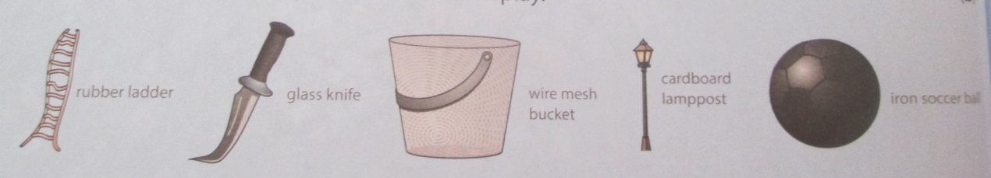

Ladder made of rubber: ________________________________________

____________________________________________________________

Knife made of glass: ____________________________________________

____________________________________________________________

Bucket made of wire mesh: _______________________________________

____________________________________________________________

Lamppost made of cardboard: _____________________________________

____________________________________________________________

Soccer ball made of iron: _________________________________________

____________________________________________________________

  - Complete the table below. (10)

Object | Property that the material must have | Suitable material
Ladder
Knife
Bucket
Lamppost
Soccer ball

  - List three benefits of plastic that explain why is it such a useful material to us. (3)

____________________________________________________________

____________________________________________________________

____________________________________________________________

  - Below are pictures and names of different types of things we commonly use in a kitchen.

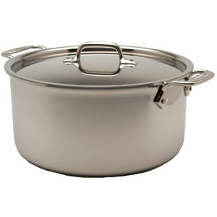 | 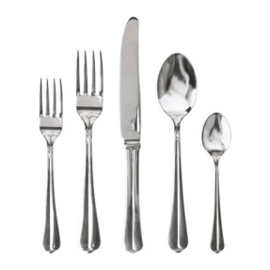 | 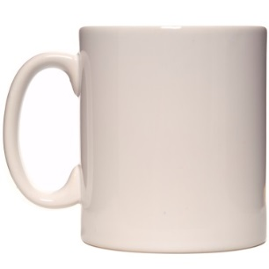
Pot | Cutlery | Mug
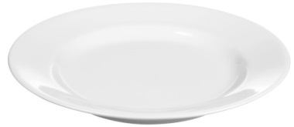 | 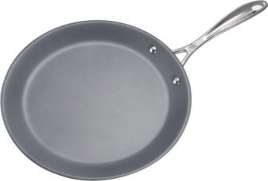 | 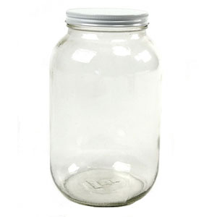
Plate | Pan | Jar
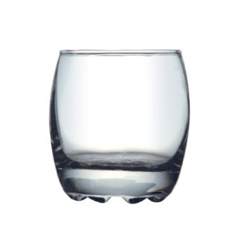 | 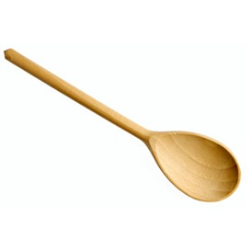 | 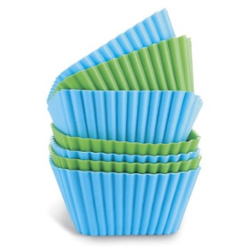
Glass | Wooden spoon | Silicone cupcake holder
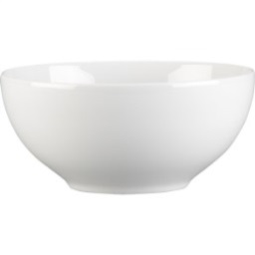 | 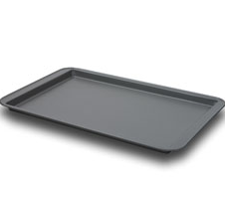 | 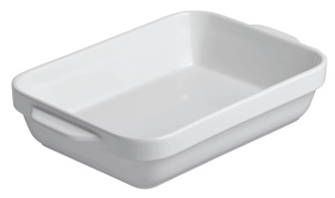
Bowl | Oven tray | Oven dish

    - In the table below, classify each one as wood, plastic, steel, fabric, glass or stone. (6)

Wood
Plastic
Steel
Fabric
Glass
Stone

    - Complete the bar graph showing the number of the different types of material (6)
Number of items | 12
Number of items | 11
Number of items | 10
Number of items | 9
Number of items | 8
Number of items | 7
Number of items | 6
Number of items | 5
Number of items | 4
Number of items | 3
Number of items | 2
Number of items | 1
 |  | Wood | Plastic | Steel | Fabric | Glass | Stone

    - Based on the graph, what conclusions can you draw about the materials found in a kitchen? Break down your conclusion into 3 sentences describing:
- which materials are found more commonly and why (1)
- which materials are found less commonly and why (1)
- Which materials are not found at all and why (1)

____________________________________________________________

____________________________________________________________

____________________________________________________________

____________________________________________________________

____________________________________________________________

____________________________________________________________

Question 2: Separating mixtures (23 marks)

  - You have a mixture of beads, sand, iron filings, salt and water. Describe how you would separate this mixture, step by step and in the correct order. For each step, mention the name of the method, and then describe what you would do. (8)
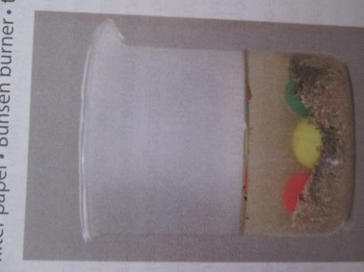

____________________________________________________________

____________________________________________________________

____________________________________________________________

____________________________________________________________

____________________________________________________________

____________________________________________________________

____________________________________________________________

____________________________________________________________
  - You are an industrial chemist working at a crude oil refinery. Crude oil is a mixture of chemicals. You want to refine them by separating them out into pure substances. You are provided with the following table of information regarding the three chemicals:

PROPERTY | PETROL | KEROSENE | DIESEL
Colour | Yellow/Orange | Yellow/Brown | Green
Boiling point | 110°C | 180°C | 260°C

Using the distillation process, describe the steps you would take to separate these 3 chemicals. (5)

____________________________________________________________

____________________________________________________________

____________________________________________________________

____________________________________________________________

____________________________________________________________

____________________________________________________________

  - Which four materials are suitable for recycling? (4)

____________________________________________________________

____________________________________________________________

  - Of these four materials, which material is the most important to recycle? Provide two reasons. (3)

____________________________________________________________

____________________________________________________________

____________________________________________________________

____________________________________________________________

  - Fill in the table be briefly stating what the resulting impact of each type of pollution is: (3)

Negative consequence | Resulting impact
Soil and water pollution
Air pollution
Blocked sewage and water drainage systems

Question 3: Acids, bases and neutrals (16 marks)

  - Fill in the following table: (12)

Substance | Acid, base or neutral | Colour in blue litmus | Colour in red litmus
Oven cleaner
Sugar water
Soap
Vinegar

  - What causes heartburn? Explain. (2)

____________________________________________________________

____________________________________________________________

____________________________________________________________

  - How can heartburn be treated? Explain how it works. (2)

____________________________________________________________

____________________________________________________________

Question 4: The periodic table of elements (20 marks)

  - Use the periodic table and the diagram below to answer the following questions:

11
Na
23

    - What is the name of the element shown above? (1)

____________________________________________________________

    - Is this element a metal or a non-metal? (1)

____________________________________________________________

    - Name four properties of this element. (4)

____________________________________________________________

____________________________________________________________

    - Write down the symbol of a non-metal in the same group as this element. (1)

____________________________________________________________

  - Copper is a metal used in electrical wires.

    - Look on your periodic table and find the symbol, atomic number and mass number of copper. (3)

Symbol: ______

Mass number: ______

Atomic number: ______

    - Which property of copper makes it useful for electrical wires? (1)

____________________________________________________________

    - Copper is malleable and ductile. What do these two words mean? (2)

____________________________________________________________

____________________________________________________________

____________________________________________________________

____________________________________________________________

    - Name a metalloid in the same period as copper. (1)

____________________________________________________________

    - Name a property of metalloids that are like metals (1)

____________________________________________________________

    - Name a property of metalloids that are like non-metals (1)

____________________________________________________________

  - Refer to your periodic table to answer the following questions:

    - Which element is found in period 3, group 16? (1)

____________________________________________________________

    - Is this element a metal or a non-metal? (1)

____________________________________________________________

    - Name two properties of this element. (2)

____________________________________________________________

____________________________________________________________

Total = 90 marks

