Natural Science June Exam June 2014

Mrs Magid
Beis Yaacov Girls High School / Mesivta Shaarei Torah
Gr 7

Name:______________________________

Answer ALL the questions. Ensure that your handwriting is legible. Do not write in red ink. Good luck!

Question 1: Properties of material (40 marks)

  - We learnt that matter can exist as solid, liquid and gas. We learnt about the change of state of material. Based on what we learnt, apply it to the water cycle by filling in the missing words. (4)

The sun evaporates water from water bodies such as rivers and oceans.
As the water vapour rises, it cools and condenses into tiny droplets of water.
The droplets crowd together and form clouds.
Clouds get moved around by wind.
Eventually the tiny droplets come together and fall as rain to the ground.
When it is very cold, the droplets in the cloud freeze or solidify. This will result in snow.
When it is warm enough, the snow melts into water.
The water (from precipitation or from melting snow) soaks into the ground and lands in water bodies.
The cycle begins again.

  - Fill in the missing words (3)
We use material like steel to make pots because we know they are not going to melt when we heat them up to cook something. We would not use a material like plastic to make a pot.

  - Look at the objects in the pictures below. They are made of different materials. For each object, explain why the material used is not suitable. (5)

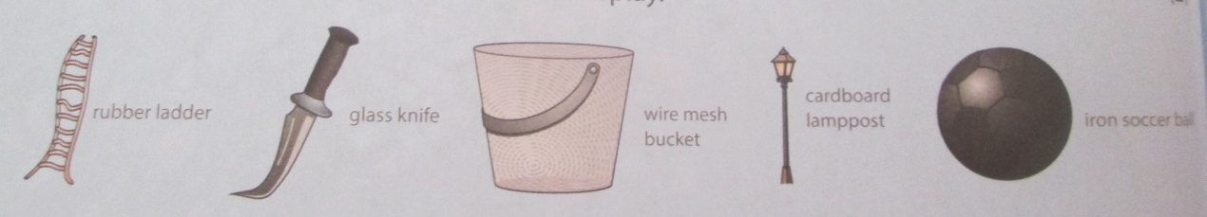

Ladder made of rubber is bendy and cannot stand upright.
Knife made of glass would shatter.
Bucket made of wire mesh would not hold the water.
Lamppost made of cardboard would get wet and fall down.
Soccer ball made of iron is too heavy to play with.

  - Complete the table below. (10)

Object | Property that the material must have | Suitable material
Ladder | Strong/stiff | Iron/aluminium
Knife | Strong/stiff | Iron/steel
Bucket | Waterproof | Iron/steel/plastic
Lamppost | Waterproof/strong/stiff | Iron/steel
Soccer ball | Flexible/light | Leather/plastic/rubber

  - List three benefits of plastic – why is it such a useful material to us? (3)
It is cheap, it can be made into many things, it is an electrical insulator, it is a heat insulator.

  - Below are pictures and names of different types of things we commonly use in a kitchen.

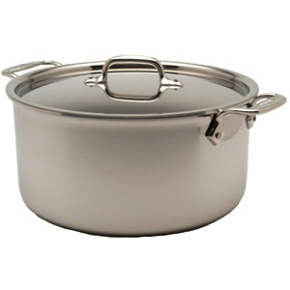 | 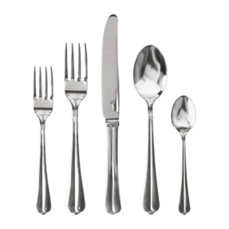 | 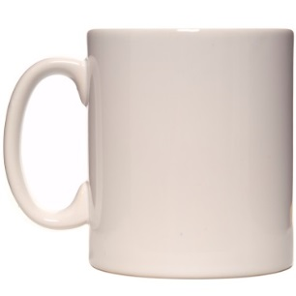
Pot | Cutlery | Mug
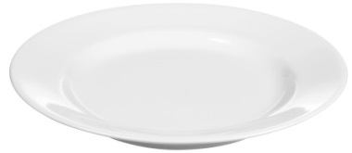 | 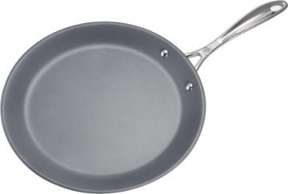 | 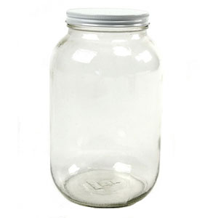
Plate | Pan | Jar
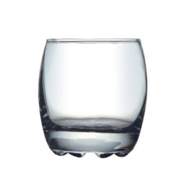 | 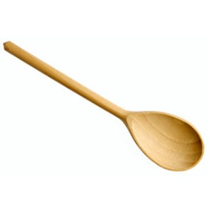 | 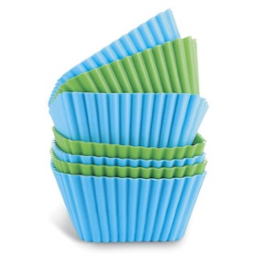
Glass | Wooden spoon | Silicone cupcake holder
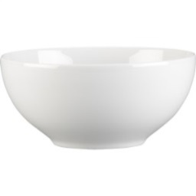 | 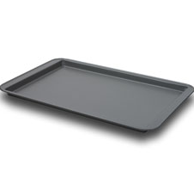 | 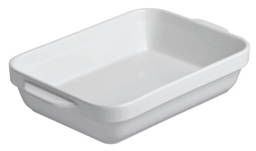
Bowl | Oven tray | Oven dish

    - In the table below, classify each one as wood, plastic, steel, fabric, glass or stone. (6)

Wood | Wooden spoon
Plastic | Silicone cupcake holders
Steel | Pot, cutlery, oven tray, pan
Fabric
Glass | Mug, plate, bowl, oven dish, jar, glass
Stone | Mug, plate, bowl, oven dish

    - Complete the bar graph showing the number of the different types of material (6)
Number of items | 12
Number of items | 11
Number of items | 10
Number of items | 9
Number of items | 8
Number of items | 7
Number of items | 6
Number of items | 5
Number of items | 4
Number of items | 3
Number of items | 2
Number of items | 1
 |  | Wood | Plastic | Steel | Fabric | Glass | Stone

    - Based on the graph, what conclusions can you draw about the materials found in a kitchen? Break down your conclusion into 3 sentences describing:
- which materials are found more commonly and why (1)
- which materials are found less commonly and why (1)
- Which materials are not found at all and why (1)
Glass/stone and steel are found commonly because they can handle heat and are therefore useful in cooking.
Wood, plastic and glass are found in small amounts, because they are not as resilient to heat.
We don’t use fabric utensils as they may burn

Question 2: Separating mixtures (23 marks)

  - You have a mixture of beads, sand, iron filings, salt and water. Describe how you would separate this mixture, step by step and in the correct order. For each step, mention the name of the method, and then describe what you would do. (8)

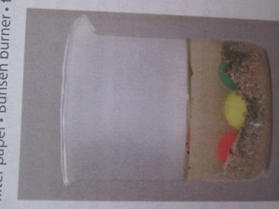

Step 1: Hand sort to remove the beads.
Step 2: Filtration to get the salt and water separated from the insoluble material.
Step 3: Evaporate or distil salt water to be left with salt and water.
Step 4: Use a magnet to separate the iron filings from the sand.

  - You are an industrial chemist working at a crude oil refinery. Crude oil is a mixture of chemicals. You want to refine them by separating them out into pure substances. You are provided with the following table of information regarding the three chemicals:

PROPERTY | PETROL | KEROSENE | DIESEL
Colour | Yellow/Orange | Yellow/Brown | Green
Boiling point | 110°C | 180°C | 260°C

Using the distillation process, describe the steps you would take to separate these 3 chemicals. (5)

Heat the chemicals close to 110°C and the petrol would boil. Collect the pure petrol.
Continue heating the mixture to 180°C, and the next substance to begin evaporating will be kerosene. Collect the pure kerosene.
You would then be left with diesel.

  - Which four materials are suitable for recycling? (4)
Glass Paper Metal Plastic

  - Of these four materials, which material is the most important to recycle? Provide two reasons. (3)
Plastic. Most of our waste is plastic-derived. Plastic is made from oil, which is a limited resource. Making plastic uses a lot of water and energy.

  - Fill in the table be briefly stating what the resulting impact of each type of pollution is: (3)

Negative consequence | Resulting impact
Soil and water pollution | Harms and even kills plants and animals.
Air pollution | Lung disease, asthma and allergies.
Blocked sewage and water drainage systems | Causes the spread of viruses and bacteria, some of which are fatal.

Question 3: Acids, bases and neutrals (16 marks)

  - Fill in the following table: (12)

Substance | Acid, base or neutral | Colour in blue litmus | Colour in red litmus
Oven cleaner | Base | Blue | Blue
Sugar water | Neutral | Blue | Red
Soap | Base | Blue | Blue
Vinegar | Acid | Red | Red

  - What causes heartburn? Explain. (2)
Food is pushed back into the oesophagus when the stomach gets too full. This means that the oesophagus gets filled with acid.
  - How can heartburn be treated? Explain how it works. (2)
You can take a base. The base acts against the acid.

Question 4: The periodic table of elements (20 marks)

  - Use the periodic table and the diagram below to answer the following questions:

11
Na
23

    - What is the name of the element shown above? (1)
Sodium

    - Is this element a metal or a non-metal? (1)
Metal

    - Name four properties of this element. (4)
Shiny, malleable, ductile, conductor of electricity, conductor of heat, high boiling point, high melting point, solid.

    - Write down the symbol of a non-metal in the same group as this element. (1)
H

  - Copper is a metal used in electrical wires.

    - Look on your periodic table and find the symbol, atomic number and mass number of this element. (3)
Symbol: Cu
Mass number: 29
Atomic number: 64

    - Which property of copper makes it useful for electrical wires? (1)
It is a good conductor of electricity.

    - Copper is malleable and ductile. What do these two words mean? (2)
Malleable means it can be bent without breaking and ductile means it can be stretched without breaking.

    - Name a metalloid in the same period as copper. (1)
Germanium or arsenic

    - Name a property of metalloids that are like metals (1)
They are silver-grey in colour. They are shiny

    - Name a property of metalloids that are like non-metals (1)
They are not ductile. They are not malleable

  - Refer to your periodic table to answer the following questions:

    - Which element is found in period 3, group 16? (1)
Sulfur

    - Is this element a metal or a non-metal? (1)
A non-metal.

    - Name two properties of this element. (2)
Dull in colour, yellow, not malleable, not ductile, brittle, not conductor of electricity, not conductor of heat, low boiling point, low melting point, solid.

Total = 90 marks

