Natural Sciences November Exam

Mrs Magid
Beis Yaacov Girls High School / Mesivta Shaarei Torah
Gr 8

Name:______________________________

Instructions:
- Please refer to the periodic table on page 12
- Ensure that your handwriting is legible.
- Do not use shorthand in your answers.
- You need not answer in full sentences.
- Consider the mark allocation. For example, 3 marks require you to make 3 correct and relevant points.
- You may use a calculator.
- Do not write in red ink.
GOOD LUCK!

Total: 130 marks
Time: 2h

Question 1: One word/term answers (5)

- Provide a one name or term for each of the following descriptions: (5×1=5)
  - Anything that has mass and takes up space. _________________
  - A chemical reaction that releases heat. _________________
  - Takes the shape of the container it is in. _________________
  - The central region of the atom. _________________
  - Movement of particles from high concentration to low concentration. _________________

Question 2: Multiple choice (10)

- Circle the correct answer: (10×1=10)

  - An example of a mixture is…
- Distilled water
- Copper sulfate
- Air
- Hydrochloric acid
  - To separate a mixture by filtration…
- One of the substances should be liquid
- Both substances should be liquid
- One substance should be a liquid and the other a soluble solid
- One substance should be a liquid and the other a non-soluble solid

  - A small block of wood is placed in a measuring cylinder with water. The level of the water rose by 40cm³. The mass of the block is 21.6g. What is the density of the wood?
- 0.54 g/cm³
- 1.85 g/cm³
- 864 g/cm³
- 5.4 g/cm³

  - Mercury, water and petrol are poured into a cylinder. The order in which they will occur from top to bottom is:
- Mercury, water, petrol
- Petrol, mercury, petrol
- Water, petrol, mercury
- Petrol, water, mercury

  - The direction of the current in a circuit is always:
- From the negative pole to the positive pole of the cell
- From the positive pole to the negative pole of the cell
- In a clockwise direction
- Dependent on the position of the resistors in the circuit

  - When energy is added to a liquid without changing phase, the particles will:
- Move faster
- Be arranged in a more disorderly fashion
- Move away from their fixed position
- Vibrate faster and further apart in their position

  - The reason that helium rises is:
- Helium is lighter than air
- Helium is less dense than air
- Helium is lighter than the balloon
- Helium is less dense than the balloon

  - Which list below includes ONLY diatomic molecules?
- Fluorine, chlorine, iodine, nitrogen
- Iodine, helium, hydrogen, oxygen
- Calcium, oxygen, chlorine, nitrogen
- Oxygen, hydrogen, carbon, bromine

  - A rectangular pine block has measurements of 40cm×30cm×10cm. The density of the pine is 0.6g/cm³. The mass of the pine is:
- 720g
- 20000g
- 2000g
- 7200g

  - You charge two balloons. You put them near each other. What do you observe?
- The two balloons move away from each other
- The two balloons move towards each other
- The two balloons remain in their position
- One balloon moves towards the other balloon

Question 3: Match the columns (6)

- Choose an item from COLUMN B that best matches a description/item in COLUMN A. (6×1=6)

COLUMN A |  | COLUMN B
3.1 | Filament of a bulb | A | Wool
3.2 | Material that gives up electrons | B | Polystyrene
3.3 | The part of the circuit where energy is stored | C | Resistor
3.4 | A neutral object and a like charge | D | Transparent
3.5 | Material that gains electrons | E | Tungsten
3.6 | The part of the circuit where energy is converted | F | Attract
 |  | G | Cell
 |  | H | Conducting wires
 |  | I | Repel

  - ____
  - ____
  - ____
  - ____
  - ____
  - ____

Question 4: Atoms (23)

  - Consider the element cobalt (a metal) on your periodic table.

    - What group and period is cobalt in based on the periodic table? (2)

____________________________________________________________

    - What is the chemical symbol of cobalt? (1) __________________

    - What is the atomic number of cobalt? (1) __________________

    - What does the atomic number represent? (1)

____________________________________________________________

    - How many neutrons does cobalt have in its nucleus? (1) __________________

    - Cobalt reacts with oxygen to form cobalt oxide (a black powder). What type of chemical reaction is this? Explain. (2)

____________________________________________________________

____________________________________________________________

    - What is/are the reactant/s in this chemical reaction? (1)

____________________________________________________________

    - What is/are the product/s in this chemical reaction? (1)

____________________________________________________________

    - Is cobalt oxide a mixture or a pure substance? Explain. (2)

____________________________________________________________

____________________________________________________________

    - Can you separate cobalt oxide using physical means? Explain. (2)

____________________________________________________________

____________________________________________________________

  - Consider diagrams A and B below and decide which is exothermic and which is endothermic. Explain. (4)

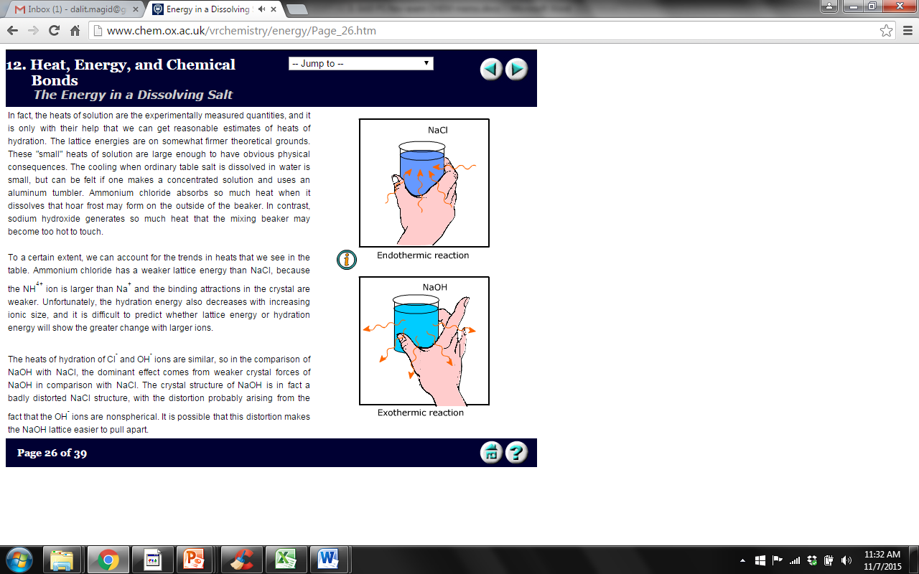
Diagram A Diagram B

____________________________________________________________

____________________________________________________________

____________________________________________________________

  - Consider diagram below. It represents a separation method which has separated alcohol with a boiling point of 78°C and ether with a boiling point of 34°C.
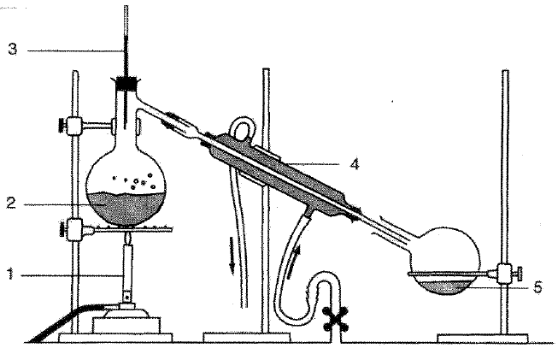

    - What method of separation does this represent? (1) ____________________

    - Which liquid is represented by 2? (1) ____________________

    - Which liquid is represented by 5? (1) ____________________

    - What is the function of the part labelled 3? Explain. (2)

____________________________________________________________

____________________________________________________________

____________________________________________________________

Question 5: The particle model of matter (33)

  - Complete the following sentenced by filling in the missing words/phrases: (11)
    - Gases can easily be compressed because large ______________ exist between the gas particles.
    - ______________ is the movement of particles from a high concentration to a low concentration.
    - When ice absorbs energy is changes to ______________ and then to ______________. These processes are known as ______________ and ______________ respectively.
    - Clouds are formed during a phase change where ______________ changes to ______________. This process is known as ______________.
    - As gas particles are added to an enclosed container, it results in an increase in ______________ due to an increase in _____________________________.

  - In the spaces provided below, draw a diagram to show the arrangement of particles in a solid and a gas. Use small circles to represent the particles. (2)

Solid |  | Gas

  - In an experiment, a group of students want to observe the temperature change of water as they apply heat from a Bunsen burner. They measure the temperature every 30 seconds and record the data in the table below:

Time (seconds) | Temperature (°C)
0 | 20
30 | 27
60 | 36
90 | 50
120 | 64
150 | 72
180 | 85
210 | 100

    - Plot a line graph using the data in the table. Use the graph paper provided. (10)

    - Use the graph to determine the temperature of the water after 45 seconds. Make lines on your graph to indicate how you came to your answer and write it here. (2)

____________________________________________________________

  - A student set up the apparatus shown below to measure the volume of object X. Study the diagrams below and answer the questions that follow.

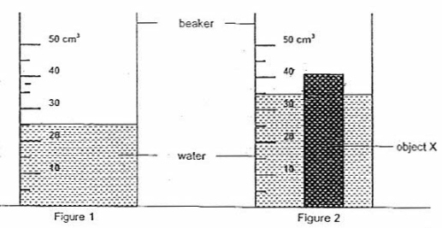
    - What is the volume of the water in figure 1? (1) _________

    - When object X is placed in the beaker, it results in the arrangement that can be seen in figure 2. Write down the new reading in figure 2. (1) _________

    - Calculate the volume of object X. Show all your calculations. (2)

____________________________________________________________

____________________________________________________________

  - You connect a metal wire to two clamps. You heat the wire. You find that, once heated, the wire sags.

    - Using the particle model of matter, explain what happens to the particles in the wire. (3)

____________________________________________________________

____________________________________________________________

____________________________________________________________

    - What happened to the wire? (1) ___________________________________

Question 6: Chemical reactions (21)

  - For the following, decide whether or not a chemical reaction has taken place. Say yes if it is chemical reaction, no if it’s not a chemical reaction: (6)
    - Inhaling oxygen __________
    - Respiration __________
    - Droplets of water forming on the outside of your cold glass __________
    - Souring milk __________
    - Rotting bananas __________
    - Using a battery __________

  - ONE zinc atom (Zn) reacts with TWO molecules of hydrochloric acid (HCℓ) to form ONE molecule of zinc chloride (ZnCℓ₂) and ONE hydrogen diatomic molecule (H₂).

    - Write out the chemical reaction using the symbols. (4)

____________________________________________________________

    - Using different coloured pens (where a certain colour represents a certain element) draw out the chemical reaction. (6)

    - How many zinc atoms can you count on EACH side of the equation? (1) ___
    - How many hydrogen atoms can you count on EACH side of the equation? (1) ___
    - How many chlorine atoms can you count on EACH side of the equation? (1) ___
    - What conclusion can you draw from the answers to the three questions above? (2)

____________________________________________________________

____________________________________________________________

Question 7: Static electricity (8)

  - Which of the following are true of static charges? Choose all that apply by circling the letters.
- Like charges repel.
- Like charges attract.
- Opposite charges repel.
- Opposite charges attract.
- A positively charged object has lost electrons.
- A positively charged object has gained protons.
- A negatively charged object has lost protons.
- A negatively charged object has gained electrons.

  - A neutral plastic strip is rubbed with cotton and gets a positive charge. Which of the following statements are true of the positively-charged plastic strip?
- It lost some electrons to the cotton during the charging process.
- It lost all of its electrons to the cotton during the charging process.
- It has the opposite charge as the cotton.
- It would now be repelled by the piece of cotton which was used to charge it.
- It gained protons during the rubbing process.
- It could exert either a repulsive or attractive influence upon neutral paper bits.
- It would attract neutral paper bits.
- It would repel neutral paper bits.
- It has an excess of protons compared to the number of electrons.
- It lost negative electrons and gained positive electrons during the charging process.
- It lost neutrons during the charging process (or at the very least, its neutrons became ineffective).

Question 8: Energy transfer in electrical systems (24)

  - In an electric circuit, where is the energy stored? (1)

____________________________________________________________

  - In what form is the energy stored? (1)

____________________________________________________________

  - What three things make up the simplest electric appliance? (3)

____________________________________________________________

  - What is the difference between an open circuit and a closed circuit? (2)

____________________________________________________________

  - Draw a circuit below that has an open switch, two cells, a resistor and a light bulb. Draw it in pencil and make it large and neat. (5)

  - What is the difference between a wet cell and a dry cell? (2)

____________________________________________________________

____________________________________________________________

  - Which one do we use more commonly today and why? (2)

____________________________________________________________

  - What does electrical resistance measure? (2)

____________________________________________________________

____________________________________________________________

  - You are cooking food in your oven. What is the resistor in the oven and what energy transfer takes place in the resistor? (3)

____________________________________________________________

____________________________________________________________

  - You are sitting in front of the fan on a hot day. What is the resistor in the fan and what energy transfer takes place in the resistor? (3)

____________________________________________________________

____________________________________________________________

Total = 130 marks

