Natural Science November Exam: 2 hours xx November 2013

Mrs Magid
Beis Yaakov Girls High School
Gr 9

Name:______________________________

Answer ALL the questions. Ensure that your handwriting is legible. Do not write in red ink. Good luck!

Question 1: Experiments integrating graphs and ‘matter and material’ (47 marks)

  - Sugar is broken down into lactic acid by a type of bacterium called Lactobacillus.

Scientists often use a gelatine based substance called agar inside a petri dish on which to grow bacteria. John wants to prepare a pure sample of Lactobacillus, but he only has a mixed culture medium of four different bacteria. This means that when he places his mixed culture medium on the agar in the petri dish, he will end up with 4 different types of bacteria growing.

John prepares some agar and adds some sugar and some calcium carbonate to the agar solution. Calcium carbonate is a cloudy substance which reacts with acid to form a colourless solution. The agar which has the calcium carbonate in it becomes cloudy in appearance.

He spreads some of his culture medium on the agar and leaves it for three days. At the end of three days, the agar plate looks like this:

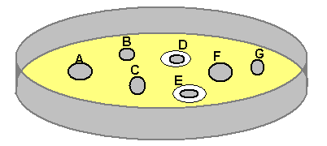

John labels the bacterial colonies A, B, C, D, E, F and G.

    - Identify the Lactobacillus colonies (2)
The Lactobacillus colonies are D and E.

    - Gives a reason for your answer. (1)
They can be identified as such due to the colourless agar around each of the two colonies.

    - Explain the chemical reaction that has taken place based on the information given to you above. (2)
The Lactobacillus are digesting the sugar in the agar and converting it into lactic acid. Acids react with calcium carbonate to produce a colourless solution.

    - When we leanrt about acids and bases, we learnt about different types of neutralisation reactions. What is a neutralisation reaction? (1)
When an acid and base react together.

    - What type of neutralisation reaction has taken place above to produce the colourless solution? Write out the chemical equation in words (5)
Acid and calcium carbonate --- water and salt and CO2

    - What is the colourless solution that has been produced by Lactobacillus likely to be? (1)
Water

  - Table A below shows the pH values in different parts of the digestive system.

Table A
Organ | pH Range
Mouth | 6.5 – 7.5
Stomach | 2
Small intestine | 7.5 – 8

A scientist tested 3 different enzymes to find out how they reacted in different pHs. Table B shows his data.

(Note: Rate of enzyme activity was measured in g/min, which is g of product that the enzyme makes per minute)

Table B
pH | Rate of enzyme activity (g/min)
pH | Enzyme A | Enzyme B | Enzyme C
1 | 100 | 0 | 0
2 | 250 | 0 | 0
3 | 80 | 0 | 0
4 | 10 | 10 | 0
5 | 0 | 60 | 0
6 | 0 | 180 | 60
7 | 0 | 260 | 180
8 | 0 | 20 | 260
9 | 0 | 0 | 20
10 | 0 | 0 | 0

The scientist knows that the three enzymes are:
- Salivary amylase – secreted by the salivary glands in the mouth.
- Pancreatic proteinase – secreted by the pancreas into the small intestine.
- Gastric proteinase – secreted by the stomach.

Unfortunately, the scientist cannot remember which set of data (Enzyme A, B and C) corresponds with which enzyme. Help him to solve his problem by doing the following:

    - Draw a graph showing the data in Table B. (20)

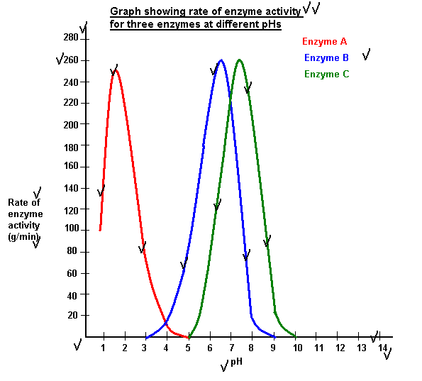

    - From the graph, work out which enzyme is which and label it clearly on your
graph. (3)
Enzyme A is gastric proteinase.
Enzyme B is salivary amylase.
Enzyme C is pancreatic proteinase.

    - We talk about the stomach having a ‘pH of 2’. What does the term ‘pH’ mean? (1) What are the pH ranges? (3)
pH is a measure of how acidic or basic something is.
Acids have a pH of 0-6.9.
Bases have a pH of 7.1-14.
Something that is neutral has a pH of 7.

    - If you mix a base with double the amount of acid, what will my resulting solution consist of? (3) Will it be acidic, basic or neutral? (1)?
Water, salt and acid
Acidic

    - How would you measure whether something is an acid, base or neutral? Provide only one way. (4)
Xxx

Question 2: Matter and material (24 marks)

  - Below are two graphs, one of an exothermic reaction and one of an endothermic reaction. Identify which is which and give a reason for each. (6)
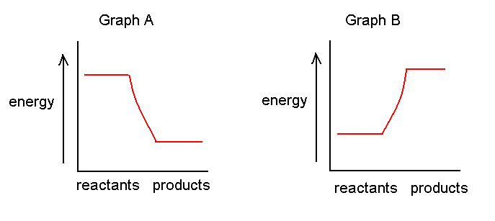
Graph A depicts the exothermic reaction, as the reactants have more energy than the products, therefore the reaction must has lost
energy. Graph B shows an increase in energy from reactants to products. Therefore energy was taken into the reaction – it is endothermic.

  - Use the following diagram to explain the difference between an element and a compound. (6)

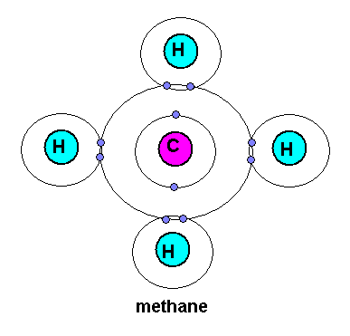
The diagram is of the compound methane. Methane is made of one carbon atom and four hydrogen atoms. Hydrogen is an element and carbon is an element. They consist of only one kind of atom. However, when atoms of two different elements combine, they form a compound.

  - Insert the words in the box on the side of the flow chart into the appropriate places. (7)

Gold
Compound
Matter
Element
Sodium chloride
Calcium carbonate
Oxygen

 |  | Can it be separated into simpler substances by chemical means?
 | Yes |  |  | No
E.g. |  |  |  | E.g.

  - Evaporation takes place at room temperature. How does this take place? Explain at a particle level (2)
Xxx

  - Will evaporation be faster or slower on a hot day relative to a cold day? Explain at particle level. (3)
Hot day. This is because the particles move faster so there will be more bumping off of particles at the surface.

Question 3: Mining and the environment (15 marks)

  - A mining company has started mining in a certain area without any permits. You are an environmental scientist hired to tell the mine what it needs to do in order to mine legally.

You note the following information:
- The mine is pumping waste water from the river nearby.
- The mine has dug a deep hole in the ground and is pumping its dirty water into the hole
- You notice a cycad at the mining site (Encephalartos hirsutus) which you know to be critically endangered.
- You measure the dust emissions coming from the mine’s dumps using a dust monitors and find the levels to be extremely high.
- You measure the particulate matter coming from the processing plant, and you find that the sulfur emissions are extremely high.

For each of the above, explain:
- The danger for the environment in what the mine is doing
- What you would advise the mine to do in order to be in line with the law (5*3=15)

- The mine is not allowed to take water from a natural water body or it may dry out or damage water life.
Need a license that tells you how much water you may take out
- Cannot just dump wastewater anywhere as it will result in soil and water pollution.
Make a lined stormwater dam to pump dirty water.
- The critically endangered species may become extint.
Relocate it
- Dust is a nuisance and it may also be damaging to health.
The mine needs to keep the dumps wet and/or to vegetate
- Sulfur is particulate matter. Damaging to health. Also reacts with oxygen to make sulfur dioxide = acid rain.
Sulfur scrubber

Question 4: Energy and change (44 marks)

  - We learnt about 7 different types of energy. What energy transfers take place in the following situations (10):

A plant photosynthesising: Radiant (light) to chemical
Nuclear power plant generating electricity: Nuclear to electrical
Coal-fired power plant generating electricity: Chemical to electrical
Light bulb burning: Electrical to heat
A radio blasting: Electrical to sound
Cricket making sounds by rubbing its legs together: mechanical to sound

  - The energy possessed by matter due to its motion is (1) .
A potential energy
B kinetic energy
C static energy
D none of the above

  - The energy of a moving object is (1)
A kinetic energy
B potential energy
C chemical energy
D nuclear energy

  - An example of the conversion of gravitational potential energy into kinetic energy is (1)
A a falling raindrop
B a gasoline powered engine
C striking a match
D a hockey puck sliding on ice

  - Write a paragraph explaining why switching to renewable energy sources will alleviate the problem of global warming. In your paragraph you will need to:
- Explain what the greenhouse effect it (2)
- Explain what the theory of global warming states (2)
- Explain how the use non-renewable energy sources contribute to the problem (2)
- Explain how renewable energy sources will alleviate the problem, and include at least one example of a renewable energy source. (2)

  - Is electrical energy potential or kinetic? Explain, giving examples. (4)
It may be either. All forms of energy may be potential or kinetic.
When it is not “in use”, it is potential electrical energy – it is stored, but it has the potential/ability to do work.
When it is “in use”, it is kinetic electrical energy. For example, when a lamp is switched on, electrical energy is transferred from a plug point to light and heat in the filament.

  - A man pushes a 5879 g box for 8 m across a smooth surface with a force of 120 N. How much work does he do on the crate? (Remember to show all units of measurement, all steps of your calculation and all conversions). (3)

W=FD
= 120N*8m
= 940J

  - The man now lifts the box onto a table that is 134 cm tall. (8)

5879g=5.879kg
134cm = 1.34m

F=mg
=5.879kg*9.8m/s2
=xxx N

W=FD
=xxxN*1.34m
=xxxJ

  - It took the man 20 seconds to push the box across the smooth surface and 5 seconds to lift the box onto the table. How much power did it take in total to complete both tasks? (6)

P=W/T

To move box across
P=940J/20s
=xxxW

To lift box
P=xxxJ/5s
=xxxW
Total P = xW+xW=xW

Total 130

