Natural Science November Exam

Mrs Magid
Beis Yaacov Girls High School / Mesivta Shaarei Torah
Gr 8

Name:______________________________

Instructions:
- Ensure that your handwriting is legible. If I cannot read your handwriting during the test, I will not award the marks after the test.
- Do not use shorthand in your answers. You will lose 1 mark for each.
- You need not answer in full sentences.
- Consider the mark allocation. For example, 3 marks require you to make 3 correct and relevant points.
- You may use a calculator.
- Do not write in red ink.

Question 1: Energy transfer in electrical systems (24 marks)

  - Study the figure below and answer the questions that follow:
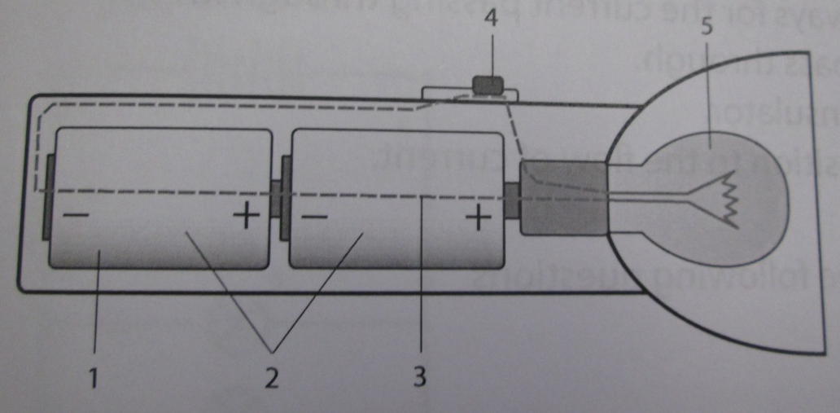

    - Identify the electrical appliances represented. (1) torch
    - Label the parts 1-5 on the diagram. (5) 1 cell, 2 battery, 3 conducting wire, 4 switch, 5 bulb
    - Describe the function each part numbered 2-5. (4) 2 to give energy to the circuit, 3 for electric current to pass through, 4 to control flow of electricity, 5 to convert electrical energy into light energy
    - How is 2 different from 1? (1) 1 is a cell. 2 is 2 cells which is called a battery
    - Which component can also be called a resistor? (1) the bulb
    - Draw a labelled circuit diagram for this circuit. (4)

  - Complete the table below by listing the 4 effects of electric current and describe each effect. (8)
Effects of electric current | Description of the effect of the electric current
Heat resistor | When electric charge flows through a resistor, electrical energy is converted into another form of energy to do something useful for us
Cause a short circuit | If there is nothing to limit or slow down the current, the conducting wires then heat up quickly, melt and cause a fire
Cause a magnetic field | When electric current passes through a wire, it causes a magnetic field.
Make an electromagnet | When an electric current is passed through metal it results in a magnetic field and we can create an electromagnet which can be very useful in everyday life e.g. electromagnetic crane.

Question 2: Series and parallel circuits (18 marks)

  - State whether the following statements are true of false. If false, provide a correct statement. (8)
- A series circuit provides two or more pathways for the current passing through it.
- Insulators do not allow electric current to pass through.
- Copper wire is an example of an excellent resistor.
- Resistance in a circuit is caused by an opposition to the flow of current.
- Our homes use a series circuit connection.

  - Consider the circuits below and answer the questions that follow:

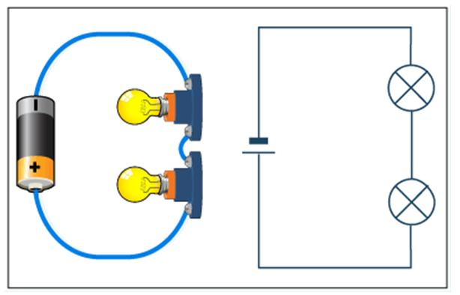  B  A | 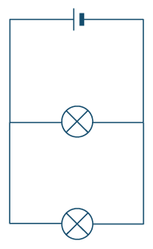  B  A
Circuit diagram A | Circuit diagram B

- Identify which diagram represents a series circuit. (1)

- Identify which diagram represents a parallel circuit. (1)

- How many bulbs and cells are there in each diagram? (2)

- Explain the difference between a series and a parallel circuit. (2)

- What will you observe if another bulb is added to diagram A? (1)

- What will you observe if another bulb is added to diagram B? (1)

- What will you observe if bulb A burnt out in diagram A? (1)

- What will you observe if bulb A burnt out in diagram B? (1)

Question 3: Visible light (24 marks)

  - White light consists of a range of difference frequencies and wavelengths.
- Give an example in nature that shows how white light can be separated into the difference frequencies and wavelengths. (1)
- Which colour has the shortest wavelength? (1)
- Which colour has the highest frequency? (1)

  - Provide one word/term for each of the following descriptions: (4)
- A surface that does not allow light to pass through, and only light to be reflected or absorbed.
- An object whose light enters our eyes directly.
- A surface that allows light to pass through it.
- Energy that comes from a source and travels through space.

  - Correct the following statements by changing one word. (2)
- An opaque object appears to be red because it illuminates red light and absorbed all the other colours.
- An object will appear white when it absorbs all colours and reflects no colours.

  - Name one difference and one similarity between light that is reflected from a white page and light that is reflected by a mirror. (2)

  - The sun is a luminous object. The moon is illuminated by the sun. Draw a ray diagram to show how the sun will illuminate the moon so that a person on Earth can see the moon. (4)

  - Explain the difference between absorption and reflection using a red flower as an example. (4)

  - Explain why most objects appear black on a dark night, especially when the moon is not visible. (2)

  - State the property of light that explains each of the following observations: (3)
- You are able to see yourself in a smooth, polished surface.
- Fish in an aquarium behind thick glass appear bigger than they actually are.
- Most of the ink on this paper appears black.

Question 4: Ecosystems, photosynthesis, feeding and adaptation (84 marks)

  - Circle the correct answer. (16)

- What is the original source of almost all the energy in most ecosystems?
A | Carbohydrates
B | Sunlight
C | Water
D | Carbon

- All of the members of a particular species that live in one area are called a(an)
A | Biome
B | Population
C | Community
D | Ecosystem

- Which of the following descriptions about the organization of an ecosystem is correct?
A | Communities make up species, which make up populations
B | Populations make up species, which make up communities
C | Species make up communities, which make up populations
D | Species make up populations, which make up communities

- One of the main characteristics of a population is its
A | Change over time
B | Geographic distribution
C | Dynamics
D | Habitat

- Which of the following explains why producers are always found at the beginning of a food chain?
A | Consumers are eaten by a variety of producers
B | Producers convert light energy into chemical energy
C | Producers are larger than consumers
D | Producers are found in fewer numbers than consumers.

- What is an ecological model of the relationships that form a network of complex interactions among organisms in a community from producers to decomposers?
A | Food web
B | Ecosystem
C | Food chain
D | Population

- What animal eats both producers and consumers?
A | Carnivore
B | Herbivore
C | Omnivore
D | Decomposer

- We learnt that when an animal eats or consumes a plant or another animal, energy is transferred. We also learnt that energy is lost from one trophic level to the other. The lost energy is…
A | Stored as fat
B | Used in life processes
C | Stored as body tissue
D | Used in reproduction

- We learnt about biotic and abiotic factors. Which is a biotic factor that affects the size of a population in a specific ecosystem?
A | The average temperature of the ecosystem
B | The type of soil in the ecosystem
C | The number and kinds of predators in the ecosystem
D | The concentration of oxygen in the ecosystem

- If elements are to be recycled in nature, which organisms must be present?
A | Decomposers
B | Predators
C | Scavengers
D | Parasites

- During a long period when there is no rainfall, a mountain lion may temporarily leave its usual hunting territory to drink from a farm pond. This behaviour is probably due to…
A | Its need to find different foods to eat
B | The change in an abiotic factor in its environment
C | Its need to find a new habitat
D | The change in a biotic factor in its environment.

- The symbiotic relationship between a flower and the insect that feeds on its nectar is an example of…
A | Mutualism
B | Parasitism
C | Commensalism
D | Predation
- A community in which barn owls and snakes consume only mice is being observed. If the number of snakes increases, which of the following is most likely to happen first?
A | The barn owl population will increase
B | The mouse population will decrease
C | The barn owl population will decrease
D | The mouse population will remain the same

- Which interaction best illustrates the concept of mutualism?
A | Aphids feeding on rose leaves
B | Oxpecker picking ticks off a giraffe
C | Infectious bacteria living on the blood of a host
D | Wolves and arctic foxes feeding on snowshoe rabbits

- One bird species that feeds on large seeds nests in the same tree as a bird that feeds on small seeds. How are the birds able to coexist? (1)
A | They occupy different ecosystems
B | They occupy different communities
C | They occupy different habitats
D | They occupy different positions within the same habitat

- Deer share the open plains with other grazing animals and predators. Which of the following would lead to a decrease in the deer population? (1)
A | A reduction in the predator population
B | An increase in the number of other grazing animals
C | A reduction in the grazing animal population
D | An increase in restrictions on the hunting of deer

  - The chemical formula for photosynthesis is:
Carbon Dioxide + Water + Light → Glucose + Oxygen

- Where does the carbon dioxide come from? _____________________ (1)

- Where does the water come from? ____________________________ (1)

- What is the glucose use for by the plant? _______________________ (1)

- What happens to the oxygen? ________________________________ (1)

  - Is a food chain or a food web a more accurate or realistic depiction of what really happens in nature? Explain. (2)

  - Study the following food web and answer the questions that follow. Assume that this is the entire ecosystem and there can be no outside influences. Also assume that the ecosystem is in balance.

 | Coyotes
 |  |  |  | Road runner
Rats |  | Insects
 |  |  |  | Lizards
 | Shrubs |  | Cacti
 |  | Bacteria

- What is the function of the bacteria in this food web? Explain. (2)
Bacteria are decomposers. They break down dead plants and animals and return it to the soils.

- If these organisms were arranged in a food pyramid, which organism would have the least amount of total energy available? (1)
Coyote

- Insects eat both shrubs and cacti. Would shrubs or cacti increase most if the insects were eliminated? (1)
Cacti

  - Study the following food web and answer the questions that follow. Assume that this is the entire ecosystem and there can be no outside influences. Also assume that the ecosystem is in balance.
Snapping turtle
Small fish | Large fish
Tadpoles
Algae

- What do you think would happen if the algae in the ecosystem all died off? Explain. (2)
Without producers there is no food for consumers so the ecosystem would collapse.

- What do you think would happen if the number of small fish in the ecosystem decreased? Explain. (2)
There would be less food for the large and the turtles so their populations would decrease.

- What do you think would happen if the large fish in the ecosystem died off? (2)
Small fish would have fewer predators. The turtle would eat more small fish. Ecosystem likely to stay in balance.

  - Study the food web below and answer the following questions. (8)

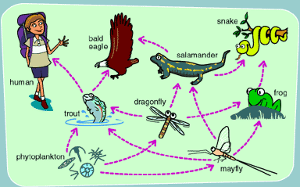

- What is eating the dragonfly? Name all.
- What does the bold eagle eat? Name all.
- Give one example of a primary consumer in the food web.
- Give one example of a secondary consumers in the food web.
- Give an example of a tertiary consumers in the food web.

  - Study the ecological pyramid below and answer the questions that follow:
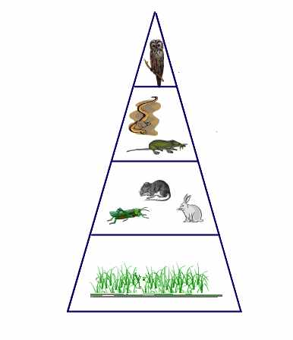
- What is each level or feeding position in the food pyramid called? (1)

- Is an ecological pyramid more similar to a food web or a food chain in terms of the way that it depicts relationships? Explain (2)

  - In the Kruger National Park, the elephant population is unstable. This is due to culling or removing of the elephants from the Kruger National Park to other ecosystems when their numbers get too large. Elephant culling was stopped in 1994.

- Consider the table below that tabulates the elephant population size in the Kruger National Park over certain years. Draw a bar graph on the graph paper provided. (20)

Year | Elephant population size
1925 | 100
1947 | 560
1960 | 1200
1967 | 6500
1985 | 8000
2004 | 11500
2010 | 13000

- Based on what we have learnt, why does the elephant population keep on rising rather than being maintained naturally? Explain. (2)
Elephants are at the top of the food chain. This means that they have no predators.

  - In a healthy ecosystem, all the components are in balance. Provide two ways that the ecosystem balance may be disrupted. Hint: think about human impacts as well as natural phenomena. (2)
Building over natural land, pollution, drought

  - There are two types of adaptations: physical and behavioural. Based on that, answer the following true/false questions. (10)

- From what we learnt and what you understand about adaptation, adapt means “to fit”.
A | True
B | False

- A behavioural adaptation allows animals to respond to life needs by acting in a certain way.
A | True
B | False

- Behavioural adaptations are the things animals do to survive.
A | True
B | False

- A behavioural adaptation can be learnt or instinctive.
A | True
B | False

- Anything that helps an organism survive in its environment is an adaptation.
A | True
B | False

- Cows have five stomachs to hold the grass longer to aid digestion of grass. This is an example of a physical adaptation.
A | True
B | False

- Plants have leaves that are thin, flat structures to absorb light. This is an example of a behavioural adaptation.
A | True
B | False

- Hedge-hogs make themselves into a ball when they sense danger. This is an example of a physical adaptation.
A | True
B | False

- Cats can sit really still when they are stalking a bird. This is an example of a physical adaptation.
A | True
B | False

- Camouflage is a behavioural adaptation.
A | True
B | False

  - There are three types of symbiotic relationships. Based on symbiosis, answer the following questions.

- A lichen is a combination of fungus and algae that lives on the sides of trees, rocks, and other materials. The fungus provides the algae with water and minerals and the algae uses the water and minerals to make food for both organisms. What type of relationship does the lichen represent? (1)
Mutualism

- Which of the following is NOT an example of a symbiotic relationship: a mother bear caring for her cub; a worm living in a cow’s intestine; or a bacterial infection (1)
A mother bear caring for her cub
- When a symbiotic relationship helps one organism while the other organism is unharmed is an example of… (1)
Commensalism

- In a parasitic relationship, the harmed species is called the… (1)
Host

- The following picture is an example of what kind of symbiotic relationship? (1)
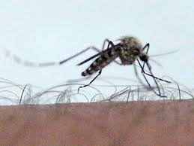
Parasitism

- Consider the following statement: members of a symbiotic relationship cannot live without each other. Do you agree with the statement? Motivate your answer. (2)
Not true

Total = 150 marks

