Physical Science June Exam June 2014

Mrs Magid
Beis Yaacov Girls High School
Gr 10

Name:______________________________

Answer ALL the questions. Ensure that your handwriting is legible. Do not write in red ink. Good luck!

Question 1: Matter and classification (34 marks)

  - Write down a word that describes each of the following statements: (6)
    - The common name for dihydrogen monoxide. Water
    - The ending of a compound’s name that is made up of three elements, one of which is oxygen. -ate
    - The name of the compound made from lithium and chlorine. Lithium chloride
    - The name of the compound made from lithium, chlorine and oxygen. Lithium chlorate
    - The larger number in the block of an element in the periodic table. Mass number
    - The element with 30 neutrons in its nucleus. Iron

  - Classify each of the following substances as an element, a compound, a homogeneous mixture, or a heterogeneous mixture: (6)
    - Iodated salt hom mix
    - Tap water hom mix
    - Soil hetero mix
    - Pure air hom mix
    - Carbon dioxide gas compound
    - Platinum element

  - Given the following descriptions, write the chemical formula for each of the following substances: (3)
    - Tin Sn
    - A compound that contains only potassium and bromine KBr
    - A gas that contains the elements carbon and oxygen in a ratio of 1:2 CO₂

  - Give the names of each of the following compounds: (4)
    - NaBr Sodium bromide
    - PCl₅ Phosphorus pentachloride
    - Al₂S₃ Aluminium sulfide
    - Ca(NO₃)₂ Calcium nitrate

  - Give the formula for each of the following compounds: (4)
    - Boron trichloride BCl3
    - Calcium sulfide CaS
    - Sulfur dioxide SO2
    - Sodium chloride NaCl

  - State whether the following statements are true or false: (3)
    - Ductile materials can be formed into long wires. True
    - Malleable materials are materials that break easily. False
    - Materials that conduct electricity are thermal conductors. False

  - Sugar is a compound or a molecule. The chemical formula of sugar is C₁₂H₂₂O_{11.}
    - What 3 elements make up sugar, and what is the atomic number of each? (3)

    - Provide a physical property of each of the elements that make up sugar. (3)

    - Provide 2 physical properties of sugar. (2)

Question 2: States of matter and the kinetic molecular theory (18 marks)

  - Why are gases more compressible than liquids or solids? (1)
Because they have much larger spaces between them

  - What is the boiling point of water? (1)
100C

  - Define the phrase boiling point. (2)
The boiling point of a liquid is the temperature at which a liquid changes into a gas by evaporation.

  - Kinetic molecular theory compares the movement of atoms and molecules in their different states. Complete the table to show what happens at a microscopic level in the different states. Be as brief as possible. (6)

 | Solid | Liquid | Gas
Arrangement of the particles | Fixed arrangement | No fixed arrangement | No fixed arrangement
Spaces between the particles | Very small | Small | Large
Movement of the particles | Vibrate in position | Slip and slide over each other | Move over large distances
Forces of attraction between the particles | Strong | Strong | None

  - Here are some examples of melting and boiling points of various substances.
    - Fill in the last column of the table, giving the state of the substance at 100°C. (5)

Substance | Melting point (°C) | Boiling point (°C) | State
Helium | -272 | -269 | Gas
Oxygen | -218 | -183 | Gas
Mercury | -39 | 257 | Liquid
Iron | 2080 | 3570 | Solid
Diamond (carbon) | 4100 | 5400 | Solid

    - Which of these elements has the strongest forces between its atoms? Explain fully. (3)
The diamond because it has the highest boiling point so it’s hardest to separate the atoms from their forces of attraction.

Question 3: The atom (36 marks)

  - Write down only the word/term for each of the following descriptions. (6)
- The sum of the number of protons and neutrons in an atom. Mass number
- The defined space around an atom’s nucleus, where an electron is most likely to be found. Orbital
- Atoms of the same element that differ in the number of neutrons. Isotopes
- The nucleus of an isotope. Nuclide
- Tiny distinct quantities of energy. Quanta
- Electrons in completely filled energy levels. Core electrons

  - State whether the following statements are true or false: (3)
- The atomic mass of any atom of a particular element is always the same. False
- It is safer to use helium gas rather than hydrogen gas in balloons. True
- Group 1 elements readily form negative ions. False

  - When group 1 atoms react with oxygen, they burn with brightly coloured flames. Different elements produce different coloured flames. Why are the colours specific to each element? Explain this based on what happens to the electrons. (3)
When an electron is heated, it gets ‘excited’ as it gains more energy. The electron in its excited state moves to a higher energy level. When the electron drops down to its normal energy level, it gives out the energy in the form of light.

  - How many protons, electrons and neutron are there in Uranium-234 and Uranium-238? (3)
Uranium-234 has (234-92=142) neutrons, 92 p, 92 e
Uranium-238 has (238-92=146) neutrons, 92 p, 92 e

  - Provide the electron configurations and Aufbau VERTICAL diagrams for the following elements: (3×5=15)
- Aluminium
1s²2s²2p⁶3s²3p¹

- Oxide ion
Gains 2 e, therefore 10e
1s²2s²2p⁶

- Calcium ion
Loses 2 e, therefore 18e
1s²2s²2p⁶3s²3p⁶

  - Based on your Aufbau diagrams, how many valence electrons are in each of the above? (3)
- Aluminium 3
- Oxygen ion 0
- Calcium ion 0

  - If a sample contains 69% of copper-63 and 31% of copper-65, calculate the relative atomic mass of an atom in that sample. (3)

Ar = 63*69% + 65*31%
= 43.47 + 20.15
= 63.62

Question 4: The periodic table (9 marks)

  - Given chlorine and fluorine, compare them with full logical explanations in terms of: (2×3=6)
- Atomic radius
- Ionisation energy
You may make use of the graphs in the APPENDIX.
Note: For your explanation, don’t simply say that it’s the trend across groups or periods. That is not good enough. I want a full explanation based on energy levels, distance of electrons from the nucleus etc.

Cl has a larger atomic radius than F. Cl has more electrons than F and is filling an extra energy level. This increases the atomic radius.
F has a higher first ionisation energy than Cl. The outermost electrons of Cl are further away from the nucleus and are not held as tightly. So it’s easier to remove the outermost electrons. OR the closer the electrons to the nucleus the higher the force of attraction and the harder it is to remove them.

  - Group 1 metals are very reactive. Explain why in detail. Make sure you use the word electrons and the phrase ionisation energy to motivate your answer. (2)
Only need to lose 1 electron from their outer shell. The ionisation energy of elements in this group very low.

  - Why are group 18 elements unreactive? (1)
They have a full p shell.

Question 5: Chemical bonding (20 marks)

  - Complete the following sentences: (6)
A covalent bond occurs between two none metals. The atoms share electrons. An ionic bond occurs between a metal and a non-metal. The atoms trade electrons. In a metallic bond, the metal atoms lose the strong attraction of their outer electrons because these electrons are equally attracted to other nearby metal atoms. This is known as the electron-sea model.

  - Draw the Lewis structure for each of the following:
- Calcium (1)
- Iodine (I₂) (2)
- hydrogen bromide (HBr) (2)

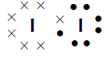
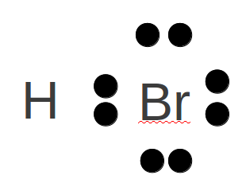
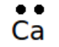

  - Given the following Lewis structure, where X and Y each represent a different element:
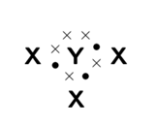
- What is the valency of X? 1 (1)
- What is the valency of Y? 3 (1)
- Which elements could X and Y represent? X-H Y-N (3)

  - Complete the table to show what compounds the following ions would make: (4)

 | $${\text{K}}^{+}$$
$${\text{OH}}^{-}$$ | KOH
$${\text{O}}^{2-}$$ | K2O
$${\text{NO}}_{3}^{-}$$ | KNO3
$${\text{PO}}_{4}^{3-}$$ | K3PO4

Question 6: Transverse and longitudinal pulses and waves (36 marks)

  - A pulse has a speed of 3 m/s. How far will it travel in 1 minute? (3)
D= VT = 3m/s*60s

  - A pulse covers a distance of 75 cm in 2.5 s. What is the speed of the pulse? (3)
V=D/T = 0.75m/2.5s

  - How long does it take a pulse to cover a distance of 200 mm if its speed is 4m/s? (3)
T=D/V = 0.2m/4m.s

  - A wave travels along a string at a speed of 1.5 m/s. If the frequency of the wave is 7.5 Hz, calculate:
- the wavelength of the wave (3)
λ=ν/ƒ
=1.5m/s / 7.5 Hz
=0.2m

- the period of the wave (3)
T=1/f
=1/7.5Hz

  - Consider the diagram below and answer the questions that follow:
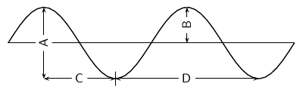

- The wavelength of the wave is shown by letter… (1) D
- The amplitude of the wave is shown by letter… (1) B

  - Study the following diagram and answer the questions:

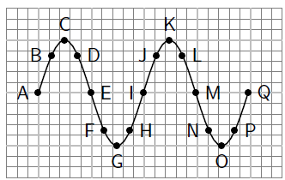

- Identify two sets of points that are in phase. (1)
- Identify two sets of points that are out of phase. (1)
- Identify any two points that would indicate a wavelength. (1)

  - Tom is fishing from a pier and notices that four wave crests pass by in 8 s and estimates the distance between two successive crests is 4 m. The timing starts with the first crest and ends with the fourth. Calculate the speed of the wave. (3)

The wavelength is 4 m, since this is the distance between successive crests. The period is 2 sec since four waves pass in 8 seconds.
Therefore the speed is:
$$\begin{aligned}v=\frac{λ}{T} \\ v=\frac{4}{2} \\ v=2\text{m}⋅{\text{s}}^{-1}\end{aligned}$$

  - Which of the following is not a longitudinal wave? (1)
a. light
b. sound
c. ultrasound

  - Which of the following media can a longitudinal wave like sound not travel through? (1)
a. solid
b. liquid
c. gas
d. vacuum

  - A longitudinal wave has a compression to compression distance of 10 m. It takes the wave 5 s to pass a point.
- What is the wavelength of the longitudinal wave? (1)
10m

- Calculate the speed of the wave. (3)
V=λ/T
=10m/5s
=2m/s

  - A flute produces a musical sound travelling at a speed of 320 m/s. The frequency of the note is 256 Hz. Calculate:
- The period of the note. (3)
T=1/f
=1/256s

- The wavelength of the note. (3)
λ=ν/ƒ
=320m/s / 256Hz
=1.25m

Total = 150 marks

The periodic table of elements
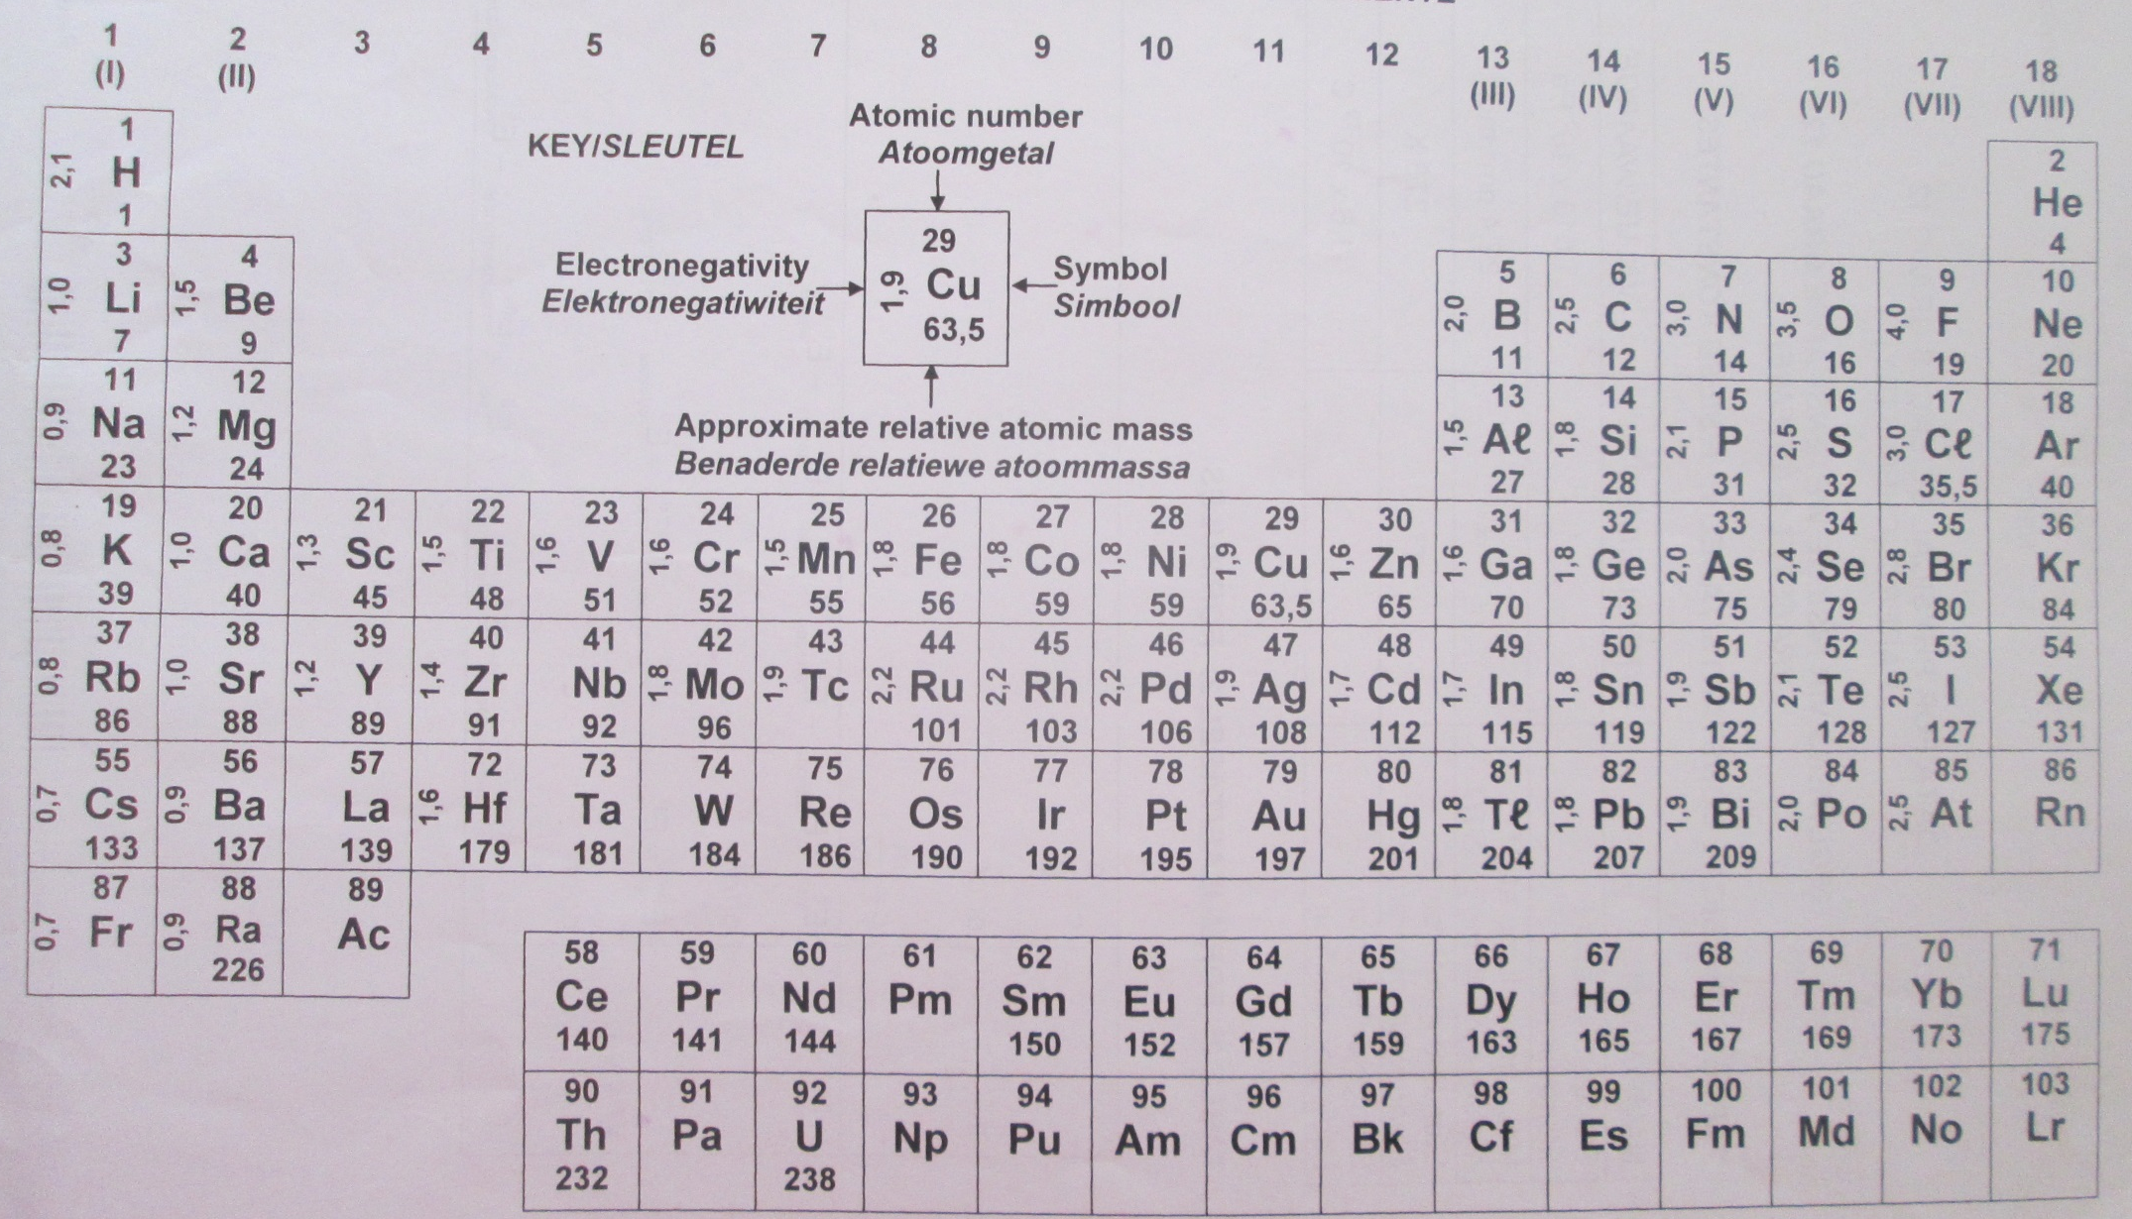

Appendix

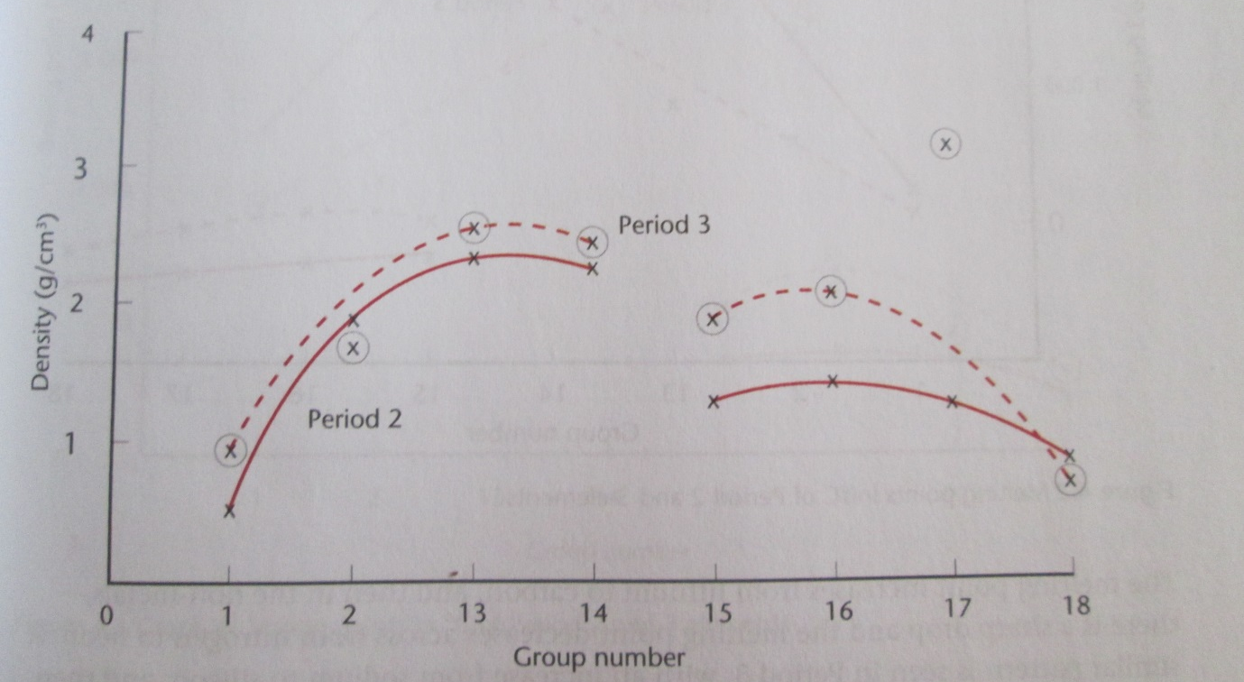
Density of the elements in periods 2 and 3

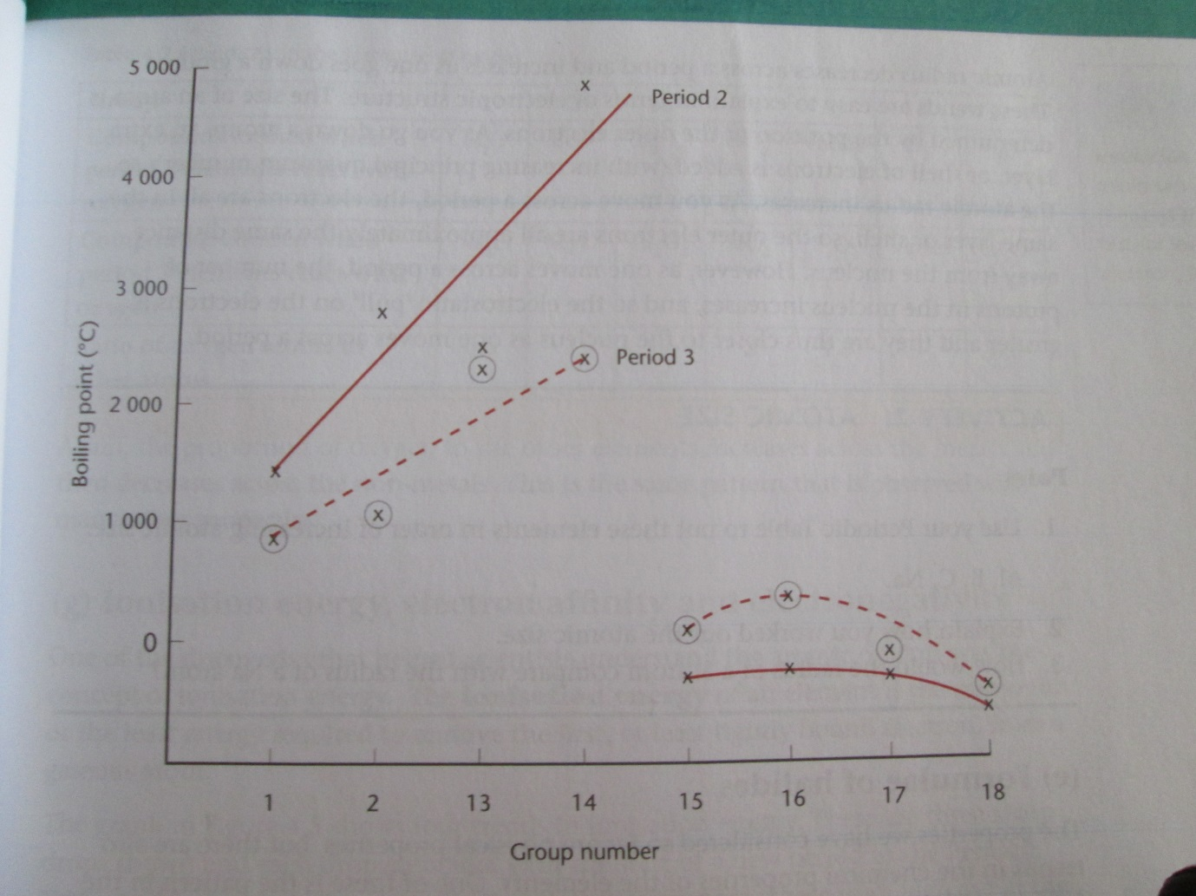
Boiling points of the elements in periods 2 and 3

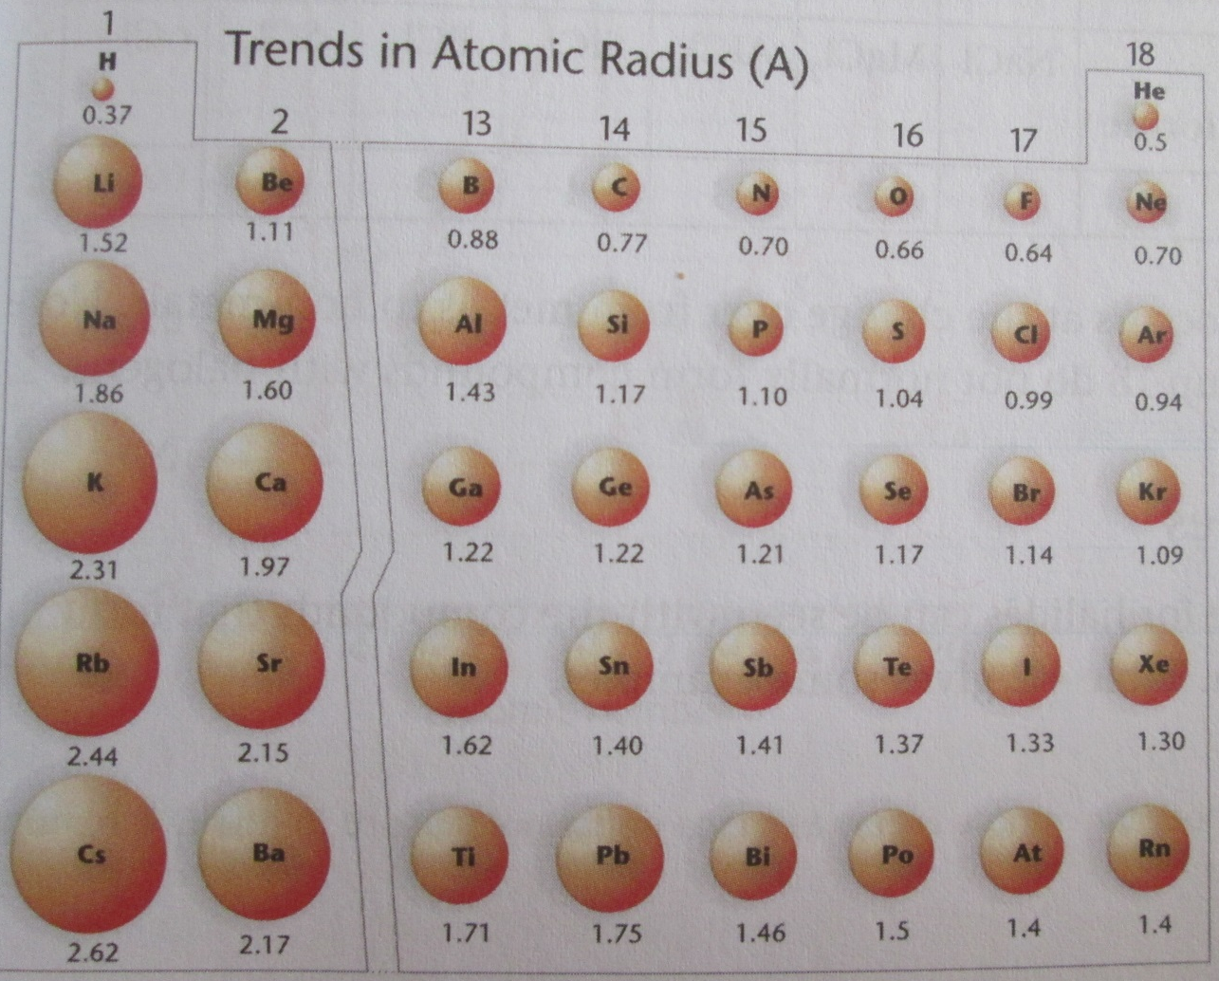
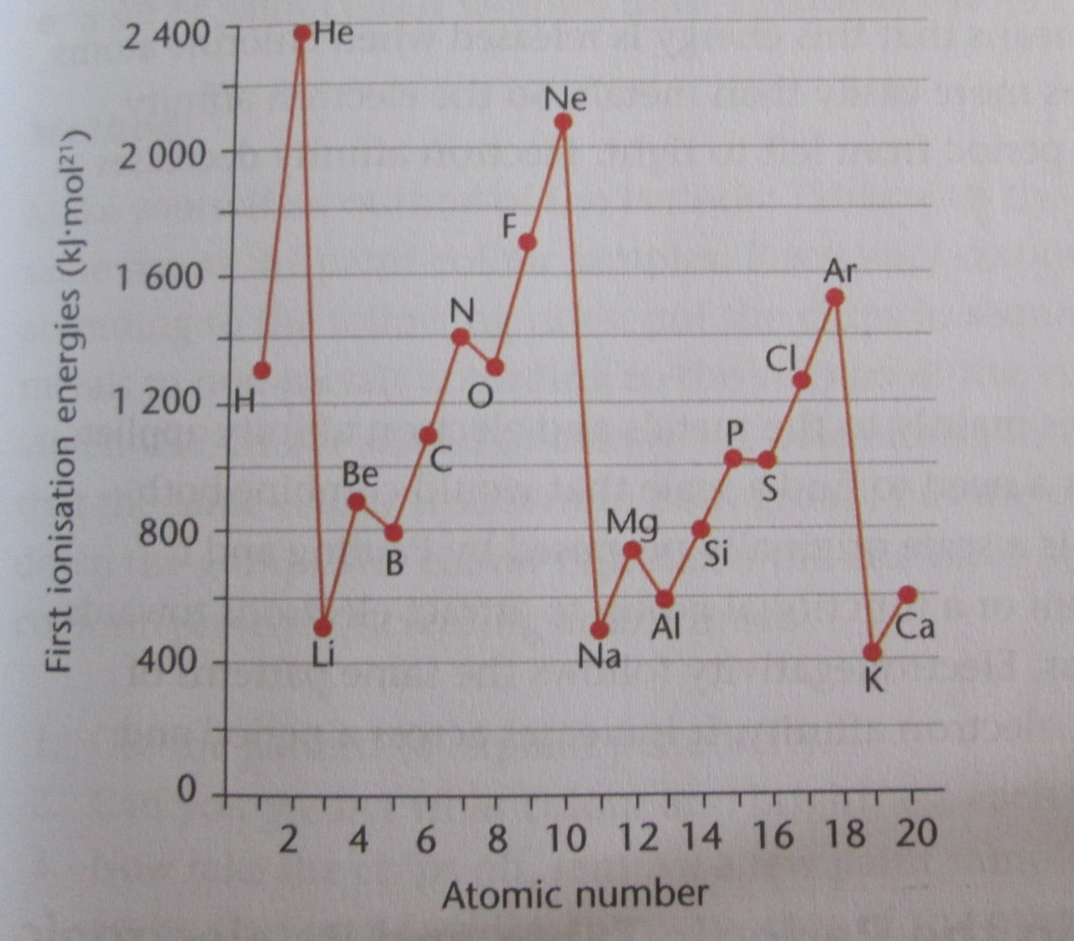
Graph of the first ionisation energies versus atomic number of elements 1-20

