Natural Sciences November Exam

Mrs Magid
Beis Yaacov Girls High School / Mesivta Shaarei Torah
Gr 8
GRAPH PAPER
Name:______________________________

Instructions:
- Please refer to the periodic table on page 12
- Ensure that your handwriting is legible.
- Do not use shorthand in your answers.
- You need not answer in full sentences.
- Consider the mark allocation. For example, 3 marks require you to make 3 correct and relevant points.
- You may use a calculator.
- Do not write in red ink.
GOOD LUCK!

Total: 130 marks
Time: 2h

Question 1: One word/term answers (5)

- Provide a one name or term for each of the following descriptions: (5×1=5)

  - Anything that has mass and takes up space. Matter
  - A chemical reaction that releases heat. Exothermic
  - Takes the shape of the container it is in. Liquid
  - The central region of the atom. Nucleus
  - Movement of particles from high concentration to low concentration. Diffusion

Question 2: Multiple choice (10)

- Circle the correct answer: (10×1=10)

  - An example of a mixture is…
- Distilled water
- Copper sulfate
- Air
- Hydrochloric acid

  - To separate a mixture by filtration…
- One of the substances should be liquid
- Both substances should be liquid
- One substance should be a liquid and the other a soluble solid
- One substance should be a liquid and the other a non-soluble solid

  - A small block of wood is placed in a measuring cylinder with water. The level of the water rose by 40cm³. The mass of the block is 21.6g. What is the density of the wood?
- 0.54 g/cm³
- 1.85 g/cm³
- 864 g/cm³
- 5.4 g/cm³

  - Mercury, water and petrol are poured into a cylinder. The order in which they will occur from top to bottom is:
- Mercury, water, petrol
- Petrol, mercury, petrol
- Water, petrol, mercury
- Petrol, water, mercury

  - The direction of the current in a circuit is always:
- From the negative pole to the positive pole of the cell
- From the positive pole to the negative pole of the cell
- In a clockwise direction
- Dependent on the position of the resistors in the circuit

  - When energy is added to a liquid without changing phase, the particles will:
- Move faster
- Be arranged in a more disorderly fashion
- Move away from their fixed position
- Vibrate faster and further apart in their position

  - The reason that helium rises is:
- Helium is lighter than air
- Helium is less dense than air
- Helium is lighter than the balloon
- Helium is less dense than the balloon

  - Which list below includes ONLY diatomic molecules?
- Fluorine, chlorine, iodine, nitrogen
- Iodine, helium, hydrogen, oxygen
- Calcium, oxygen, chlorine, nitrogen
- Oxygen, hydrogen, carbon, bromine

  - A rectangular pine block has measurements of 40cm×30cm×10cm. The density of the pine is 0.6g/cm³. The mass of the pine is:
- 720g
- 20000g
- 2000g
- 7200g

  - You charge two balloons. You put them near each other. What do you observe?
- The two balloons move away from each other
- The two balloons move towards each other
- The two balloons remain in their position
- One balloon moves towards the other balloon

Question 3: Match the columns (6)

- Choose an item from COLUMN B that best matches a description/item in COLUMN A. (6×1=6)

COLUMN A |  | COLUMN B
3.1 | Filament of a bulb | A | Wool
3.2 | Material that gives up electrons | B | Polystyrene
3.3 | The part of the circuit where energy is stored | C | Resistor
3.4 | A neutral object and a like charge | D | Transparent
3.5 | Material that gains electrons | E | Tungsten
3.6 | The part of the circuit where energy is converted | F | Attract
 |  | G | Cell
 |  | H | Conducting wires
 |  | I | Repel

  - E
  - A
  - G
  - F
  - B
  - C

Question 4: Atoms (23)

  - Consider the element cobalt (a metal) on your periodic table.

    - What group and period is cobalt in based on the periodic table? (2) Group 9 period 4
    - What is the chemical symbol of cobalt? (1) Co
    - What is the atomic number of cobalt? (1) 27
    - What does the atomic number represent? (1)The number of protons in an atom of cobalt
    - How many neutrons does cobalt have in its nucleus? (1)32
    - Cobalt reacts with oxygen to form cobalt oxide (a black powder). What type of chemical reaction is this? Explain. (2) Synthesis reaction. The atoms have combined.
    - What is/are the reactant/s in this chemical reaction? (1) Cobalt and oxygen
    - What is/are the product/s in this chemical reaction? (1) Cobalt oxide
    - Is cobalt oxide a mixture or a pure substance? Explain. (2) Pure substance. The cobalt and oxygen bonded make a single substance.
    - Can you separate cobalt oxide using physical means? Explain. (2) No. It is chemically bonded/need chemical reaction.

  - Consider diagrams A and B below and decide which is exothermic and which is endothermic. Explain. (4)

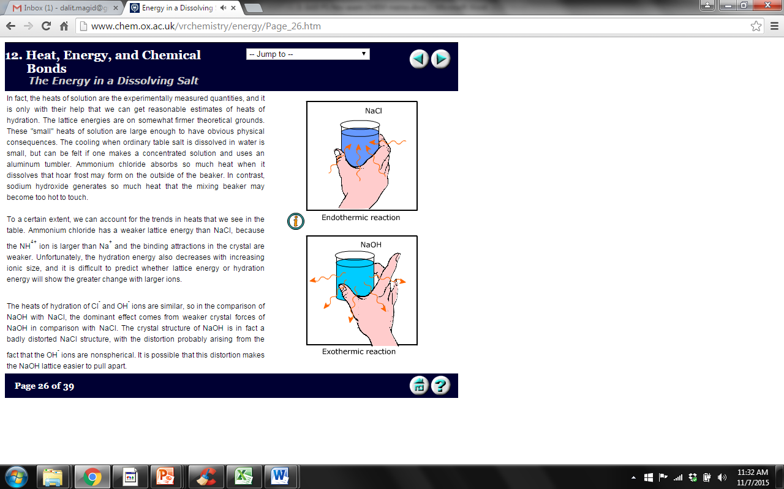
Diagram A Diagram B

Diagram A is endothermic because it uses energy from outside. Diagram B is exothermic because it releases energy

  - Consider diagrams below. It represents a separation method which has separated alcohol with a boiling point of 78°C and ether with a boiling point of 34°C.

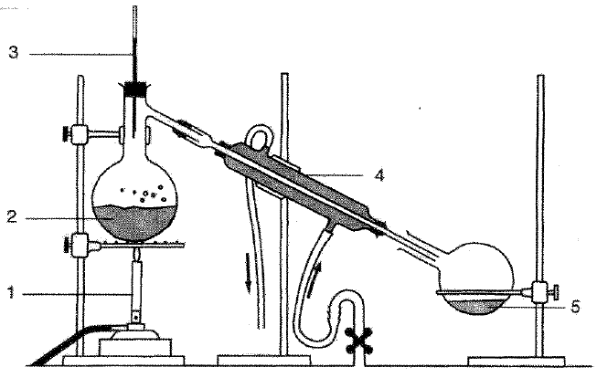

    - What method of separation does this represent? (1) Distillation
    - Which liquid is represented by 2? (1)Alcohol
    - Which liquid is represented by 5? (1)Ether
    - What is the function of the part labelled 3? Explain. (2) It measures the temperature. The temperature needs to be above 34°C but below 78°C for the ether to boil.

Question 5: The particle model of matter (33)

  - Complete the following sentenced by filling in the missing words/phrases: (11)
    - Gases can easily be compressed because large spaces exist between the gas particles.
    - Diffusion is the movement of particles from a high concentration to a low concentration.
    - When ice absorbs energy is changes to liquid and then to gas. These processes are known as melting and evaporation respectively.
    - Clouds are formed during a phase change where gas changes to liquid. This process is known as condensation.
    - As gas particles are added to an enclosed container, it results in an increase in pressure due to an increase in collisions against the wall.

  - In the spaces provided below, draw a diagram to show the arrangement of particles in a solid and a gas. Use small circles to represent the particles. (2)

Close together, orderly |  | Far apart, no order
Solid |  | Gas

  - In an experiment, a group of students want to observe the temperature change of water as they apply heat from a Bunsen burner. They measure the temperature every 30 seconds and record the data in the table below:

Time (seconds) | Temperature (°C)
0 | 20
30 | 27
60 | 36
90 | 50
120 | 64
150 | 72
180 | 85
210 | 100

    - Plot a line graph using the data in the table. Use the graph paper provided. (10)
Heading 2
Y axis label 1
X axis label 1
Y axis scale 1
X axis scale 1
3 points plotted correctly 3
Size and neatness 1

    - Use the graph to determine the temperature of the water after 45 seconds. Make lines on your graph to indicate how you came to your answer and write it here. Accept 30-34°C (2)

  - A student set up the apparatus shown below to measure the volume of object X. Study the diagrams below and answer the questions that follow.
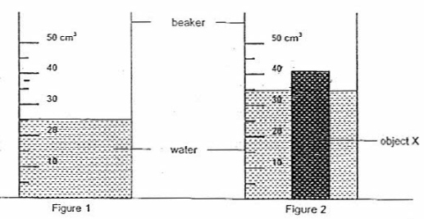
    - What is the volume of the water in figure 1? (1) 25cm³
    - When object X is placed in the beaker, it results in the arrangement that can be seen in figure 2. Write down the new reading in figure 2. (1) 35cm³
    - Calculate the volume of object X. Show all your calculations. (2)
Volume of object X = volume after – volume before = 35cm3-25cm3=10cm3

Note that there is a mistake in the section. 35ml-25ml=10ml only measures the volume of the submerged part. I accepted both answers.

  - You connect a metal wire to two clamps. You heat the wire. You find that, once heated, the wire sags.

    - Using the particle model of matter, explain what happens to the particles in the wire. (3)
Particles Gain energy
Particles move faster
Particles move further apart
Forces of attraction weaken

    - What happened to the wire? (1)
It expanded/increases in size

Question 6: Chemical reactions (21)

  - For the following, decide whether or not a chemical reaction has taken place. Say yes if it is chemical reaction, no if it’s not a chemical reaction: (6)
    - Inhaling oxygen No
    - Respiration Yes
    - Droplets of water forming on the outside of your cold glass No
    - Souring milk Yes
    - Rotting bananas Yes
    - Using a battery Yes

  - ONE zinc atom (Zn) reacts with TWO molecules of hydrochloric acid (HCl) to form ONE molecule of zinc chloride (ZnCl₂) and ONE hydrogen diatomic molecule (H₂).

    - Write out the chemical reaction using the symbols. (4)
Zn + 2 HCl → ZnCl₂ + H₂

    - Using different coloured pens (where a certain colour represents a certain element) draw out the chemical reaction. (6)

 | + |  | → |  | +

    - How many zinc atoms can you count on EACH side of the equation? (1) 1
    - How many hydrogen atoms can you count on EACH side of the equation? (1) 2
    - How many chlorine atoms can you count on EACH side of the equation? (1) 2

    - What conclusion can you draw from the answers to the three questions above? (2)
No elements are created or destroyed in a chemical reaction.

Question 7: Static electricity (8)

  - Which of the following are true of static charges? Choose all that apply by circling the letters.
- Like charges repel.
- Like charges attract.
- Opposite charges repel.
- Opposite charges attract.
- A positively charged object has lost electrons.
- A positively charged object has gained protons.
- A negatively charged object has lost protons.
- A negatively charged object has gained electrons.

  - A neutral plastic strip is rubbed with cotton and gets a positive charge. Which of the following statements are true of the positively-charged plastic strip?
- It lost some electrons to the cotton during the charging process.
- It lost all of its electrons to the cotton during the charging process.
- It has the opposite charge as the cotton.
- It would now be repelled by the piece of cotton which was used to charge it.
- It gained protons during the rubbing process.
- It could exert either a repulsive or attractive influence upon neutral paper bits.
- It would attract neutral paper bits.
- It would repel neutral paper bits.
- It has an excess of protons compared to the number of electrons.
- It lost negative electrons and gained positive electrons during the charging process.
- It lost neutrons during the charging process (or at the very least, its neutrons became ineffective).

Question 8: Energy transfer in electrical systems (24)

  - In an electric circuit, in where is the energy stored? (1)
In the cell
  - In what form is the energy stored? (1)
Chemical energy
  - What three things make up the simplest electric appliance? (3)
Power source, electric wires, resistor.
  - What is the difference between an open circuit and a closed circuit? (2)
In an open circuit, current cannot flow. In a closed circuit, current can flow.

  - Draw a circuit below that has an open switch, two cells, a resistor and a light bulb. Draw it in pencil and make it large and neat. (5)
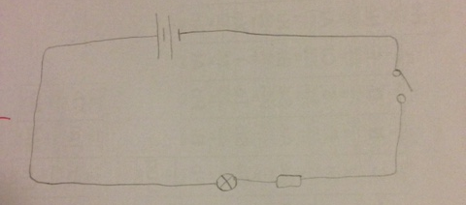

  - What is the difference between a wet cell and a dry cell? (2)
The chemicals inside dry cells are made of a paste or powder. The chemicals inside wet cells are made of a liquid.

  - Which one do we use more commonly today and why? (2)
Dry cell because it is safer.

  - What does electrical resistance measure? (2)
How much an object opposes or resists the flow of electric charge.

  - You are cooking food in your oven. What is the resistor in the oven and what energy transfer takes place in the resistor? (3)
Heating element. Electrical energy to heat energy.

  - You are sitting in front of the fan on a hot day. What is the resistor in the fan and what energy transfer takes place in the resistor? (3)
The fan that spins. Electrical energy to mechanical energy.

Total = 130 marks

