Physical Sciences November Exam Paper 2: Chemistry

Mrs Magid
Beis Yaacov Girls High School
Gr 10

Name:______________________________

Instructions:
- Please refer to the periodic table on page 13.
- Ensure that your handwriting is legible.
- Do not use shorthand in your answers.
- You need not answer in full sentences.
- Consider the mark allocation. For example, 3 marks require you to make 3 correct and relevant points.
- You may use a calculator.
- Do not write in red ink.
GOOD LUCK!

Total: 130 marks
Time: 2h

Question 1: One word/term answers (6)

- Provide a one name or term for each of the following descriptions: (6×1=6)

  - A substance that consists of two or more different atoms. Molecule/compound
  - The random motion of microscopic particles due to constant bombardment of the atoms/molecules surrounding them. Brownian motion
  - The collective name given to the particles of the nucleus of an atom. Nuclide
  - The name given to the elements in group 17 of the periodic table. Halogens
  - A bond that takes place by sharing electrons. Covalent
  - The average kinetic energy of a substance may be measured as… Heat/temperature

Question 2: Multiple choice (16)

- Circle the correct answer: (8×2=16)

  - When an atom X of an element in Group 1 reacts to become X⁺, the …
- Mass number of X increases
- Atomic number of X decreases
- Charge of the nucleus increases
- Number of filled energy levels decreases

  - The correct chemical formula for potassium permanganate is …
- KMnO₄
- KMnO₂
- CaMnO₄
- Ca(MnO₄)₂

  - The number of atoms in ONE formula-unit of copper(II)sulphate (CuSO₄) is …
- 6
- 4
- 16
- 12

  - In which ONE of the following compounds do BOTH ions have the same electron configuration as argon?
- Calcium sulfide
- Magnesium oxide
- Sodium sulfide
- Calcium bromide

  - Metallic bonding is…
- An electrostatic force of attraction between the positive atomic portion and the sea of delocalised electrons that surround them
- The transfer of electrons between two metals
- The sharing of electrons between two metals
- An electrostatic force of repulsion between the positive atomic portion and the seal of delocalised electrons that surround them

  - In an exothermic reaction, the following occurs:
- The reacting substances gain chemical energy
- The surrounding gain thermal energy
- The products of the reaction have more mass than the reactants
- The reacting substances lose chemical energy

  - An atom which is positively charged has
- Lost proton
- Lost electrons
- Gained protons
- Gained electrons

  - An atom of chlorine that has 18 electrons has…
- Become an anion
- Become a cation
- Become a neutral atom
- An equal number of protons

Question 3: Match the columns (7)

- Choose an item from COLUMN B that best matches a description/item in COLUMN A.

COLUMN A |  | COLUMN B
3.1 | Potassium chloride | A | Heterogeneous mixture
3.2 | A good conductor of electricity | B | Homogenous mixture
3.3 | A non-metal element | C | Silicon
3.4 | Sugar dissolved in water | D | Density
3.5 | Blood (looking under a microscope) | E | Sulfur
3.6 | Increasing conductivity with an increase in temperature | F | Compound
3.7 | Mass per volume | G | Cu

  - F
  - G
  - E
  - B
  - A
  - C
  - D

Question 4: Properties of material (10)

- A student collects the materials listed in the table below in order to investigate some of their physical properties. Three of the observations are shown as YES/NO in the table and the others are represented by letters (a)-(f).
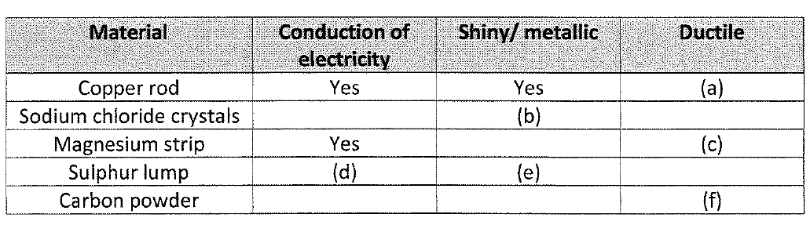
To investigate the conductivity of the materials, the learner connects the materials alternately in a closed circuit containing a battery and a light bulb. For this investigation, answer the following questions:

  - What is the independent variable? (1) Type of material
  - What is the dependent variable? (1) Conduction of electricity
  - Write down the observations represented by letters (a) to (f) as YES or NO. (6)
(a) YES
(b) NO
(c) YES
(d) NO
(e) NO
(f) NO

  - State another two physical properties of magnesium (other than the three properties included in the table). (2)
Malleable, solid at room temperature, reflect light, conduction of heat, not magnetic, strong, waterproof, high boiling point, high melting point, high density, metal.

Question 5: States of matter and the kinetic molecular theory (17)

  - Container A contains 1 litre of water. Container B contains 1 L of petrol. Both containers are left open at a temperature of 25°C. After 50 minutes, half of the liquid in container A has disappeared.

    - What happened to the liquid that “disappeared”? (1) It evaporated

    - How does the average kinetic energy of the molecules in container A compare with the average kinetic energy of the molecules in container B? (1) Higher
    - If left long enough, the liquid in both containers will disappear. Explain what would happen at a molecular level. (2)
Molecules inside the liquid bump off the surface molecules.
    - What can be done to prevent the liquid from disappearing? (1) Close the lid

  - When you take a block of butter out of the fridge, it is hard. However, after 15 minutes at room temperature it is soft enough to spread. Use the kinetic theory to explain the above observation. (3)

Due to the higher temperature outside:
Particles have higher average kinetic energy./Particles vibrate (move) faster. 
Forces of attraction (between molecules) become weaker. 
Regular pattern (structure) breaks down./Phase change starts to occur. 

  - The heating curve for a pure substance at atmospheric pressure is shown in the graph below.
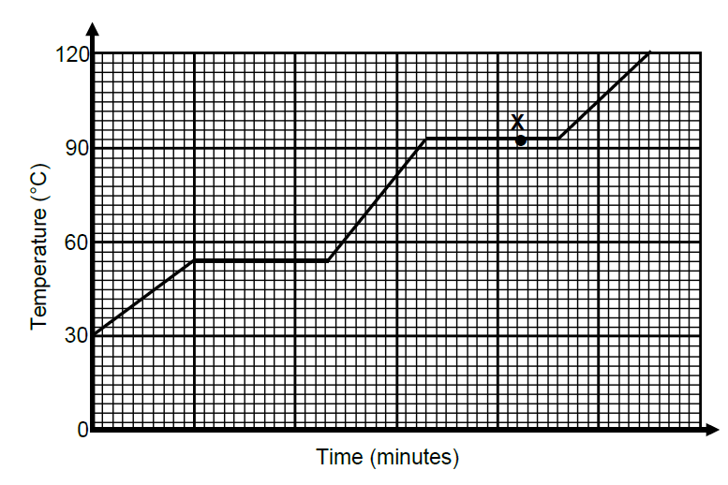

    - Write down the melting point of this pure substance. (1) 54°C
    - Write down the boiling point of this pure substance. (1) 93°C

    - Is this pure substance water? Give a reason for the answer. (2) No. The melting point is not 0°C / the boiling point is not 100°C
    - What is the physical state of the substance at point X. (1) Liquid and gas
    - What is the physical state of the substance at room temperature (around 21°C) (1) Solid
    - What happens to the temperature while the substance melts? Explain this observation. (3) Remains constant 1. Energy is used to break bonds during a phase change 1. This energy is not used to increase the kinetic energy of the particles 1.

Question 6: The atom (19)

  - Sodium reacts with chlorine to form sodium chloride, a substance used in all households.

    - Write down the household name of sodium chloride. (1) Salt
    - Write down the chemical formula of sodium chloride. (1) NaCl
    - For the chlorine atom, draw its Aufbau diagram. (3)

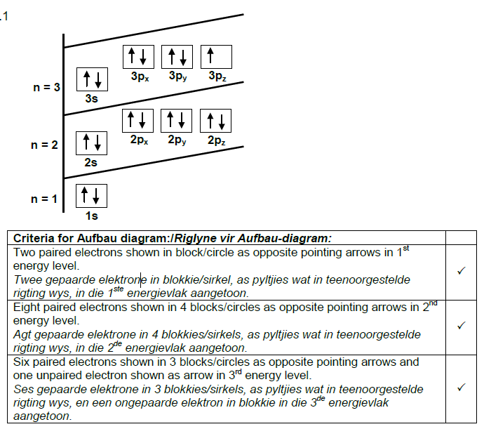

    - For the chlorine atom, write down its number of valence electrons. (1) 7
    - For the sodium atom, write down its sp notation (electron configuration). (1) 1s²2s²sp⁶ 3s¹
    - For the sodium atom, write down its number of protons. (1) 11
    - Represent the formation of sodium chloride from sodium and chlorine with the aid of Lewis diagrams. You need to show it in 3 steps. (6)
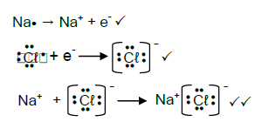

  - A chlorine atom can also bond to another chlorine atom to form a molecule.

    - What is a molecule? (2) 2 or more atoms bonded in a chemical reaction
    - What type of bond exists between two chlorine atoms? (1) Covalent
    - Represent the chlorine molecule with a Lewis diagram. (2)
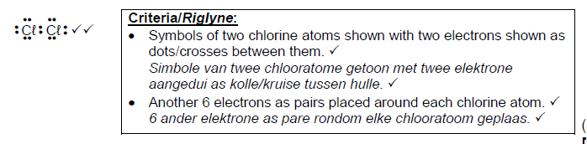

Question 7: The atom (17)

- Information of six elements, represented as P, Q, R, S, T and Y, are given in the table below.
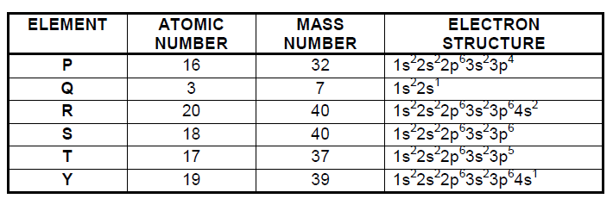
  - Which element, P, Q, R, S, T or Y:

    - Has 22 neutrons in each atom? (1) S
    - Is a noble gas? (1) S
    - Has two core electrons? (1) Q

  - Two of the above elements are in the same group of the periodic table. Write down:

    - The letters representing these TWO elements. (2) Q and Y
    - Their group number on the periodic table. (1) Group 1

  - Write down the formula of the compound formed by the combination of elements:

    - Q and P. (1) Q₂P or Li₂S
    - R and T. (1) RT₂ or CaCl₂
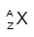
  - Identify element T and write down its notation. (3) ³⁷₁₇Cl

  - Another element, X, occurs in nature as two isotopes, X-23 and X-25. The drawing below represents a sample of this element.
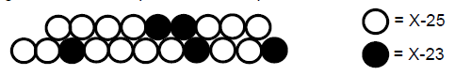

    - What is an isotope? (2)

Atoms of the same element/Atoms with the same atomic numbers 1, but different mass numbers/atomic mass (due to difference in number of neutrons) 1
 
    - Use the above information to calculate the relative atomic mass of element X. (4)
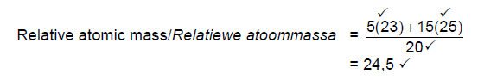

Question 8: The periodic table (8)

- Consider the graph below and answer the questions that follow:
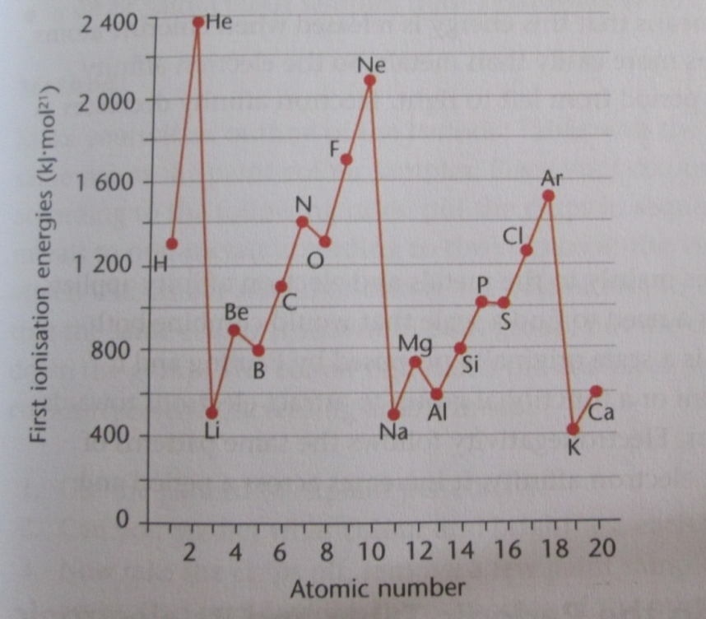

  - What is ionization energy? (2)
The minimum or the least energy required to remove the first or least tightly bound electron.

  - Based on the graph, what is the trend in ionization energy from left to right in a period on the periodic table? Explain. (3)
Increases 1. This is because as we move from left to right, on the periodic table, there are more protons 1. It is harder to remove electrons from a stronger electrostatic attraction 1.

  - Based on the graph, what is the trend in ionization energy from top to bottom in a group on the periodic table? Explain. (3)
Decreases 1. As we go down a group there is an extra energy level 1 which is further away from the nucleus 1 so the electrostatic force of attraction is weaker.

Question 9: Chemical reactions (35)

  - Ammonium nitrate is dissolved in distilled water.
    - Write down the formulae of the ions present in this solution. (2) NH₄⁺, NO₃⁻
    - Write down the chemical formula of ammonium nitrate. (1) NH₄NO₃
    - Draw a diagram of the dissolution process that takes place that takes place between ammonium nitrate and the water molecules. (4)

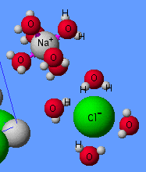
NO3-
NH4+

  - MgSO₄ solution and BaCℓ₂ solution are mixed and a white precipitate is observed.

    - Write down a balanced ionic equation for the reaction that takes place after mixing the two solutions. Show ALL phases of reactants and products. (4)
Ba²⁺ (aq) + 2Cl⁻ (aq) + Mg²⁺ (aq) + SO₄²⁻(aq) → BaSO₄ (s) + 2Cl⁻ (aq) + Mg²⁺ (aq)

    - Write down a balanced net ionic equation for the reaction that takes place after mixing the two solutions. Show ALL phases of reactants and products. (2)
Ba²⁺ (aq) + SO₄²⁻ (aq)→ BaSO₄ (s)

    - Write down a balanced molecular equation for the reaction that takes place after mixing the two solutions. Show ALL phases of reactants and products. (4)
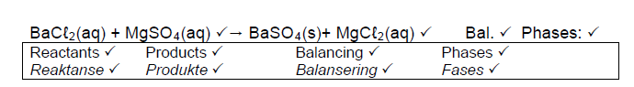

  - Hydrogen chloride (HCl) is a strong acid that can react with a strong base, sodium hydroxide (NaOH).

    - Write down a balanced ionic equation for the reaction that takes place after mixing the two solutions. Show ALL phases of reactants and products. (4)
H⁺ (aq) + Cl⁻ (aq) + Na⁺ (aq) + OH⁻ (aq) → Cl⁻ (aq) + Na⁺ (aq) +H₂O (l)
    - Write down a balanced net ionic equation for the reaction that takes place in the test tube after mixing the two solutions. Show ALL phases of reactants and products. (2)
H⁺ (aq) + OH⁻ (aq) → H₂O (l)

Write down a balanced molecular equation for the reaction that takes place in the test tube after mixing the two solutions. Show ALL phases of reactants and products. (4)
HCl (aq) + NaOH (aq) → NaCl (aq) +H₂O (l)

  - Dissolving an ionic molecule in water may be an exothermic or an endothermic process. Consider the diagrams below and complete the paragraph below. (8)
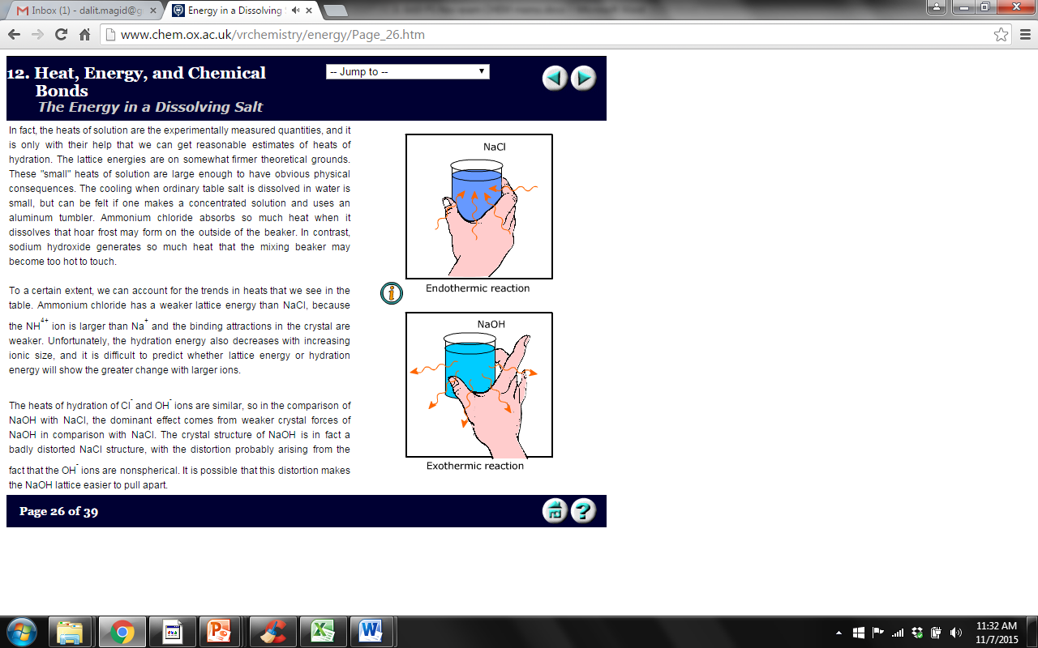

Energy is used to break the attraction between the molecules of the solute. Energy is released when water molecules attract to the solute molecules or ions. In the case of NaCl, it takes more energy to separate the particles of the NaCl than is released when the water molecules attract to the particles. Therefore the temperature in the cup will go down. In the case of NaOH, it takes less energy to separate the particles of the NaOH than is released when the water molecules attract to the particles. Therefore the temperature in the cup will go up.

Total = 130 marks

