Natural Science June Exam June 2014

Mrs Magid
Beis Yaacov Girls High School / Mesivta Shaarei Torah
Gr 8

Name:______________________________

Answer ALL the questions. Ensure that your handwriting is legible. Do not write in red ink. Good luck!

Question 1: Atoms (54 marks)

  - Complete the following sentences by filling in the missing words: (4)
    - Elements are pure substances because all the atoms of a specific element are ___________________.
    - Some elements such as oxygen exist in bonded pairs. These are called ___________________ molecules.
    - The atoms in a compound are always combined in a ___________________ ratio.
    - When we ___________________ different elements or compounds together, there is no chemical reaction.

  - Identify the following as an element, a compound or a mixture: (3)
    - Carbon dioxide ___________________
    - Air ___________________
    - Hydrogen gas ___________________

  - Use the periodic table to write down the SYMBOL AND NAME of the element that: (12)
    - Is in period 1, group 18 ___________________
    - Has 16 protons in the nucleus of one atom ___________________
    - Is in group 1 and the 2nd period ___________________
    - Has 8 electrons in the orbitals of one atom ___________________
    - Has 28 subatomic particles in the nucleus of an atom ___________________
    - Has 7 neutrons in nucleus the nucleus of one atom ___________________
  - The boiling point of water is 100°C. If a sample of water boils at 102°C, what do you know about the sample? Give a reason for your answer. (2)

____________________________________________________________

____________________________________________________________

  - Draw a labelled mercury (Hg) atom indicating all the things that an atom is made up of, including the charges of the different components. Remember all the rules of scientific diagrams! (10)

  - For the following, decide whether each is a mixture or a pure substance. If it is a mixture, say if it’s homogeneous or heterogeneous: (9)

    - Mud _____________________________________
    - A cup of coffee _____________________________________
    - Non-iodated table salt _____________________________________
    - Oxygen _____________________________________
    - Sponge cake batter _____________________________________
    - Iron _____________________________________
  - Insert the words in the box on the side of the flow chart into the appropriate places. (10)

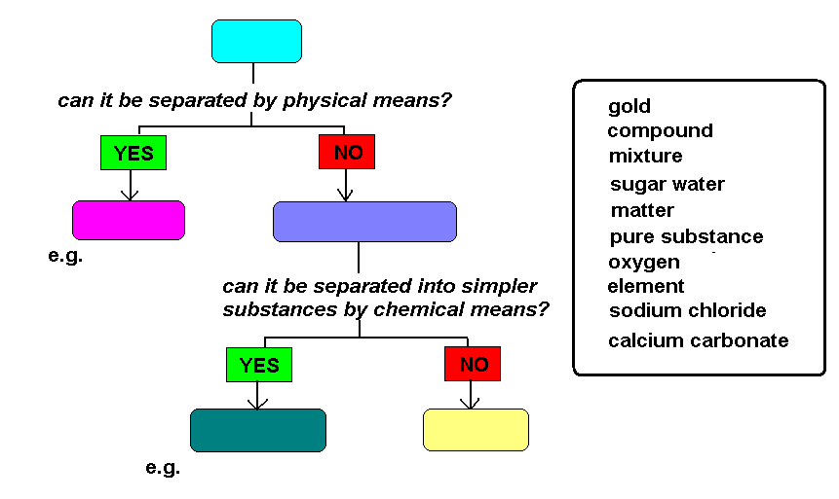
A

D
B
C

e.g. H
G
F
E

A: __________________________________________________________
B: ________________________________________________________
C: (one examples)_______________________________________________
D: ________________________________________________________
E: ________________________________________________________
F: (two examples)_______________________________________________
G: ________________________________________________________
H: (two examples)______________________________________________

  - In the graphs below, which one represents and endothermic reaction and which one represents an exothermic reaction? Explain. (4)
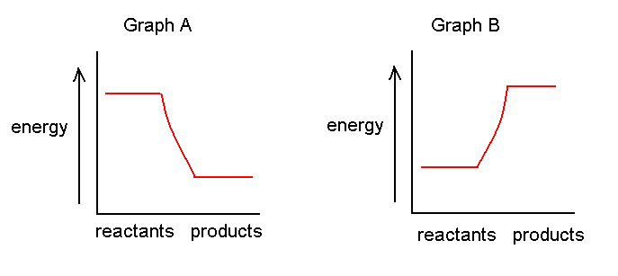
____________________________________________________________

____________________________________________________________

____________________________________________________________

____________________________________________________________

Question 2: The particle model of matter (30 marks)

  - Railway lines are made of steel, which expands and contracts as the temperature changes. Use the particle model of matter to explain what happens to the railway tracks when the temperature increased and decreases. (6)

When the temperature increases, __________________________________

____________________________________________________________

____________________________________________________________

When the temperature decreases, __________________________________

____________________________________________________________

____________________________________________________________

  - You burn toast in the kitchen. A minute later your mom calls out from the bedroom – “what is burning?” Use the particle model of matter to explain how your mom knew that something was burning even though she did not see or hear it. (2)

____________________________________________________________

____________________________________________________________

____________________________________________________________

____________________________________________________________

  - You heat up water to boiling point in a pot. Describe what happens to the water in a paragraph. You must use the following words: energy, particles, move/moving, state, gas. (5)

____________________________________________________________

____________________________________________________________

____________________________________________________________

____________________________________________________________

  - Which two factors affect density? (2)

____________________________________________________________

  - Why does a balloon filled with helium rise? (1)

____________________________________________________________

  - See the diagram below and answer the questions that follow. The values represented below are in ml.

Cylinder A Cylinder B Cylinder C
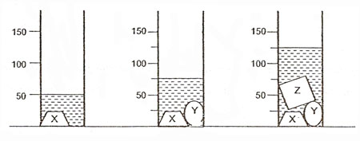
    - What is the volume of object Y? Show your calculation. Provide the answer in cm^{3.} (4)

    - What is the volume of object Z? Show your calculation. Provide the answer in cm^{3.} (4)

    - Assume that the mass of object Y is 0.5 kg. Calculate the density of object Y. (3)

    - Assume that the density of object Z is 12g/cm³. Calculate the mass of object Z. (3)

Question 3: Chemical reactions (25 marks)

  - For the following, decide whether or not a chemical reaction has taken place. Say yes if it is chemical reaction, no if it’s not a chemical reaction: (6)

    - Ice cream melting ______
    - Burning wood ______
    - Liquid water freezing to ice ______
    - A nail rusting ______
    - Photosynthesis ______
    - Water evaporates from your glass ______

  - For the following, provide TWO indications that a chemical reaction is taking place: (10)

    - A candle flame burning __________________________________________
    - Lighting a match _______________________________________________
    - Cooking an egg ________________________________________________
    - Baking a cake _________________________________________________
    - Brewing beer _________________________________________________

  - ONE hydrochloric acid (HCl) reacts with ONE potassium hydroxide (KOH) to form ONE potassium chloride (KCl) and ONE water (H₂O).

    - Write out the chemical reaction using the symbols. (3)

____________________________________________________________

    - Using different coloured pens (where a certain colour represents a certain element) draw out the chemical reaction. (6)

Question 4: Static electricity (21 marks)

  - Complete the following sentences by filling in the missing words: (8)

    - One element ______________ be changed into another element by a chemical reaction.
    - The nucleus of an atom is made up of ______________ charged particles called protons and electrically ______________ particles called neutrons.
    - Atoms are ______________ because the number of electrons is equal to the number of protons.
    - ______________ charges repel each other.
    - ______________ charges attract each other.
    - The build-up of electrons in an object is called ______________.
    - ______________ is a form of natural static electric discharge.

  - How does friction cause static electricity? (2)

____________________________________________________________

____________________________________________________________

____________________________________________________________

____________________________________________________________

  - What causes an electric spark? (2)

____________________________________________________________

____________________________________________________________

____________________________________________________________

  - Why does a rubbed balloon stick to the wall? (3)

____________________________________________________________

____________________________________________________________

____________________________________________________________

____________________________________________________________

  - Draw a diagram indicating the charges in the balloon and in the wall to support your answer to the previous question. (3)

  - Why is it not safe to stand next to a tree during an electric storm? (1)

____________________________________________________________

  - Why is it not safe to speak on a land line phone during an electric storm? (1)

____________________________________________________________

  - Why is it not safe to have a bath during an electric storm? (1)

____________________________________________________________

Total = 130 marks

