Physical Science November Exam Paper 2: Physics
Mrs Magid
Beis Yaacov Girls High School
Gr 10

Name:______________________________

Instructions:
- Ensure that your handwriting is legible.
- Do not use shorthand in your answers.
- You need not answer in full sentences.
- Consider the mark allocation. For example, 3 marks require you to make 3 correct and relevant points.
- You may use a calculator.
- Do not write in red ink.

  - Circle the correct answer. (16)

- Which one of the following has both magnitude and direction?
- Mass.
- Distance.
- Acceleration.
- Speed.

- Which one of the following position vs. time graphs represents the motion of an object at a constant velocity?
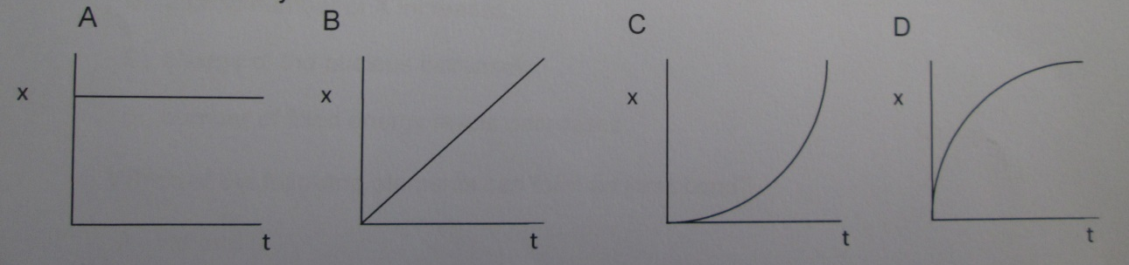

- Two pulses with amplitudes x and y move towards each other until they need at point Q.
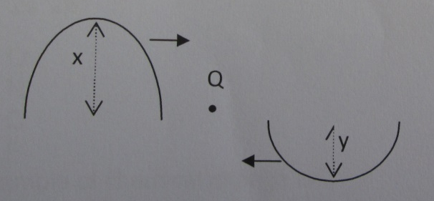

Which one of the following gives the correct amplitude of the resultant pulse?
- x+y.
- 2y.
- x-y.
- xy.

- The energy of an electromagnetic wave is E. What will the new energy be if the frequency of the electromagnetic wave is doubled?
- E/2.
- 2E.
- E.
- E/λ

- Which of the following is the correct arrangement of electromagnetic waves in order of increasing wavelength?
- Visible light, radio waves, gamma rays.
- Gamma rays, visible light, radio waves.
- Visible light, gamma rays, radio waves.
- Gamma rays, radio waves, visible light.

- Consider the following statements regarding waves:
- The velocity at which a wave travels along a spring is directly proportional to the tension of the spring.
- The velocity at which a wave travels along a spring decreases as the mass of the spring increases.

Which of the above statement/s is/are correct, if any?
- (i) and (ii).
- (i) only.
- (ii) only.
- Neither

- Consider the diagram of a wave with a frequency of 5 Hz.
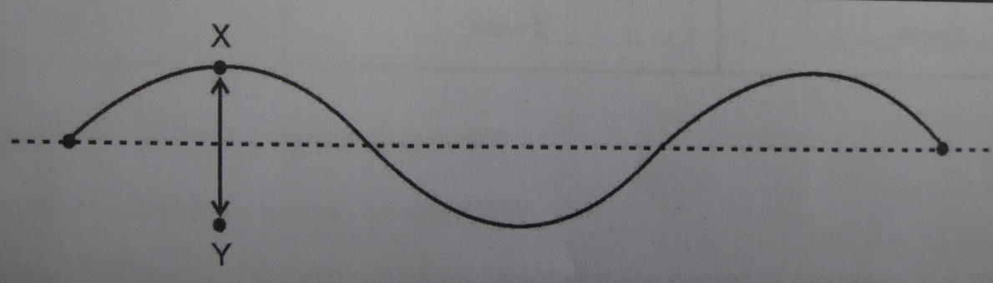

The distance XY can be described as:
- The wavelength.
- The amplitude.
- The period.
- Twice the amplitude.

- The distance between two consecutive crests in a wave is 8 cm. If two complete waves pass a point in 1 s, then the velocity of the wave is:
- 16 cm/s.
- 8 cm/s.
- 4 cm/s.
- 1.25 cm/s.

- Joseph is leaning on the railing of a tall building. His cell phone drops out of his hands and to the ground. Which of the following combinations of velocity and acceleration for the motion of the cell phone is correct?
- Velocity increases, acceleration increases.
- Velocity decreases, acceleration increases.
- Velocity increases, acceleration remains constant.
- Velocity remains constant, acceleration remains constant.

- A truck is travelling at a constant velocity along a straight road. As it travels up a steep hill it slows down uniformly. Which one of the following velocity vs. time graphs best represents the motion of the truck?
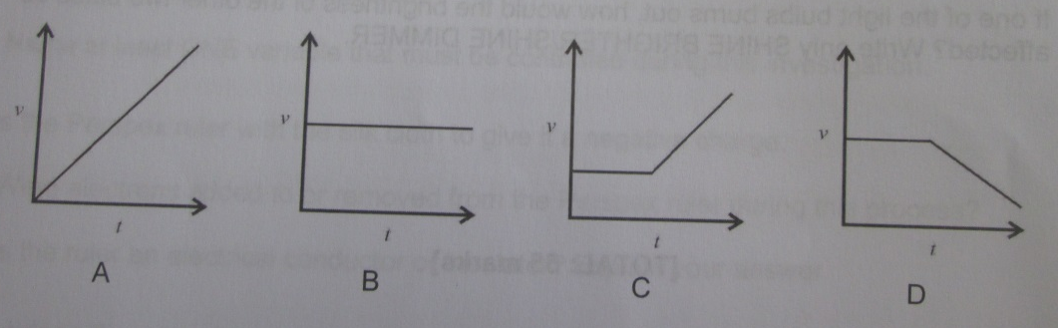

- Which one of the following statements is true of a body that is accelerating at a constant rate?
- The rate of the change of velocity with time remains constant.
- The velocity of the body increases by increasing amounts in equal time intervals.
- The position changes by the same amount in equal time intervals.
- The rate of change of position with time remains constant.

- The equation Δx = ½aΔt² + v_{i}Δt represents the…
- Displacement.
- Time.
- Velocity.
- Acceleration.

- The gravitational potential energy of an object is dependent on the object’s…
- Speed.
- Position.
- Velocity.
- Change in velocity.

- Which one of the following statements about electromagnetic waves is correct? In a vacuum, all electromagnetic waves have the same…
- Amplitude.
- Frequency.
- Wavelength.
- Speed.

- A tuning fork is made to vibrate by striking it gently. The sound waves produced are…
- Transverse waves and require a medium for propagation.
- Transverse waves and do not require a medium for propagation.
- Longitudinal waves and require a medium for propagation.
- Longitudinal waves and do not require a medium for propagation.

- Which of the following statements is correct? All waves are…
- Transverse.
- Longitudinal.
- Transmit energy.
- Travel though vacuum.

  - Provide a word/term for each of the following descriptions: (7)
- A single disturbance that moves along or through a medium. Pulse
- The rate of change in the distance that an object travels. Speed
- The place on a wave where the particle displacement has the maximum positive value. Crest
- The phenomenon that occurs when superposition results in greater displacement of the particles in the medium. Constructive interference
- Sound caused by irregular vibrations. Noise
- A wave in which the particles of a medium move at right angle in the direction of the wave motion. Transverse wave
- The speed and direction of an object at a given instant. Instantaneous velocity

  - Consider the diagram of four waves travelling in the same medium.
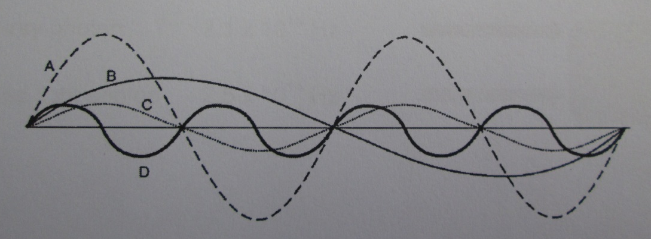

- Which one of these waves will have the highest frequency? (1) D
- Which two waves have the same wavelength? (1) A and C
- The wavelength of B is 1 m. Determine the wavelength of A. (2) 0.5 m
- If C has a frequency of 5 Hz, what is the frequency of D? (2) 10 Hz
- Use the information that the wavelength of B is 1 m to calculate the speed of D. (4) v=λf = 0.25m*10Hz = 2.5m/s

  - In the sketch below (not drawn to scale) Q represents an object on the surface of the water in a dam. A person standing on a bridge observes object Q moving up and down. Object Q rises to the top every 5 s.
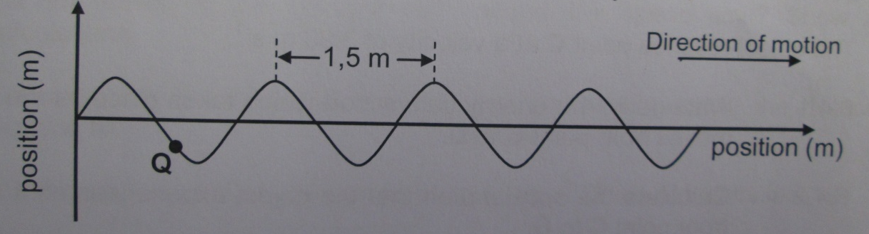

- Calculate the speed of the wave? (3) v=λ/t = 1.5m/5s=0.3m/s
- Calculate the frequency of the wave? (3) f=v/λ = 0.3m/s / 1.5 m = 0.2 Hz OR f= 1/t = 1/5s = 0.2 Hz

  - Some electromagnetic waves are listed below.
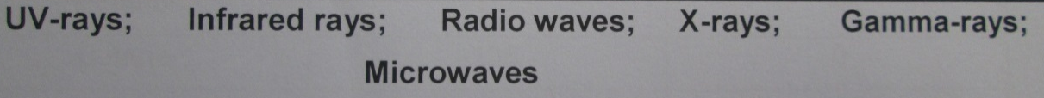

From the list above, write down the name of the wave…
- With the highest frequency in the electromagnetic spectrum. (1) Gamma
- Used to detect objects in the absence of visible light. (1) Infrared
- Used to transfer energy to water molecules to warm food. (1) Micro
- That have the lowest energy. (1) Radio

  - An x-ray photon of frequency 2.1×10¹⁸ Hz and a photon of red light of frequency 2.5×10¹⁴ Hz fall on a body as shown below.

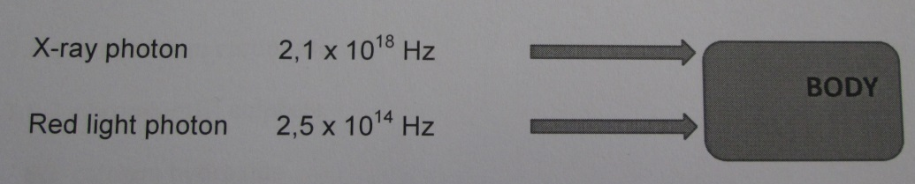

By means of calculation, show which of the photons will have the higher penetrating ability. (7)

E=hf
Xray
E=6.6*10⁻³⁴Js * 2.1*10¹⁸Hz
=1.39*10⁻¹⁵J

Red
E=6.6*10⁻³⁴Js * 2.5*10¹⁴Hz
=1.65*10⁻¹⁹J

X ray has higher pen ability

  - A ship stationary on the surface of the water is using a sonar device to track a shoal of fish. The sonar device emits waves of frequency 25 kHz. The speed of sound in water can be taken to be 1484 m/s.

- Calculate the wavelength if the waves produced by the sonar device. (4) λ=v/f = 1484m/s/25000Hz = 0.06m
- Can the sound produced by this sonar device be heard by the human ear? Give a reason for your answer. (2) no, humans only hear sound freq between 20 and 20 000 Hz

  - The houses of three learners are shown in the sketch below:

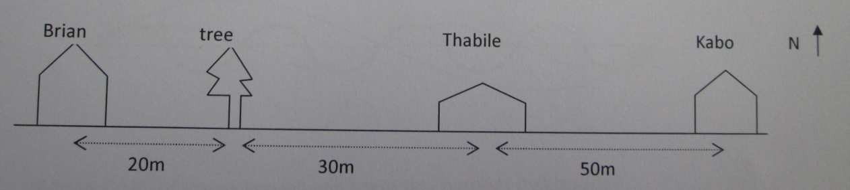

- Define the term displacement (2) The change in position from starting point to ending point, in a straight line.

- Write down the displacement of Brian’s house relative to Thabile’s house. (1) 50 m W
- Write down the displacement of Kabo’s house relative to the tree. (1) 80 m E

  - A school bus is travelling at 20 m/s on a straight road in an easterly direction. The driver suddenly sees a speed trap ahead. The speed limit on that part of the road is 60 km/h. He immediately applies brakes for 4 s to reduce the speed to 12 m/s.

- Convert 60 km/h to m/s. (1) 16.67m/s

- Define acceleration. (2) The rate at which velocity changes.

- Calculate the acceleration of the bus during the 4 s. (4) a = delta v / t or vf = vi + a delta t. Answer is -2m/s2 which is 2m/s2 slowing down / negative acceleration

- If the speed trap is 80 m ahead. Determine by calculation whether he will avoid a traffic fine or not, assuming a constant acceleration (you need not follow the 5 steps). (5)
vf2 = vi2 + 2a delta x
Delta x = vf2-vi2
2a
(12m/s)2 – (20m/s)2 / 2(-2m/s2)
= -256 m/s / 4m /s2
=64 m
Or
Delta x = vi delta t + ½ adelta t 2

  - Consider the position vs. time graph below.

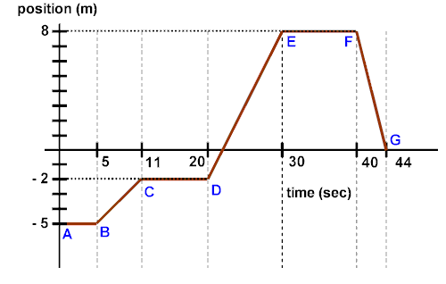

- What does the gradient of the position vs. time graph represent? (1)
Velocity

- Describe the motion of the object as represented by the position vs. time graph. (3)
The object starts at a position of 5 m in the negative direction for 5s.
The object then moves at a constant velocity from 11s-22s in the positive direction.
The object then stays at a position of 2 m in the negative direction for 9s.
The object then moves at a constant velocity in the positive direction from 20s-30s. At 22s the object crosses the origin.
From 30-40s the object stays in one position at 8m away from origin in the positive direction.
From 40-44s the object moves in the negative direction at a constant velocity.

- Based on the position vs. time graph, construct a velocity vs. time graph in the empty graph below. Remember to insert x and y axis labels. (8)

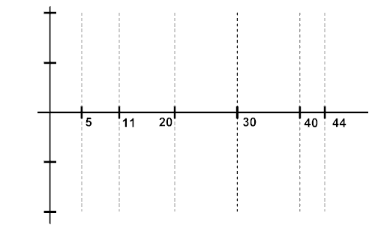

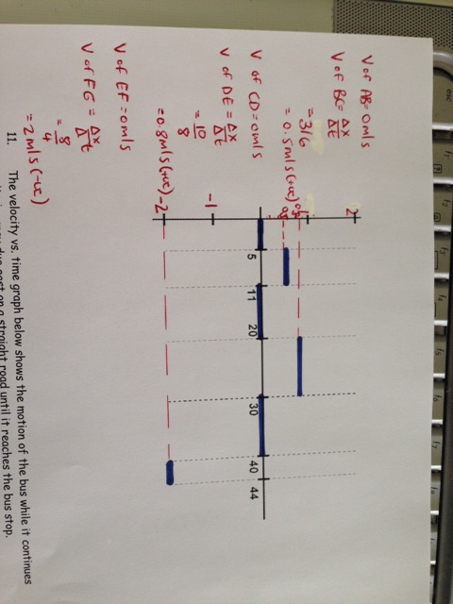

  - The velocity vs. time graph below shows the motion of the bus while it continues on its journey due east on a straight road until it reaches the bus stop.

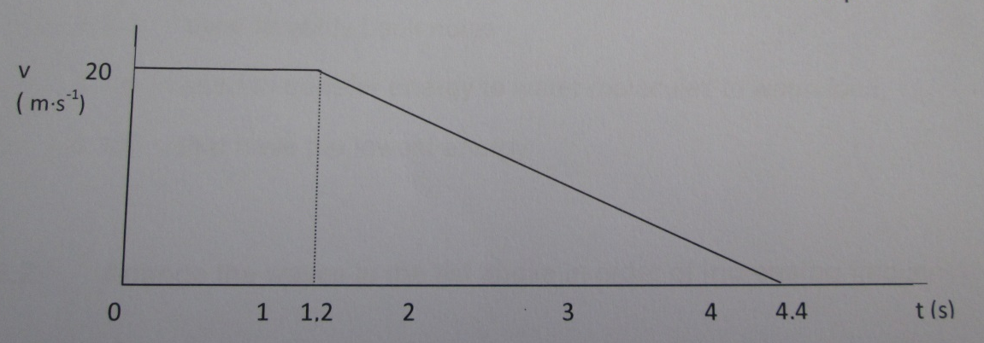

- Describe the motion of the bus as represented by the velocity vs. time graph. (4)

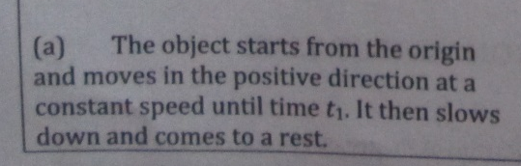

- What does the gradient of the s time velocity graph represent? (1)
Acceleration
- Use the graph in order to calculate the displacement during this time. (4)
Area under the graph

- Based on the velocity vs. time graph, construct a position vs. time graph drawn to scale below. Remember to insert x and y axis labels. (4)

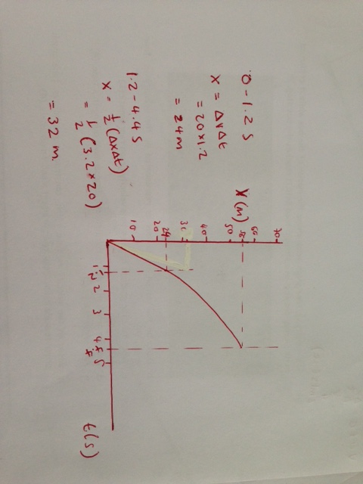

  - A chair lift carries two hikers, Jack of mass 70 kg and Jill of mass 50 kg, to the top of a mountain slope.
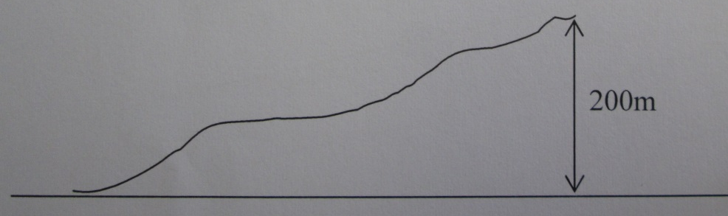

- State the law of conservation of energy. (2)
The law of conservation of energy states that energy cannot be created or destroyed.

- Calculate Jack’s increase in potential energy as he moves through a vertical height of 200 m. (2)
E_{p} = mgh = 70*9.8*200 = 137200J

- Upon reaching the top, they decide to ski from rest down the slope. Ignore the effect of friction. Calculate Jack’s speed when he reaches the bottom of the slope. (5)

E_{k1} + E_{p1} = E_{k2} + E_{p2}
∴ 0 + mgh = ½mv² + 0
∴ v² = 2(9.8)(200) = 3920
∴ v = 62.6m/s
Or
Mgh = ½mv²
137200 = ½(70)v²
v² = 3920m/s
V=62.6m/s

- How do Jack and Jill’s speeds compare when they reach the bottom of the slope? Briefly explain your answer. (2)
Jill’s speed will be slower bcause her mass is lower.

  - A lift carries four people form the ground floor to the 6th floor at a height of 19 m. The average mass of each person is 65 kg. The mass of the lift is 800 kg.

- What is the definition of gravitational potential energy? (2)
Potential energy because of an object’s position relative to the surface of the earth.

- Calculate the potential energy of the lift and the passengers when it has come to rest at the 6th floor. (5)
E_{p} = (800+65*4)*9.8*19 = 197372J

The lift is stationary on the 6th floor when the cable holding the lift suddenly snaps, and the lift and the passengers fall to the ground. Ignore the effects of friction.

- Using the law of conservation of energy, calculate the velocity of the lift just before it hits the ground. (3)
E_{k1} + E_{p1} = E_{k2} + E_{p2}
∴ 0 + mgh = ½mv² + 0
∴ v² = 2(9.8)(19) = 372.4
∴ v = 19.6m/s
Or
Mgh = ½mv²
197372 = ½(1060)v²
v² = 372.4m/s
V=19.6m/s

- In reality, mechanical energy is not conserved during such a fall. Give a reason why the falling lift may experience a lower velocity than calculated. (1)
Air resistance

- What is the energy conversion that takes place based on your answer to “d”? (1)
Heat energy.

Total = 120 marks

