Natural Science June Exam June 2014

Mrs Magid
Beis Yaacov Girls High School / Mesivta Shaarei Torah
Gr 9

Name:______________________________

Answer ALL the questions. Ensure that your handwriting is legible. Do not write in red ink. Good luck!

Question 1: Compounds and chemical reactions (45 marks)

  - Write down a word that describes each of the following statements: (12)
    - The common name for dihydrogen monoxide. __________________
    - The ending of a compound’s name that is made up of three elements, one of which is oxygen. __________________
    - The common name for sodium chloride. __________________
    - The name of the compound made from lithium and chlorine. __________________
    - The name of the compound made from lithium, chlorine and oxygen. __________________
    - Substances found in the region between metals and non-metals in the periodic table. __________________
    - The larger number in the block of an element in the periodic table. __________________
    - The columns in the periodic table. __________________
    - An element with 25 protons in its nucleus. __________________
    - The noble gas in period 2. __________________
    - The elements with the symbol Sn. __________________
    - The element with 30 neutrons in its nucleus. __________________

  - Give one example of: (3)
    - A metal. __________________
    - A non-metal. __________________
    - A metalloid. __________________

  - Use the periodic table to complete the following table: (11)

Formula of compound | Number of each type of element in the compound. Provide the NAME of the elements | Name of compound
NaOH |  | Sodium hydroxide
MgO | 1 magnesium, 1 oxygen
 |  | Water
Al₂S₃

 |  | Carbon monoxide
 |  | Carbon dioxide
Ca(NO₃)₂ |  | Calcium nitrate

  - Balance the following equations: (9)

    - H₂ + O₂ → H₂O

____________________________________________________________

    - C + H₂ → CH₄

____________________________________________________________

    - CaCO₃ + HCl → CaCl₂ + CO₂ + H₂O

____________________________________________________________

  - Draw a labelled mercury (Hg) atom indicating all the things that an atom is made up of, including the charges of the different components. Remember all the rules of scientific diagrams! (10)

Question 2: Reactions of metals and non-metals with oxygen (18 marks)

  - Fill in the missing words: (2)
    - Metal + oxygen → __________________
    - Non-metal + __________________ → non-metal oxide

  - Write a balanced chemical equation using symbols for each of the following reactions: (6)
    - Carbon burns in oxygen

____________________________________________________________

    - Magnesium burns in oxygen

____________________________________________________________

    - Sulfur burns in oxygen

____________________________________________________________

  - Describe the term rusting. (3)

____________________________________________________________

____________________________________________________________

____________________________________________________________

  - Explain why rust costs the South African economy millions of rands every year. (2)

____________________________________________________________

____________________________________________________________

____________________________________________________________

  - A student wants to investigate how well different methods of preventing rust work. He writes down the following materials and method:

Materials: three nails, three jars with lids, paint, oil, water

Method:
 | Actions | Observations
Jar 1 | Place nail in jar, pour water to cover half the nail, close lid
Jar 2 | Paint nail in paint, allow to dry, place nail in jar, pour water to cover half the nail, close lid
Jar 3 | Place nail in jar, pour water to cover half the nail, pour layer of oil on top of water to cover the nail completely, close lid

    - Which jar is used as the control? Explain. (2)

____________________________________________________________

____________________________________________________________

    - Complete the table with the observations that the student is likely to find when he returns to the laboratory two weeks later. (3)

Question 3: Acids, bases and pH values (14 marks)

  - Explain the meaning of the term pH. (1)

____________________________________________________________

____________________________________________________________

  - Categorise the following substances as a strong or weak acid or base: (5)
    - Milk __________________
    - Hand soap __________________
    - Hydrochloric acid __________________
    - Oven cleaner __________________
    - Orange juice __________________

  - What colour would you expect each to turn in the presence of a universal indicator? (5)
    - Milk __________________
    - Hand soap __________________
    - Hydrochloric acid __________________
    - Oven cleaner __________________
    - Orange juice __________________

  - Jane investigates a reaction between an acid and a base. She tests the pH of a beaker that contains 5 ml hydrochloric acid. She then pours 5 ml of sodium hydroxide into the beaker. She mixes the two solutions and then measures the pH of the product. She also adds a few drops of universal indicator and it turns green.

    - Predict the pH of the product. (1)

____________________________________________________________

    - Explain what took place in the experiment. (1)

____________________________________________________________

____________________________________________________________

    - Jane pours the product into an evaporating dish. She places it in a sunny spot for one week. Predict what she would find in the evaporating dish a week later. (1)

____________________________________________________________

Question 4: Reactions of acids with bases and metals (12 marks)

  - Write down a word or term that describes each of the following statements: (5)
    - An acid and a base react together to produce a salt and water. __________________
    - A base or a basic salt that neutralises stomach acids. __________________
    - A gas with no colour or smell that is less dense than air. __________________
    - Agricultural lime to neutralise soils. __________________
    - Forms a milky solution when bubbled through limewater. __________________

  - Fill in the missing words: (7)
    - Metal hydroxide + acid → ________________________________________
    - Metal carbonate + acid → ________________________________________
    - Metal + acid → ________________________________________________

Question 5: Forces (18 marks)

  - What is an unbalanced force? Support your answer with an example. (2)

____________________________________________________________

____________________________________________________________

____________________________________________________________

  - Differentiate between a contact and a non-contact force. (2)

____________________________________________________________

____________________________________________________________

____________________________________________________________

  - Consider the diagram below. What is the resultant force? (2)

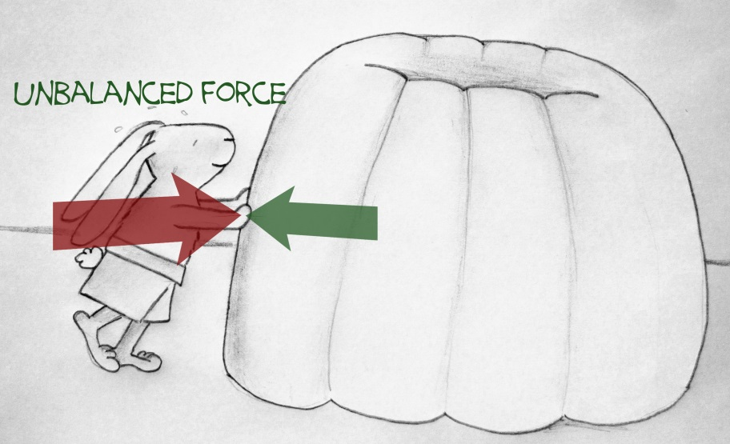
2 N
5 N

____________________________________________________________

  - You want to move a box from point A to point B. You push on the box but it does not move.

- What two forces are acting against each other? (2)

____________________________________________________________

____________________________________________________________

- What two possible things may you conclude from the fact that the box is not moving? (2)

____________________________________________________________

____________________________________________________________

  - What two factors does weight take into account? (2)

____________________________________________________________

____________________________________________________________

  - Complete the table below: (6)

Type of force | Contact or non-contact force | Example of where we see this type of force
Tension
Gravitational
Friction

Question 6: Graphs and controls (23 marks)

  - Using the graph paper provided, construct a graph based on the data provided in the table below. It shows the blood glucose level of a diabetic person and a non-diabetic (normal) person after a meal. (Note that 0 hours is just as the meal is about to be eaten). (16)

Time After Eating hours | Blood glucose level (mg /dL) of normal person | Blood glucose level (mg /dL) of diabetic person
0 | 85 | 170
0.5 | 90 | 220
1 | 100 | 300
1.5 | 110 | 360
2 | 90 | 350
3 | 85 | 300
4 | 85 | 280
5 | 85 | 240
6 | 85 | 220

- What is the approximate blood glucose level of a normal person JUST BEFORE the meal is eaten? (1)

____________________________________________________________

- What is the approximate blood glucose level of a normal person at its peak? (1)

____________________________________________________________

- After how long (more or less) does the normal person reach the maximum blood glucose level? (1)

____________________________________________________________

- What conclusion can you draw about the glucose level of a diabetic person 5 hours after eating when you relate it to a normal person? (2)

____________________________________________________________

____________________________________________________________

____________________________________________________________

- Why is the diabetic’s blood glucose level JUST BEFORE the meal is eaten so high? (2)

____________________________________________________________

____________________________________________________________

____________________________________________________________

Total = 130 marks

The periodic table of elements
